**Autonomous Carrier Assistant (A.C.A)**

 A motorized platform to follow the user with collision detection

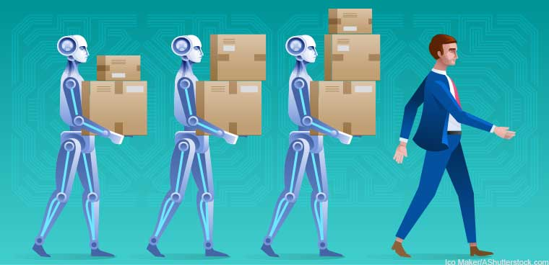

Department of Electrical Engineering & Computer Science



University of Central Florida

*Group 5*

Amine Chahli   Electrical Engineering

Hunter Busa Computer Engineering

Muhammad Khan Electrical Engineering

Richard Garces Electrical Engineering

Table of Contents

Executive Summary 1

Project Description 2

Project goals and objectives 3

The Challenges 4

Problems Solution 4

The project requirement and specifications 5

Block Diagram 6

House of Quality 7

Research and part Selection 8

Micro-controller 8

Raspberry Pi Zero 9

Arduino Uno 10

MSP 430FR6989 11

Teensy 3.6 12

MCU Selection 12

Bluetooth 13

Frequency-hopping spread spectrum 13

Different versions of Bluetooth 14

Bluetooth 5.0 14

Bluetooth Applications 15

Bluetooth Devices 16

GPS (Global Positioning System) 17

GPS Devices 19

GPS Applications 19

GPS Communication 20

Mobile Application 21

Native Application 22

Web-based Application 22

Hybrid Application 22

Mobile Application Development 22

Flutter 23

Java Virtual Machine 27

Java 27

JDK 1.0 28

J2SE 5.0 28

Java SE 6 28

Java SE 7 29

Java SE 8 29

Java SE 9 29

Java SE 10 29

Java SE 11 30

Java SE 12 30

Java Script 30

JavaScript Growth 31

JavaScript Security 31

JavaScript Security 31

JSON 32

Python 33

Python 2 34

Python 3 34

Python Features 34

API 35

Remote APIs 35

Web APIs 36

API Design 36

REST API 36

REST Constraints 37

XML 39

Sensors 39

Types of sensors 40

How sensors work? 40

HC-SR04 ultrasonic sensor 41

Maxbotix LV-EX3 42

Arduino KY-032 Infrared Sensor 42

Parallax Ping ultrasonic distance sensor 43

Sensor Selection 45

Motors 45

Types of motors 45

Working principle of motors 46

Actuators 47

DC motors 47

Comparison of Motors 48

LMioETool DC gear motor 48

Greartisan DC gear motor 49

BBT permanent magnet DC motor 49

Magnolora DC gear motor 50

Motor Selection 51

Motor finalization 51

L298 Motor Control Drive Board 52

L293 Motor Drive Shield 53

Sparkfun Motor Driver TB6612FNG 54

Voltage regulator and DC power supply 55

Voltage regulator 56

How voltage regulators work? 57

Type of voltage regulator 58

Linear voltage regulators 58

Types of linear regulators 59

Switching voltage regulator 61

Types of switching regulators 61

Voltage Regulator Selection 63

Batteries 64

Types of batteries 64

Lithium-ion batteries 65

Nickel Cadmium batteries 66

Nickel Metal Hydride Batteries 67

Lead acid batteries 69

Charging: 69

Constant Voltage charging 70

Float charging 70

Battery Selection 71

Printed Circuit Board ( PCB ) 72

The types of PWBS 72

Joystick 73

Assembly Design 73

Wheel 74

Wheel vs Continuous track 75

One-wheel Concept 76

Two wheels Concept 77

Three Wheels Concept 77

Four wheels Concept 78

Wheel Diameter 79

Different Tread Types 79

Wheel Selection 80

Scale 82

History of Scales 82

Digital Scales 82

Load Cell 84

Display 85

Segments 85

LCD 85

OLED 87

TFT 88

Display selection 88

Charge Controller 89

PWM Pulse Width Modulation : 90

RENOGY 12V Charge Controller 90

Dual Battery PWM : 91

PCB Implementation 92

Eagle 92

Prototype PCB 92

PCB’s First Design 94

Second PCB Design 95

Standards 96

IPC PCB Standards 98

Soldering Standards 99

Project Constraints 100

Design Constraints 100

Financial constraints 101

Safety constraints 101

Environmental constraints 103

Social constraints 104

Time constraint 104

Administration 105

Marketing 105

Marketing strategies 106

Video content and YouTube 106

Facebook and SMM 107

LinkedIn Marketing 107

Market requirements 107

Defining buyer person 108

Persona engagement 108

Preparation of research questions 108

Competition analysis 108

Use case scenarios 109

Financial Plan and Budgeting 110

Testing Equipment 111

Sensor Testing 111

Motor and Motor Driver Testing 112

Switch Voltage Regulator Testing 114

LCD Display Test 114

Load Cell Test 116

Microcontroller Test 118

BlueTooth Testing 119

Available Parts 120

ACA OPERATION 121

Conclusion 122

References 123

**List of Figure**

Figure 1: Enabling technologies for Industry 4.0 2

Figure 2: Autonomous mobile robot on factory floor 3

Figure 3 Microcontroller diagram 8

Figure 4 Raspberry Pi Zero 9

Figure 5: Arduino Controller 10

Figure 6 Pin Mapping 10

Figure 7 MSP430FR6989 Controller 11

Figure 8 Teensy 3.6 Controller 12

Figure 9 HC-05 Bluetooth Module 16

Figure 10 PMOD GPS Receiver 20

Figure 11 Flutter Program 23

Figure 12 Unity Software Development Kit 24

Figure 13 React Native Development Kit 25

Figure 14 Android Studio 26

Figure 15 JAVA Script 30

Figure 16 Java Script Object Notation 32

Figure 17 Pytheon Language 33

Figure 18 Sensor Block Diagram 39

Figure 19 : HC-SR04 Ultrasonic Sensor 41

Figure 20 : Maxbotix LV-EZ3 Ultrasonic Range Finder 42

Figure 21 KY-032 Infrared Obstacle Sensor 43

Figure 22 : Parallax Ping Sensor Operating Principle 44

Figure 23 : Parallex Ping Sensor 44

Figure 24 Working Principle of Motor 46

Figure 25: Different Types of Motors 46

Figure 26 Servo and Stepper Motor Actuators 47

Figure 27 Motor Configuration 47

Figure 28 LMioETOOL DC Gear Motor 49

Figure 29 Greartisan DC Gear Motor 49

Figure 30 BBT PMDC Motor 50

Figure 31 Magnolora 12V DC Gear Motor 50

Figure 32 H-Bridge Circuit for Motor Control 52

Figure 33 Qunqi L298N dual H-bridge Motor Control Drive 53

Figure 34 L293 Motor Driver Shield 53

Figure 35 L293 Pin Configuration 54

Figure 36 Spark fun Motor Driver 54

Figure 37 Full-Wave Bridge Rectifier Circuit 55

Figure 38 Input and Output Waveforms of the Full-Bridge Rectifier 56

Figure 39 Voltage Waveform with and without Smoothing Capacitors 56

Figure 40 Power Supply with Voltage Regulator IC 57

Figure 41 Voltage Regulator Pinout 57

Figure 42 Voltage Regulator IC with Heat Sink 58

Figure 43 Internal Circuit of a Linear Regulator 58

Figure 44 Pros and cons of linear regulators 59

Figure 45 Standard NPN Darlington Voltage Regulator 59

Figure 46 Low Dropout Voltage LDO Regulator 60

Figure 47 Qausi-LDO Voltage Regulator 60

Figure 48 Comparison of Standard, LDO and quasi-LDO Voltage Regulators 60

Figure 49 Switching Voltage Regulator Circuit 61

Figure 50 Pros and Cons of Switching Regulators 61

Figure 51 Buck Switching Regulator 62

Figure 52 Boost Switching Converter 62

Figure 53 Buck-Boost Switching Regulator 63

Figure 54 Voltage Regulator Circuit 63

[Figure 55 Battery Circuit Diagram 64](https://d.docs.live.net/f7a2e6860c0f709f/Desktop/EEL4914_SD1_120_Junaid%20Amine.docx#_Toc38313440)

Figure 56 Lithium-ion Battery Composition 66

Figure 57 Nickel Cadmium Battery Construction 67

Figure 58 NIMH Battery Construction 68

Figure 59 Battery System Diagram 70

Figure 60 Assembly Model 73

Figure 61 # # Assembly Base 74

Figure 62 Different Types of Wheels 74

Figure 63 Wheels Vs Tracks 75

Figure 64 One Wheel Concept 76

Figure 65 Two wheels Concept 77

Figure 66 Three Wheels Concept 77

Figure 67 Four Wheels Concept 78

Figure 68 Different Treads 79

Figure 69 Scales 83

Figure 70 Load Cell 84

Figure 71 LCD 1602 A 86

Figure 72 MPPT Charge Controller 89

Figure 73 Voyager Charge Controller 90

Figure 74 Dual PWM Charge Controller 91

Figure 75 PCB Schematic 93

Figure 76 PCB Proto-type 94

Figure 77: Goals of social media marketing 107

Figure 78: Market research methodology 109

Figure 79 Sensor Schematic 111

Figure 80 Sensor Testing 111

Figure 81 Motor Testing 112

Figure 82 Motor Testing with breadboard Schematic 113

Figure 83 Motor and L298N Driver testing With Arduino 113

Figure 84 voltage Regulator Testing 114

Figure 85 LCD Schematic 114

Figure 86 Adapter Module 115

Figure 87 LCD Testing 115

Figure 88 Schematic of Load Cell and HX711 with LCD display 116

Figure 89 Load Cell Set up 117

Figure 90 Load Cell Test with 2.5 lbs 118

Figure 91 Bluetooth Testing 119

# Executive Summary

This paper will develop the choices made for both the hardware and the software implemented in the design of the Autonomous Carrier Assistant. The specification and requirements were discussed. The Research and comparisons of all the components considered was carefully discussed. The reasons behind each selection was explained as well.

The Autonomous Carrier Assistant or A.C.A. is at its very essence, an autonomous robot. The Autonomous robot is not a new concept. Autonomous robots that can follow someone are nothing new as well. This project creates an autonomous robot which leads and follows someone, it is versatile and efficient as well as being low cost to both produce and sell on the market. The hardware and software chosen to complete this project were all extensively researched to produce the most cost-efficient product to go to market.

In today’s world of modern technology life is becoming more and more automated. Conserving energy has been a human trait since the days of hunter gatherers. Our laziness has brought about ingenious ways to get things done. This project is derived from this concept. Why carry something when you can just make something to do it for you. The A.C.A. will be designed to carry your belonging for you and give you the ability to conserve your energy. This can be applied in several ways. whether in your backyard or in an industrial setting or commercial setting. Each component used in the A.C.A. was chosen for specific reasons. Low cost weighs in on every chose made, because the budget is very important to consider on any project. Efficiency also held a lot of weight in the decision-making process. The base was chosen for its strength and durability. The base is the platform on which everything will be attached. Its durability is important, the A.C.A. is tasked with carry load up to 30lbs and carrying them over considerable distance. While the base houses all the major components, the base itself moves due to the wheels on which it sits. The choice of the wheel effects how it moves, and it also effects the terrain in which it can move. The battery also plays its role in the movement abilities of the A .C.A the power provided determines what it can carry and how far as well as how much energy can be conserved for the consumer or consumers off of one charge.

The brain of the A.C.A. is the microcontroller. This component was chosen based on its efficiency to carry out the coding needed to make the A.C.A. run smoothly and do what it is intended to do. This MCU with control the aspects of collision detection, the leading and following mode along with a joystick mode. It also allows the communication between the Bluetooth and the mobile app that is implemented for each mode of the A.C.A. The Bluetooth plays a vital role in the success of the project. It is thru the Bluetooth that the A.C.A is able to follow and lead the consumer. The choice of Bluetooth used is based on its ability to connect and range of connectivity.

The success of this project allows for many applications of this technology. At first it was developed to be a luggage carrier for airports. It was then decided that having a more general-purpose device would allow for more flexibility is design. It is our hope that with very little fine tuning the A.C.A. can be use not just to carry luggage but also any belongs or product that a person or persons do not want to carry. I t can be used in shopping centers, conventions center, in transportation within a warehouse for instance. Perhaps in one’s own backyard to help carry tools or in a farming area to help carry produce that is picked. These technologies exist in today world. This project will try and produce a more efficient and low-cost product that can have many uses.

# Project Description

The modern-day life in the 21st century is at large shaped by the technological advances and innovations made in the recent past. Without these technologies, life in the 21st century is hard to imagine. The level of comfort, ease and efficiency that these technologies have brought has been unprecedented in the human history.

It is interesting to note that with the passage of time the pace of technological innovation is increasingly gaining momentum. Latest technologies such as electric vehicles, smart phones, 5G networks, artificial intelligence and autonomous robots were only a figment of imagination a decade or two earlier. However, today such technologies are not only existent but very much functional in several areas of modern-day life.

With the revolutionary breakthroughs in engineering and technology, the current civilization is ready to enter the fourth industrial revolution. This industrial revolution is also referred to as Industry 4.0. The industry 4.0 is not a concrete technology in itself rather it is a collection of several key enabling technologies which work in synchronization in order to create a highly automated and interconnected society with smart factories and smart cities.

The key enabling technologies for the industry 4.0 paradigm include internet of things, big data, cloud computing, cyber physical systems, machine learning, augmented reality, additive manufacturing, and collaborative/autonomous robots.

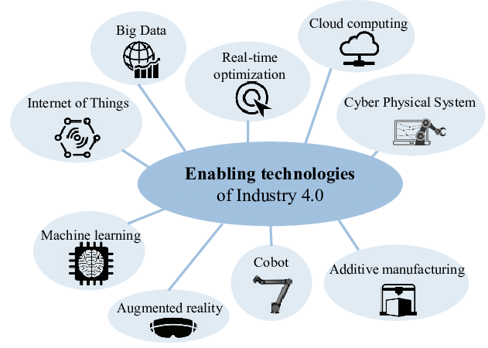

Figure 1: Enabling technologies for Industry 4.0

The project that we are going to discuss in this report is related to autonomous robots which is one of the keys enabling technologies of Industry 4.0 paradigm. Such autonomous robots have varied applications in the fields of medicine, defense, manufacturing, security, and transportation.

An autonomous robot is a robotic system which possesses high degree of autonomy and requires none or very little intervention from human operators to complete its tasks. A truly autonomous robot has the ability to perceive its environment, make decisions on the basis of its perception, and manipulate the environment based on its decision.

One of the major features of autonomous robots is that of autonomous navigation. This means that the robot has the capability to plan its path and execute the motion along that path without external help. Such a robot can make decisions regarding starting, stopping, accelerating, decelerating, and avoiding obstacles. Such self-driving robots have huge applications in many areas of modern society.

The purpose of our project was to develop an autonomous luggage carrier (ACA) robot. The ACA is a motorized robot platform whose primary purpose is to assist humans in transporting goods, objects or luggage. Such an autonomous robot can be effectively used to carry heavy objects on the factory floors, airport terminals, rough terrains, and many other places.

The ACA is not only able to carry the luggage and follow the users while avoiding the obstacles, but it is also capable of guiding the users to their destination using autonomous navigation capabilities.

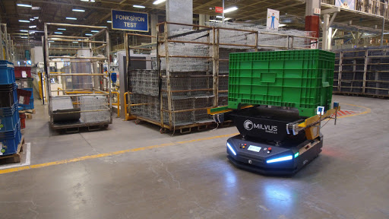

Figure 2: Autonomous mobile robot on factory floor

# Project goals and objectives

The definition of clear goals and objectives is the key requirement for the successful completion of any project. Without setting well-defined goals, the project team does not have any direction and there is no agreement on project related matters.

Therefore, before starting the actual development of the project, it is essential that we define the goals and objectives for our autonomous carrier assistant robot system. There are three main objectives of the ACA which are listed as following:

1. Luggage carrying ability
2. Obstacle avoidance and following the user
3. Path planning and autonomous navigation

The first objective of the ACA (Autonomous Carrier Assistant) was that the robot is able to carry substantial amount of weight in a stable manner to the user’s destination. This is the primary feature of the autonomous luggage carrier that it should be able to help the user in carrying his weight. The robot was designed in such a way that it does not drop the luggage accidently or get unstable due to the loaded weight.

The second objective of the ACA (Autonomous Carrier Assistant) is that it should be able to follow the user accurately while maintaining a proper distance as well as avoiding obstacles. Obstacle avoidance is one of the main features of autonomous mobile robots. Without effective obstacle avoidance capabilities, such robots will either cause damage to themselves or to the objects and people they collide with. Therefore, it is crucial that all such robots consist of reliable obstacle avoidance capabilities.

The third objective of the ACA (Autonomous Carrier Assistant) is that it should be able to perform effective path planning in real time as well as navigation services to the user. This means that, when asked, the robot should be able to guide the user to its destination without external help or intervention. The robot should be able to do effective path planning which means that it should be able to evaluate multiple paths to the user’s destination and select the most appropriate one. The robot is capable to navigate around the obstacles in order to reach its destination.

# The Challenges

There are many problems we faced in completing this project. Our choice of hardware and software will have a great effect on how well the ACA performs in different environment. Performing in crowded areas is essential for the ACA. The challenge to avoid collisions was solved by using accurate sensor and the right number of sensors. Applying the proper coding was also enhanced this feature of the ACA. Following at the correct distance was another hurdle that had been overcome. Maneuvering through different terrains was achieved with a good quality motor and wheels. Having enough power to carry loads and perform efficiently is determined by our power supply along with motor quality. Choosing the right microcontroller with versatility so that we can implement all of our feature is pivotal. The PCB design is another important aspect that could have made or broken the ACA. The coding for paring with an application is efficient to provide quick and accurate responses. The application itself is also be key to the success of following the consumer. The coding part of this project was essential to its success. All these hurdles we face must be overcome within a budget as well. Keeping the cost as low as possible was another problem that was always be taken into consideration when choosing hardware.

# Problems Solution

Technology now a day changes the way we are living and how we are acting too. It is one of the tools that solve human being problem and make our living easier, practical, and faster. One of the technologies that are grown in the world is the Automation car or what do we call a self-driving car and The Autonomous Assistance Carrier. The ACA (Autonomous Carrier Assistant) will help and solve many problems for the user, for example, if you are old man or woman and can’t carry a heavy back or box because your age or your back hurt the Autonomous carrier Assistant will help you to carry your box and follow you to your final destination. The shopping carts are helping the user to store more product that he or she needs and pushing to the checkout point, on the other hand, we can use the ACA to help the customer in the supermarket to buy easily and with saving time of pushing the old carts around the supermarket to find the products. I work in a hotel as maintenance and we are using manual carts that carry heavy tools. I got a heart in my shoulder by just pulling the carts around to do the job. I had almost 3 months of absence because I cannot do the job. In my case, we can use ACA where I work at or in any work that needs pushing or pooling carts that will solve people getting injured at work and losing their job or their weekly paid.

# The project requirement and specifications

• The cart should be autonomously following the user by 1.5 mph

• Battery allowing to be rechargeable

• Has a collision detection using sensors.

• the cost should not be no more than $600

• Two LED show the level of the battery (Red shows low & Green fully charged)

• The device weight should be less than 30lb

• The device should be able to carry at least 40lbs

• Battery should last for 6 hours

• The design should be able to move

• The design should be able to charge when it is plugged in

• two electrical motor in the design

• Four sensors in the design

• App detection

• 3-wheel stable model

• The front two wheels change the direction of the cart

• The autonomously vehicle should be environment friendly

• Object detection distance range 2 to 8 ft

• Equip printed circuit board

• The application should be able to use the Android & IOS both

• Notification in the app or the phone that the battery is low

• The app should notice the user that communication is lost

• Make the user know how long he can use the device

• The weight sensors used to measure the amount of weight

• The device should be able to connect to the wall charger

• the first two wheels will change the direction of the cart

• if the cart has over weighted the sensor will give the order to note move and make sure the user know that.

# Block Diagram

Each block in this diagram will responsibility for each team member and his job.

Movement system

- Motor & Driver

-Wheels

-Sensors

-Application

-Bluetooth

GPS Module

Power

-Battery

-Voltage regulator

-PCB

Controller

-Microcontroller

-Display

-Scale

Report & Organization

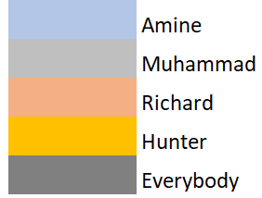

# House of Quality

|  |  |  |  |  |  |  |  |
| --- | --- | --- | --- | --- | --- | --- | --- |
| Engineering  Requirements  Marketing  Requirements | | Cost | Battery Life | Weight | Dimensions | Target Detection | Application Connectivity |
| - | + | - | - | + | + |
| Cost | - | ↑↑ | ↓↓ |  | ↓ | ↓ |  |
| Durability | + | ↑↑ | ↑ | ↑ | ↑ |  |  |
| Usability Radius | + | ↓ | ↑ |  |  | ↑↑ |  |
| Duration of Use | + | ↓ | ↑↑ |  |  |  |  |
| Targets for Engineering Requirements | | < $400 | >4 hours | <25lbs | 2ft x 2ft x 1ft | 5-10 feet | 20-30 sec |

# Research and part Selection

# Micro-controller

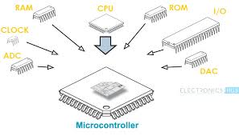

Figure 3 Microcontroller diagram

Simple put a Microcontroller is a computer. It is a simple computer used in embedded system for specialized purposes. Like a PC computer it has a CPU to execute programs. It has storage where the CPU can upload these programs from. It also has Random Access Memory (RAM). A computer has input and output devices so that it can communicate with the world around it. In the same way a microcontroller has I/O pins so that it can also communicate with the world around it i.e. sensors, LCD displays or even a PC. Microcontrollers are often found inside electronic consumer products such as vehicles, office machines, medical devices, and many of our home appliances. They are used to control features and action of that product or embedded system. They are dedicated for that specialized purpose, to make that product do whatever it is that it does. The MCU inside your washing machine is programmed for one specific purpose, to wash your clothes. For this project the Microcontroller will also have one general purpose, that purpose is to make the ACA do what it does, autonomously assist you in carrying your belongings.

There are several technology and business aspects to consider when deciding what microcontroller to use for a project. In industry bottom line or cost is always at the top of that list. The maximum speed, amount of RAM or ROM, number and types of I/O pins on an MCU, as well as power consumption and constraints and development support are all just as important to consider. The amount and quality of resources and community which are available for the microcontroller are key to its implementation. The market availability will affect the cost. Another key feature of the microcontroller is the processor. The application of the microcontroller with determine the complexity of the processor. The options can range from 4-bit to 64-bit. It can use volatile memory types like Ram and non-volatile memory types like Flash memory, erasable programmable read-only memory (EPROM) or electrically erasable programmable read-only memory (EEPROM).

# Raspberry Pi Zero

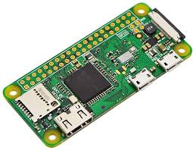

Figure 4 Raspberry Pi Zero

The Raspberry Pi deserve to be mention when considering this project only because of its constant comparison to another candidate. The Arduino uno and raspberry pi are always compared by most tinkerers of these types of project. Although the latter is more of a computer sporting a microprocessor instead of a microcontroller. The difference between microcontrollers and microprocessors has become less clear as more complex chips have become relatively cheap to manufacture and microcontrollers have begun integrating more "general computer" types of functionality. On the whole microcontrollers function usefully on their own, with a direct connection to sensors and actuators. On the other hand, microprocessors are designed to maximize computing power on the chip, with internal bus connections instead of direct I/O pins to supporting hardware such as RAM and serial ports. Another major difference is that microprocessors usually have an Operating system or OS. The Raspberry Pi Zero is basically an upgraded version of the Raspberry Pi 1. This version is being considered solely because comparing the other contenders to the latest version which is the Raspberry Pi 4 is just unfair. Using even the Raspberry Pi Zero would give the option to add more advance feature that require more processing power. It is the I/O pins that warrant the comparison. This feature of the Raspberry Pi allows the attachment of electronic components like sensor, motors, and displays. The heart of the Raspberry Pi Zero is its processor, the BCM2835 which is an ARM v7 single core that can go up to 1Ghz. The Raspberry Pi Zero has a 32-bit ARMv6Z architecture developed by Broadcom. It has 512MB RAM. It can support both audio and video and has 40 general purpose I/O pins. This chip is not easily available in retail markets. The Raspberry Pi Zero W is only $10.00. it is the latest version of the Zero and It does also come with 802.11b/g/n wireless LAN, Bluetooth 4.1 and Bluetooth Low Energy (BLE).

# Arduino Uno

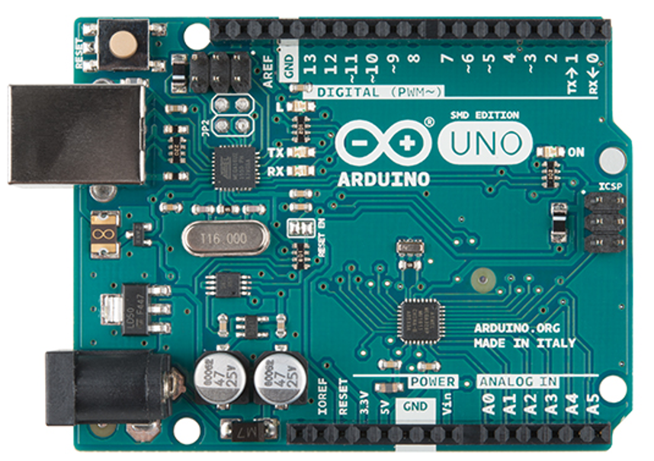

Figure 5: Arduino Controller

The Arduino uno is a very popular Micro controller that has a large amount of resources at its disposal. This is since a lot of hobbyist use this MCU. There is a lot of information on programming this microcontroller, the libraries and programming are very user friendly. This board is considered one of the best to get started with electronics and coding. It is a robust board which is why many hobbyists like it. The device operates between 1.8-5.5 volts. It has 14 digital input/output pins (of which 6 can be used as PWM outputs), 6 analog inputs, a 16 MHz ceramic resonator, a USB connection, a power jack, an ICSP header and a reset button. The cost of the Arduino comes in at 22.00.Arduino Uno is a microcontroller board based on the ATmega328p. The ATmega328P is an Advanced Virtual RISC (AVR) microcontroller that can support data up to 8-bits, has 28-pins and has 32KB flash memory. It has 1KB Electrically Erasable Programmable Read Only Memory (EEPROM), as well as 2KB Static Random-Access Memory (SRAM). The CPU speed 20 MIPS. It also has 3 built-in Timers, two of them are 8 Bit timers while the third one is 16-Bit Timer. It operates in a range from 1.8V to 5.5V. Its excellent features include the cost efficiency, low power dissipation, programming lock for security purposes, real timer counter with separate oscillator. The Chip itself cost about 2.00

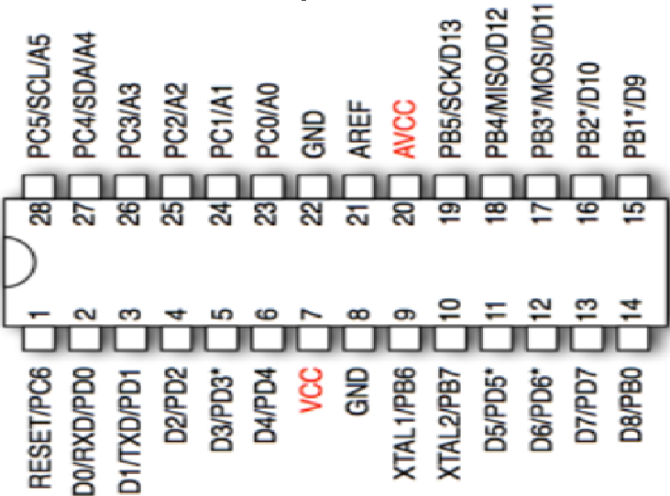

Figure 6 Pin Mapping

The Arduino Integrated Development Environment (IDE) is written in Java. The programming itself in written in C++ or the way we will be programming. The development platform for Arduino does not require high level knowledge of C or other programming languages. Shortcuts and simplified functions provided by IDE allows for an ease of use that makes this MCU stand out among the others. By using the Arduino Uno board, the ATMEGA238p can be programmed to carry out the functions needed to make this project a success.

# MSP 430FR6989

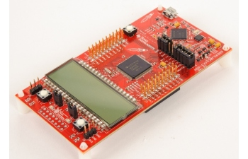

Figure 7 MSP430FR6989 Controller

The MSP430 family of boards is developed by Texas Instrument. This MCU is powerful and reliable. It is also fairly easy to implement, this is what makes it so appealing to this university. This MCU is the one that this group is most familiar with as it was used in embedded systems. The familiarity with this MCU makes it a strong candidate for out project. We will be considering the MSP430FR6989 to be specific. The cost of a MSP430 FRAM chip is between $2-$4.00. It is a 16- bit Microcontroller, runs at 24MHz and has 83 general purpose I/O pins. It also has 5 16-bit timers and 1 16-bit Real Time Clock. Other features include Direct Memory Access (DMA). Direct memory access (DMA) is a feature of computer systems that allows certain hardware subsystems to access main system memory (random-access memory), independent of the central processing unit (CPU). Without DMA, when the CPU is using programmed input/output, it is typically fully occupied for the entire duration of the read or write operation and is thus unavailable to perform other work. With DMA, the CPU first initiates the transfer, then it does other operations while the transfer is in progress, and it finally receives an interrupt from the DMA controller (DMAC) when the operation is done. This feature is useful at any time that the CPU cannot keep up with the rate of data transfer, or when the CPU needs to perform work while waiting for a relatively slow I/O data transfer. It also has 128-bit or 356-bit AES security Encryption and Decryption. This Microcontroller can also support up to 320 segment LCD. This feature would be useful as we do intend to implement an LCD display. In addition, this chip has an Extended Scan interface (ESI). The extended scan interface (ESI) is a module for the ultra-low-power MSP430FR6989 microcontroller (MCU) which consists of multiple sub-modules, which include analog front ends and different state machines. These modules minimize power consumption of the system by automating sensor measurements without CPU intervention. The pin layout is given below for MSP430FR6989.

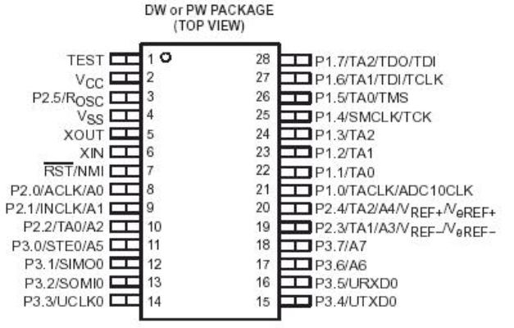

# Teensy 3.6

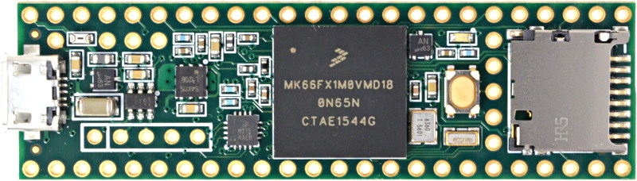

Figure 8 Teensy 3.6 Controller

When Teensy was first released, it was a revelation to the maker community. It brought together the power of ARM processors and the simplicity that is the Arduino IDE. We now have 3 MCU that have a wide variety of resource and libraries. While the Teensey 4.0 is the newest update version of the 3.6. It has features that we would not be needing. The Teensy 3.6 is more comparable to what is needed for this project. This board also has advanced features such as dedicated floating-point units, native SD card support and Ethernet which also might be overkill for this project. It uses the MK66FX1M0 microcontroller, developed by NXP, which has a 180Mhz ARM Cortex M4 core. There are plenty of general purpose I/O pins with 100. This Microcontroller has a significant advantage in the memory department over both the MSP430 and the AtMega328p boasting 256KB in Static Random-Access Memory (SRAM) and 1.25MB in Flash memory. If that was enough of step up It also has 4KB Electrically Erasable Programmable Read Only Memory (EEPROM). The microcontroller is also able to implement USB Controllers, CAN, and Ethernet. The MK66FX1M0 is a formidable microcontroller with 6 UART, 3 SPI and 4 I2C parameters. It also has Human Machine Interface (HMI) which helps in error reduction, improves reliability and maintainability and also increase system and user efficiency

# MCU Selection

The MCU that was used for this project is the Atmega328p. The Arduino Uno development board has this chip mounted on it. One of the main reasons for the choice of this MCU is because the Arduino board is so popular. Its popularity gives it a lot of advantages over the other boards that were considered. Due to that popularity there is a lot of information available about the Arduino Uno. It has a vast library which is easily accessible. The Arduino was made to be accessible to many people by its ease of use. The Cost of an Arduino uno is around 22.00. The chip itself comes in around $2.08. of the four MCU discuss this is the lowest in cost. The specifications of this chip are comparable with the MSP430 and the Teensy.

The MSP430FR6989 also has a decent community to draw information from as well as our familiarity with it due to our experience in Labs. But it is not as robust a community as the Arduino. Arduino popularity is so much that many companies have clones of these boards. The Teensy has the least community surrounding it. Of all our choices it would be the hardest one to work with. Troubleshooting programing issues could be a challenge is we had chosen to use this MCU. The Pi Zero also has a well-developed community as it is just as popular as the Arduino. The Raspberry Pi zero is a bit more advanced but for the features involved in this project the Arduino was more than enough to handle the processing needed. Another reason for this choice is the fact that similar projects have been done using this same MCU. With a similar blueprint already in place this will make troubleshooting errors easier to deal with.

|  |  |  |  |  |
| --- | --- | --- | --- | --- |
| MCU | Atmega328p | MSP430FR6989 | MK66FX1M0 | BCM2835 |
| Cost | $2.08 | $3.30 | $17.65 | $5.00(Pi Zero) |
| Power Consumption | 200uA/MHz | 100ua/MHz | 90 mA | 100mA |
| (Active) |
| I/O pins | 23 | 83 | 100 | 40 |
|
| Flash | 32KB | 128KB | 1.25MB |  |
| Architecture | 8-bit RISC | 16-bit RISC | 32-bit RISC | 32-bit RISC |
| Clock | 20Mhz | 16Mhz | 180Mhz | 1Ghz |
| RAM | 2KB(SRAM) | 128KB(FRAM) | 256KB(SRAM) | 512MB(SDRAM) |
| Operating voltage | 1.8V-5.5V | 1.8V-3.6V | 1.71V – 3.6V | 1.8V-3.3V |
| SPI | yes | 2 | 3 | 3 |
| I2C | yes | 4 | 4 | 2 |
| UART | yes | 2 | 6 | 2 |

# Bluetooth

When considering what wireless technology to use for the Autonomous Carrier Assistant Bluetooth is the first choice that comes to mind. Bluetooth is a pretty well-known short-link radio technology that was first initiated in 1989 by Nils Rydbeck, CTO at Ericsson Mobile in Lund, Sweden. It is a wireless technology standard that is used for exchanging data between fixed and mobile devices via short-wavelength radio waves which is why it is known as short-link radio technology. The range of the Bluetooth technology is a personal area network (PANs) which is perfect for the Autonomous Carrier Assistant because the ACA will always be in a close proximity of the user that is controlling it via a mobile application. Bluetooth is managed by the Bluetooth Special Interest Group or SIG and the IEEE standardized Bluetooth as IEEE 802.15.1, but no longer maintains the standard. Bluetooth operates with frequencies between 2.402 and 2.480 GHz which is in the globally unlicensed industrial, scientific and medical 2.4 GHz short-range radio frequency band. Frequency-hopping spread spectrum is what allows Bluetooth to use radio technology.

# Frequency-hopping spread spectrum

Frequency-hopping spread spectrum is a method of transmitting radio signals by rapidly changing the carrier between many different frequencies that are all in one large spectral band. Frequency-hopping spread spectrum is mainly used to avoid interference and it is also used for security purposes because it can prevent eavesdropping. Also, it enables code-division multiple access communications. Spread-spectrum signals are used by the military a lot because they are highly resistant to deliberate jamming by an enemy unless the enemy has knowledge of the hopping pattern. Frequency-hopping spread spectrum has three main advantages over a fixed-frequency transmission: the signals are difficult to intercept if the hopping pattern is not known, the transmissions can share a frequency band with many other types of transmissions with minimal interference, and the signals are highly resistant to narrowband interference because of the constant hopping to different frequency bands. This is very useful for Bluetooth because Bluetooth divides transmitted data into many different packets and transmits each packet onto one of 79 designated Bluetooth channels. Each of those channels have a bandwidth of 1 MHz and performs 1600 hops per second, so using the frequency-hopping spread spectrum is very useful for Bluetooth. Bluetooth has a master/slave architecture with a packet-based protocol and one master communicates up to seven different active slaves that are all in a piconet. A piconet is an ad hoc network that links a wireless user group of devices using Bluetooth technology protocols.

# Different versions of Bluetooth

All versions of Bluetooth are formalized by the Bluetooth Special Interest Group known as SIG and each new standard of Bluetooth that is released by the Bluetooth Special Interest Group does support downward compatibility. Downward compatibility lets the latest standard versions cover all older versions so it can implement previous applications. There are four kinds of specifications that are used when designing each version of Bluetooth and these specifications are produced by the Core Specification Working Group also known as CSWG. The first specification is the Bluetooth Core Specification and the release cycle is typically a few years in between. The second specification is the Core Specification Addendum also known as CSA which the release cycle can be as tight as a few times per year. The third specification is the Core Specification Supplements also known as CSS which can be released very quickly compared to the others. The last specification is Errata which is available with a user account and it is how the user signs into Bluetooth.

# Bluetooth 5.0

The latest version of the Bluetooth wireless communication standard is Bluetooth 5.0 which was released back in December of 2016. The Bluetooth 5.2 was just recently released in January 2020 and has some new features which include: LE Audio, Enhanced Attribute Protocol (EATT), LE Power Control, and LE Isochronous Channels. It is commonly used for wireless audio devices, keyboards, mice, game controllers, and communication between various smart home devices. This version of Bluetooth may not be necessarily required for the Autonomous Carrier Assistant because all the components that will be inside of the ACA might be built using older versions of Bluetooth so it will not utilize the new features of Bluetooth 5.0. The primary benefits of Bluetooth 5.0 are improved speed and greater range of connectivity and they also have a new feature that allows you to play audio on two different devices at the same time. The Bluetooth Special Interest Group says that it has four times the range, two times the speed, and eight times the broadcasting message capacity compared to older versions of Bluetooth. This would be very useful for the Autonomous Carrier Assistant because the range between the Carrier and the user is much greater and when the mode is set to lead it could send data of its location much quicker. Bluetooth 5.0 actually allows the user to choose between longer range or speed, so this is perfect for the Autonomous Carrier Assistant because it switches to longer range for follow mode and faster speed for lead mode.

*Table 1: Range of Bluetooth devices by Class*

|  |  |  |
| --- | --- | --- |
| Class | Max permitted Power | Range |
| 1 | 100mW | ~100m |
| 1.5 | 10mW | ~20m |
| 2 | 2.5mW | ~10m |
| 3 | 1mW | ~1m |
| 4 | 0.5mW | ~0.5m |

The different types of classes are necessary because Bluetooth is a radio communication system and the range is power class dependent and the efficiency of the ranges vary in practical uses. So, from the table you can see that Class 3 radios have a range up to 1 meter and a max permitted power of 1 Milliwatt. Class 2 has a range of up to 10 meters and a max permitted power of 2.5 milliwatts, this class is most commonly used and found in mobile devices. Class 4 has an effective range of up to 0.5 meters and a max permitted power of 0.5 milliwatts. Class 1.5 has an effective range of up to 20 meters and a max power of 10 milliwatts. Class 1 has an effective range of up to 100 meters and a max power of 100 milliwatts. The range of all these classes will not always be accurate to the table because the effectiveness also depends on the qualities of the devices of both ends of the link, as well as any possible interferences in the air between the links. For example, there could be many buildings or power lines in between the link that could disrupt the signal, also the devices could be damaged or have low power and that would limit its efficiency to send a signal. The Autonomous Carrier Assistant would require a Class 2 Bluetooth device because we did not want the ACA to be too far behind when following or be too far ahead when leading the user to his/her required destination.

# Bluetooth Applications

There are many different types of Bluetooth applications out there and that is because it does not require much out of an application to be able to use Bluetooth wireless technology. All a device needs to have is to be able to interpret certain Bluetooth profiles, which means to be able to recognize definitions of possible applications and specify general behaviors that other devices use to communicate with other Bluetooth devices. There are so many different types of applications for Bluetooth some of them being Wireless communication between a smartphone and a smart lock for a door, wireless streaming of audio to headphones, or wireless communication with PC input and out to the keyboard or mouse. For the Autonomous Carrier Assistant, the application was the wireless connection between the smartphone and the Autonomous Carrier Assistant. It would send data back and forth about the ACA’s location, what mode it is currently on, the weight it currently is carrying, the battery charge of the unit, and possibly other features that are yet to be designed.

# Bluetooth Devices

There is a plethora of different products that contain Bluetooth such as tablets, speakers, mobile devices, laptops, gaming products, and high-end headsets. Bluetooth is one of the most useful tools to use when transferring information between two or more devices that are near each other in low bandwidth situations. For a computer to use Bluetooth it either has to already have it embedded in it or it can use a Bluetooth adapter that enables a PC to communicate with Bluetooth devices. For an Operating system to have Bluetooth it would either have to install their own Bluetooth adapter that were not directly supported by Microsoft or they would have to have Bluetooth natively installed in the Operating System. Bluetooth implementation for the Autonomous Carrier Assistant would be very easy to implement because we would just have to purchase a device that already has the capability to use Bluetooth and have it interact with a mobile device to control/track the ACA. Another possible device that could be used rather than Bluetooth for the Autonomous Carrier Assistant is a GPS tracker.

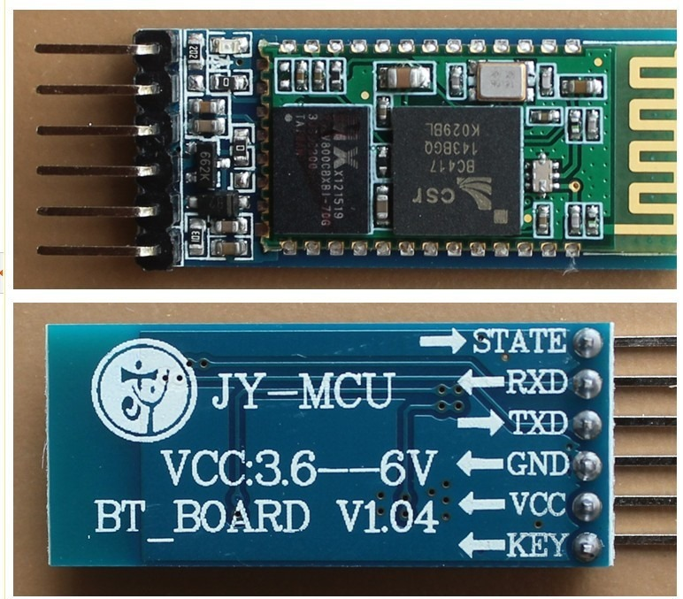

Figure 9 HC-05 Bluetooth Module

This is the HC-05 Bluetooth module which is an easy to use Bluetooth Serial Port Protocol module. It is designed for transparent wireless serial connection to an Arduino microcontroller. It is a great use for wireless communication because it can act in a Slave or Master configuration with any device that has Bluetooth capabilities. The default settings for its software is SLAVE and can be configured only by AT COMMANDS. This device was perfect for the Autonomous Carrier Assistant because it is cheap and easy to use and there are plenty of online sources to help configure it because it is well reviewed in the community. The HC-05 Bluetooth Module has 6 pins for its user to use:

● Enable This pin when pulled to LOW the module is disabled and will not turn on or it fails to communicate,

● VCC This pin supplies Voltage of 3.3V to 5V,

● GND This pin is simply the ground pin.

● TXD&RXD which acts as the UART interface for communication

● STATE This pin acts as a status indicator which shows when the module is not connected with a Bluetooth device or it shows whether the module is properly connected to another Bluetooth device. It shows the user if it is connected or not by a led that flashes continuously if it is not paired and flashes with a constant delay if it is paired with a Bluetooth device.

● BUTTON SWITCH This pin is used to switch the module into AT command mode which allows the user to change the parameters of the module but only when it is not paired with another Bluetooth device.

The Autonomous Carrier Assistant utilized these six pins by connecting them to the Arduino microcontroller that it will have in order to control its systems. Another possible device that could be used rather than Bluetooth for the Autonomous Carrier Assistant is a GPS tracker

# GPS (Global Positioning System)

GPS stands for Global Positioning System and is a satellite-based radio navigation system and is owned by the United States Government and is operated by the United States Space Force. GPS was originally created in 1973 to overcome the limitations of previous navigation systems. It was originally created to be only used by the military and civilian use was not allowed until the 1980s and it would only become fully operational until 1995. The GPS operates independently of the Internet reception, but the use of the Internet or telephonic reception can increase the effectiveness of the GPS positioning information. GPS could have been very useful for the Autonomous Carrier Assistant because if we put a GPS tracker on it then we could send the signal back to the mobile device so the user could know where it is if it’s leading the user to a destination. The GPS service is provided to the public by the United States government which means that if warranted the government can restrict access to GPS. The way GPS works is that based on the position of the tracker various GPS satellites are synchronized with each other to constantly update the receiver's position of the tracker. The satellites have atomic clocks in them that are synchronized with each and with ground clocks, any drift from time maintained on the ground is corrected daily. The following table will be a summary of satellites that were launched and how many are successful with also how many are still in use till this day.

|  |  |  |  |
| --- | --- | --- | --- |
| Launch Period | Satellite Launches | | Currently in orbit and functional |
| Success | Failures |
| 1978-1985 | 10 | 1 | 0 |
| 1989-1990 | 9 | 0 | 0 |
| 1990-1997 | 19 | 0 | 0 |
| 1997-2004 | 12 | 1 | 12 |
| 2005-2009 | 8 | 0 | 7 |
| 2010-2016 | 12 | 0 | 12 |
| From 2018 | 2 | 0 | 2 |
| Total | 72 | 2 | 33 |

1978 was when the first GPS satellite went into space and then in 1983 Ronald Regan announced that GPS would be made available for civilian use once it was completed. In 1985 ten more GPS satellites were launched into space to prepare for civilian usage and all 10 of those launches were successful. In 1989, the first modern Block-II satellite was launched which was a success. Then in 1990 the Gulf War was started, and eight more satellites were launched because the military was using GPS a lot more because of it. By 1993, there were 24 active working satellites in space and GPS achieved initial operational capability which also meant that it provided the Standard Positioning Service. Two years later Full Operational Capability was declared by the Air Force. Then in 1996, Bill Clinton issued a policy directive which declared that GPS is a dual-use system establishing an Interagency GPS Executive Board to manage it as a national asset and to allow civilians to use it. Through 1990-1997 there were 19 satellites launched into space and they were all successfully launched but none of them are still in use today. The Gulf War was a major boost in the research of Global Positioning System because the military required a lot of its usage in the wars in the Middle East. Then in 1998 plans were made to upgrade GPS with two new civilian signals for better user accuracy and reliability. GPS III was made authorized by the United States Congress in 2000 and was a major upgrade for GPS overall. 2004 was a big year for GPS because the United States signed an agreement with the European Community which was developing a very similar system called the Galileo system. By 2004, 13 more satellites were launched with one of them being a failure and the other 12 were successful and those 12 satellites are still being used today. Between 2005 and 2009 the United States Government launched 8 more satellites into space with 7 of them still being used today. Also, in 2009, the United States Government Accountability Office issued a report saying that some GPS satellites could fail as soon as 2010. As a result, in 2010 the Air Force made a contract to develop the GPS Next Generation Operational Control System to improve accuracy and availability of the GPS and this served as a major modernization of GPS. Between 2010 and 2016, 12 more satellites were launched into space and all 12 of them are still used today. Only 2 satellites have been launched since 2018 but both of them were successful and are still being used today.

# GPS Devices

A GPS receiver is a very likely possible device that could have been used for the Autonomous Carrier Assistant because it would allow the user to know of its location if for whatever reason the user loses sight of the Autonomous Carrier Assistant. GPS receivers are simple to use and are generally composed of an antenna, tuned into the frequencies transmitted by the satellites that are assigned to them. A receiver can be described by the number of channels it has which signifies how many satellites monitor it simultaneously. GPS receivers today usually have between 12 and 20 different channels available. Some receivers include an input for differential corrections using the RTCM SC-104 format which is in the form of an RS-232 port that has a speed of 4800 bit/s. The accuracy is limited when being sent using the RTCM because data is actually sent at a much lower rate than 4800 bits/s. These problems have been solved with receivers having internal DGPS receivers because they can outperform those receivers that use external RTCM data.

# GPS Applications

GPS was originally a military project, but the government has made it a dual-use technology meaning that it can now be used for civilian applications. There are three basic components to a GPS that many applications use: absolute location, relative movement, and time transfer. For the Autonomous Carrier Assistant used absolute location and relative movement to update the mobile application, that the user would be using, of ACA’s location. One of the biggest applications for GPS is used in cellular telephony which uses the component time transfer because cellular devices use clock synchronization. Time transfer is critical for clock synchronization because synchronization spreads its codes with other stations to support cellular position detection for mobile emergency calls. The accuracy of the cellular position needs to be accurate for 911 calls when the police need to locate a caller’s position. Another application that is most similar to what the Autonomous Carrier Assistant used is the Automated vehicle application. Automated vehicles apply location and routes for cars and trucks to function without a human driver, this is what the Autonomous Carrier Assistant would use to follow the user or lead the user to a destination.

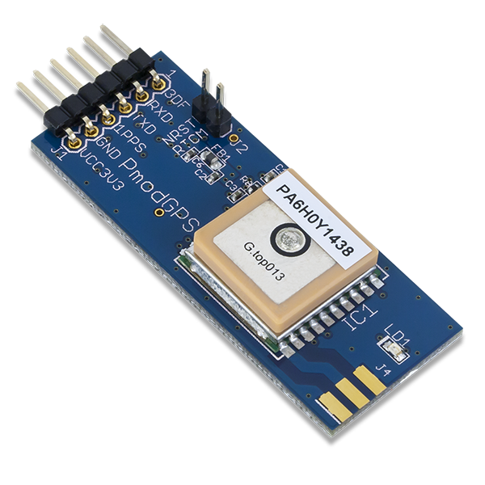

Figure 10 PMOD GPS Receiver

This is an image of a Pmod GPS Receiver that can provide satellite-positioning accuracy to any embedded system. There are some restrictions that the United States government places on civilian use of GPS: all GPS receivers capable of functioning above 60,000 ft are classified as weapons and require a State Department export license. The Autonomous Carrier Assistant will definitely not require such a license, but the Pmod GPS Receiver is a chip that it will most likely use since it is cheap and simple to use.

# GPS Communication

Communication with GPS comes in the form of navigational signals transmitted by GPS satellites encoding a variety of information which includes satellite positions, state of internal clocks and the health of the network. For security reasons there are two different encodings that are used to transmit these signals: one is a public encoding that enables lower resolution navigations and the other is an encrypted encoding which is used by the United States military. The Autonomous Carrier Assistant only needed to use the lower resolution navigation frequency because there is no need for it to use the encrypted United States military frequency. The way the GPS satellites work is that they continuously broadcast a “navigation message” on L1 and L2 frequencies at about a rate of 50 bits/s. Each message has a 1500-bit-long frame made up of five subframe with each subframe being 300 bits long. The following table describes what each subframe does and what it has to do with the satellites.

|  |  |
| --- | --- |
| Subframes | Description |
| 1 | Satellite clock, GPS time relationship |
| 2-3 | Ephemeris (precise satellite orbit) |
| 4-5 | Almanac component (satellite network synopsis, error correction) |

Each frame inside of the first subframe is encoded with the week number and the time within the week. Then inside of the second and third subframe they contain the ephemeris which is the precise orbit of the satellite. Inside of the fourth and fifth subframe is the almanac which contains the coarse orbit and status information for up to 32 satellites in the constellation. In order for receivers to distinguish individual satellites from each other, the signals are encoding using unique code division multiple access (CDMA) types. Because there are two different encodings that are used to transmit the signals these means that there are also two distinct CDMA encoding types. The first one is coarse/acquisition code which is accessible to all civilians. Then there is the precise code which is encrypted and is only used by the United States military and other NATO nations that have been given permission. Each satellite each assigned a unique binary sequence known as a Gold code because the signals have to be separated after demodulation. They have to be separated because all of the signals are modulated onto the same L1 carrier frequency. The almanac information is essential in order for the receiver to pick which satellites to listen for PRNs. In the case that the almanac information is not known it becomes much more difficult for the receiver because it then has to enter a search mode until a lock is obtained on one of the satellites. These navigation messages enable the determination of the time of transmission and the satellite position at this time. The Autonomous Carrier Assistant will use a GPS receiver as its connection to the satellite and it will use a Bluetooth device to connect to the mobile application.

# Mobile Application

A mobile application is known as a computer program that is designed to run on a mobile device such as a tablet, watch or phone. The mobile application was an essential part of the Autonomous Carrier Assistant because it was the way the user controls the bot. The goal of the mobile application for this project was to allow the user to switch between follow or lead with the bot, it will also act as a receiver or beacon for the Autonomous Carrier Assistant to know what to follow and know what to lead. Mobile applications have come a long way in recent years, they were originally intended for productivity assistance such as email, calendar, and contact databases. The potential in mobile applications was seen by the public and they demanded more which caused a rapid expansion into other areas such as factory automation, GPS, order-tracking, mobile games, and much more. The market for mobile applications was born and companies like Apple or Google launched their own app stores in order to sell a variety of different apps to the public. They also allow the public to create their own apps and sell them on the apps stores which further boosted the development of mobile applications. Mobile applications became a thing when the first smartphone came out in 2007. The huge increase in number and variety of apps made finding a good app a challenge, which led to the creation of reviews, recommendations, and curations sources dedicated to reviewing mobile applications. The many different types of mobile applications can be classified by different methods, the most common method is to distinguish them by native, hybrid, and web-based applications.

# Native Application

A Native application is an application that is specifically targeted towards a particular mobile platform. Which means that a native application for an Android device cannot work on an Apple device, this leads to many mobile app developers creating apps for multiple platforms to get the most success. The benefits of a native app are that they will have better performance, consistency, and good user experience, this is because the developers only have to focus on one mobile platform which makes programming much easier. The goal of native applications is to achieve the best performance for a specific mobile operating system. The Autonomous Carrier Assistant will most likely not require a Native application because there is no reason to make the mobile application exclusive to one mobile platform.

# Web-based Application

A web-based application requires internet access for proper behavior and user experience of this group of apps. They are usually coded in HTML, CSS, or JavaScript and capture minimum memory space in user devices compared to the other native and hybrid applications. They have minimum memory because all the personal databases are saved onto the Internet servers, which allows a user to retrieve their data from different devices as long as they are using the same mobile application. The Autonomous Carrier Assistant will most likely not require a Web-based application because it will not require Internet access to function.

# Hybrid Application

A Hybrid application is a mixture of both a Web-based application and a Native application because a hybrid application is made to support both of these technologies across multiple platforms. Hybrid applications unfortunately have lower performance compared to web-based/native applications but they are easier and faster to develop. They are easier to develop because they only require a single code base which works across different mobile operating systems like Apple or Android. The Autonomous Carrier Assistant will most likely use a Hybrid application because it will not be exclusive to one mobile platform and it will most likely be coded in JavaScript like a Web-based application is coded in.

# Mobile Application Development

Developing a mobile application is very different from developing an application for a desktop because you have to consider many different things such as: processing power of the mobile device, screen size for creating the user interface, and the different features that the mobile device has like a camera or location detection. Mobile application development requires a unique development environment specialized for mobile application development. Some development environments that are specialized for mobile application developments are Android Studio, Unity, and Flutter. The apps are first tested in the development environment using emulators which provide an inexpensive way to test applications on mobile phones, this is good because some developers may not have access too. When developing a mobile application an efficient user interface Design is an absolute necessity if you want your application to be successful. The user interface is what the user interacts with and looks at when opening the application. The goal of a user interface is to allow effective operation and control of the program from the user end. The developer has to consider constraints and contexts, screen, and input as outlines for when designing the interface. The developer wants to make it as easy as possible for the user to interact with the interface and to input whatever information the user needs. The user interface entails components of both hardware and software. The user interface needs to effectively take user input to manipulate the program and then output the correct information. The mobile user interface can be considered as the front-end of the mobile application when compared to a website the front-end is what the website looks like when a user opens it. Like a web application, a mobile application’s front-end relies on the back end to facilitate data routing, security, authentication, and many other tasks. Some AWI applications allow developers to create the backend for their mobile applications. The Autonomous Carrier Assistants mobile application will require a user interface to allow the user to switch between modes and it will also require a backend to be able to store the locations that the bot will lead the customer to.

The image given below, is taken from a program called Flutter, in this image a user interface is being created for a potential mobile application. The user interface as said before falls under the front-end development of a mobile application. The Autonomous Carrier Assistant’s mobile application was considered to use Flutter to develop its mobile application for the user to use.

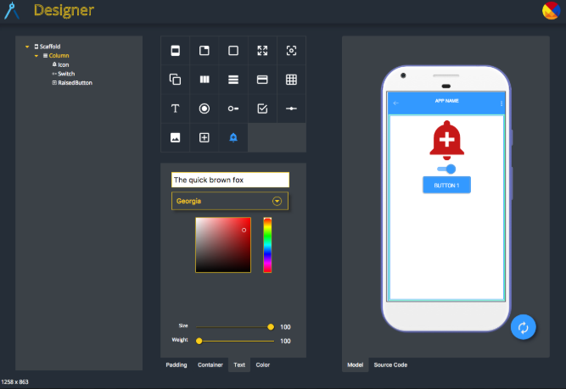

Figure 11 Flutter Program

# Flutter

Flutter is an open source user interface software development kit that was created by Google for developers to use to create mobile applications for Android, IOS, Windows, Mac, and other platforms as well. Flutter was originally released in May 2017 but was first revealed at a Dart developer summit back in 2015. Flutter applications are written in the Dart language which is a language that uses advanced features for development. Flutter takes advantage of Dart's virtual machine when it runs a program, the virtual machine features a just in time execute engine which is a way of executing computer code that involves compilation during execution of a program. Just in time executing allows a developer to make changes to the application while it is running, this is sometimes referred to as “hot reloading”. Normally a developer would have to restart the mobile application in order to make a change, but this feature makes Flutter’s performance much greater and it makes it possible to run on mobile devices and applications.



Figure 12 Unity Software Development Kit

Unity is another potential software development kit that the Autonomous Carrier Assistant could have used to create its mobile application. Unity is a cross-platform game engine developed by Unity Technologies that was first announced in June 2005 at Apple INc’s Worldwide Developers Conference. Unity was first designated for only being a video game engine, but it has now branched out to other fields such as architecture, film, engineering, automotive, and construction. Unity’s engine can create 2D, 3D, augmented reality games, and many other experiences. The engine offers a primary scripting API in C# which allows the user to create games and other experiences in 3D or 2D. Previous versions of Unity did support other languages like Boo and a version of JavaScript called UnityScript but after the release of Unity 2017.1, C# is the chosen language of Unity. Most creators using Unity create video games but in recent years there has been an increase in developers creating non video game oriented mobile applications. Unity also has a Web browser plugin called Unity Web Player however it was removed in favor of WebGL. One of the downsides for using Unity as a mobile application development kit is that most of the community uses it for gaming so there is not as much online help as compared to other development kits like Flutter or React Native. But one of the advantages of using Unity is that the program is very user friendly when it comes to developing mobile applications. Unity has become one of the most used development kits for creating mobile games, approximately half of new mobile games on the market are created using Unity. Wolfram Language was added to Unity in 2019 allowing developers to access high level functions of the Wolfram Language. Unity has much to offer for our project if we are interested in possibly creating a three-dimensional model of the Autonomous Carrier Assistant for the user to observe when selecting it. We could have created a map of available Autonomous Carrier Assistants for the user to select when logging into the mobile application. Unity is probably the best option for creating any visual model of anything for mobile applications.



Figure 13 React Native Development Kit

React Native is another possible development kit that was considered and attempted for the Autonomous Carrier Assistant’s mobile application. React Native is an open source mobile application framework that was created by Facebook and was initially released in March 2015. Its purpose is to develop mobile applications for Android, Web, iOS, and UWP. It enables its developers to use React, which is a JavaScript library for building user interfaces, and it is maintained by Facebook, and also native platform capabilities. Many people compare Flutter and React Native with each other because Facebook and Google are close competitors in the Software world. React Native is called “React Native” because it is very similar to React also known as React.js except that React Native does not manipulate the DOM via the Virtual DOM. React.js is a JavaScript library for building user interfaces and it is also maintained by Facebook just like React Native. React is used for the front-end part of development of web applications and is used in the MERN stack of software development. React Native like React uses JavaScript as its language but it also allows developers to use native code its languages. For example, React Native lets a developer use Swift for an iOS mobile application and Java for an Android mobile application. However, unlike most front-end development kits, React Native does not use HTML or CSS in any of its mobile applications. Since it allows its developers to use different native languages it has become a very popular development tool. It allows different native code by wrapping the code with native APIs via Reacts declarative UI paradigm and JavaScript. Without this core component React Native would not be able to allow its app developers to use different native code languages when creating their mobile applications. The Autonomous Carrier Assistant will likely use React Native because of this native code language component. It will make creating the mobile application much easier to create since we can use a language that we are most comfortable using. Another mobile application development kit that the Autonomous Carrier Assistant could possibly use is Android Studio which is specified for Android development.



Figure 14 Android Studio

Android studio is the official integrated development environment for Google’s Android operating system and is designed for Android mobile application development. It creates only Native applications for Android devices, and it replaces the Eclipse Android Development Tools as the primary integrated development environment. Android Studio first announced back in May 16, 2013 at the Google I/O conference and was only in early access until June 2014 when it entered beta. Version 1.0 came out in December of 2014 and the preferred language for Android mobile application development was Java, C++ was also a very popular language that was used for mobile application development. Newer versions of Android Studio have been released and other programming languages have been supported such as intelliJ, CLion, Kotlin, and Go. Kotlin has actually become Google’s preferred language for mobile application development since the update that came out in May7,2019. Not all of the language features of Java 12 are supported in Android Studio but all of Java 7 is supported and a subset of Java 8 is supported and also some Java 9 features are supported. One of the features of Android Studio is that it offers template-based wizards to create Android designs and components to make it easier for mobile application developers to get started on an application. Another feature of Android Studio is that it has an advanced layout editor that allows its developers to drag and drop user interface components and it has the option to preview different types of layouts on different screen configurations. The Autonomous Carrier Assistant most likely uses Android Studio because it only creates Native apps for Androids, and we are not interested in creating an exclusive mobile application for Android. We want our mobile application to be available on all mobile devices. The system requirements for Android Studio is not high, all it requires is a 64-bit processor, CPU with unrestricted guest support, SDK Tools 26.1.1 or higher, and HAXM 6.2.1 or later. The Autonomous Carrier Assistant will decide which type of coding language it wants to use for its mobile application development, one of the options it has is Java.

# Java Virtual Machine

The Java Virtual Machine is a virtual machine that enables a computer to run Java programs as well as programs written in other languages that are compiled to Java bytecode. The organization of the Java Virtual Machine is handled by a specification, which is a set of documented requirements to be satisfied by a material or service that shows what its implementation is. The Java Virtual Machine’s implementation is developed by the OpenJDK project as open source code. The Java Virtual machine has an algorithm called the garbage collection which is the mechanism used in Java to deallocate unused memory and is essentially tracking down all the objects that are still used and marks the rest as garbage to deallocated. The Java Virtual Machine is essentially a 32-bit machine that operates on primitive values because it uses long and double types, which are 64-bits but they consume two units of storage in a frame’s local variables and each unit is 32 bits. When it comes to objects and arrays the Java Virtual Machine has a garbage collected heap that stores them in the method area. The method area is treated differently by the implementation because it might not garbage collect it like it does with the heap. With each call of the method a frame is created and is added to a stack that each Java Virtual Machine thread has. Whenever the method exits the frame is destroyed and whenever the method is called a new frame is created. Inside of each frame is an array of local variables that are inside of an operand stack that is used for operands to compute things and it is used for receiving a return value from the method. The Java Virtual Machine is implemented in each new version of Java that has been released over the years.

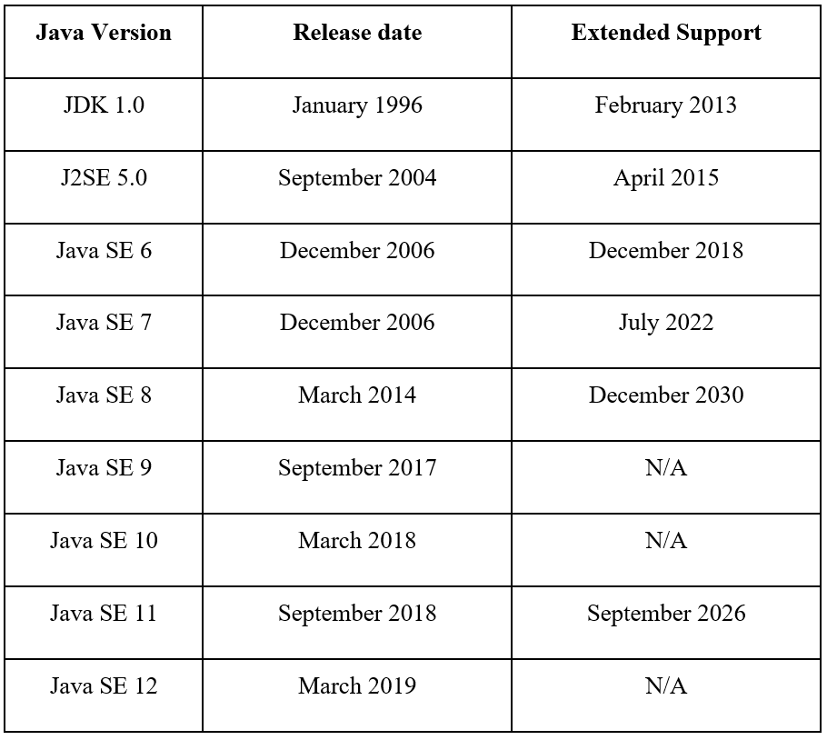

# Java

Java is an object-oriented general-purpose programming language and is designed to have as few implementation dependencies as possible. It first appeared on May 23, 1995 and has since released many different versions of itself that have many different language features. The syntax of Java is very inspired by C and C++, but it does not have as many low-level facilities as them. The original developer of Java is James Gosling from Sun Microsystems and was released as a core component of Sun Microsystems’ Java platform. Since its release it has become one of the most popular programming languages for client server web applications. One of the key features that Java has is that when Java code is compiled it can run on all platforms without the need for recompilation. Also, Java does not need its developer to handle memory allocation instead it uses its Java virtual machine which handles all bytecode.

# JDK 1.0

The first stable version of Java that was ever released was back in January 23, 1996 and many versions of 1.0 were released with it as well, they went up to J2SE 1.4. Version 1.0 was also called Java 1 and had the very basic object-oriented features nothing advanced came with Version 1.0. It was not until February 19, 1997 that JDK 1.1 was released and it included a pretty important feature called JDBC, which stands for Java Database Connectivity and is an application programming interface which defines how a user connects to a database. JDBC was Java’s first API that they released and quickly became very popular and has since become a part of the Java Platform, Standard Edition. Other features of JDK 1.1 are JavaBeans, RMI, and reflection. After JDK 1.1 there was J2SE 1.2 that came out in December 8,1998 and it also had the nickname Java 2. This replaced JDK to distinguish the platform from J2EE and J2ME. With this release the Java platform was significantly increased to 1520 classes in 59 packages. It also included API Swing which was Java’s graphical user interface widget toolkit, Java plug in, Java IDL, and Collections framework. On May 8,200 J2SE 1.3 was released and its release included Java Platform Debugger Architecture, Java Naming and Directory Interface, and it had HotSpot. HotSpot is a Java Virtual machine for desktop and server computers. The release of J2SE 1.4 on February 6, 2002 was the first release that was developed by the Java Community Process. This release came with many library improvements some of which included Non-blocking I/O, Regular expressions that are modeled after Perl, Integrated XML parser and XSLT processor, and Logging API.

# J2SE 5.0

This was released on September 30, 2004 and was originally called J2SE 1.5, but the community felt that this version increased the level of stability and scalability enough that it should be 5.0. One of the major changes that came with this release was Metadata, which was also called annotations, this allowed language constructs such as classes to be tagged with additional data. Metadata by definition is data that provides information about other data, so this allows those constructs to be tagged with more detailed data. Another update that came with this release was improved semantics of execution for multiple threaded Java programs. The improved semantics addressed issues of complexity, effectiveness, and performance. There were also various improvements to the standard libraries like Swing, the concurrency utilities, and also the scanner class for parsing data.

# Java SE 6

This was released on December 11, 2006 and replaced the name J2SE with SE and was developed under JSR 270. Some of the major changes in this update was the support of Scripting languages. An API was released for integration with scripting languages and it had built-in Mozilla JavaScript Rhino integration. Another API was released called the Java Compiler and allowed the Java programs to select and invoke a Java Compiler programmatically. Major updates and performance improvements for Java Swing and the platform itself came with the update. Some upgrades to the garbage collection algorithms in the Java Virtual Machine was released and the application start-up performance was improved.

# Java SE 7

One of the biggest updates for Java was released on July 7, 2011 and this update was so major that its development was organized into thirteen different milestones. The Java Virtual Machine was changed dramatically because it now allowed support for dynamic languages with the new invoke dynamic bytecode. Another major change was the addition of the I/O library that created support for multiple file systems, file metadata, symbolic links, and multiple file programs. More APIs were released for the graphics features and improvements for Java Swing was also released. The codename for this update was Dolphin and this update became the default download on the website for Java.

# Java SE 8

This update came out on March 18, 2014 and had some leftover features from Java 7 that could not make it due to development issues. The biggest feature in this update was the addition of language-level support for lambda expressions. A lambda expression is a function definition that is not bound to an identifier and these expressions are often arguments being passed to higher-order functions. The addition of lambda expressions enables functional-style operations on streams of elements. It also allowed users of an API to add new methods to the program without causing errors in the old code while using it. Other features of this update include unsigned integer arithmetic, date and time API, statically linked JNI libraries, and launch JavaFx applications. Java 8 was also supported on Windows XP.

# Java SE 9

Java SE 9 was released on September 21, 2017 but was released with some controversy because other projects were still being accepted at the time and that caused some open issues and concerns. Some of the features in this update are Modularization of the JDK, variable handles that define a standard means to call the equivalents of various operations, compact strings, and the milling project coin. Java SE 9 was delayed multiple times because there were some security issues and critical bug fixes to do. Also, Oracle wanted Java SE 9 to include a different default garbage collector, self-tuning Java Virtual Machine, and native code integration. All of this caused Java SE 9 to be delayed for months, it was originally supposed to be released back in early 2016 but was delayed until September 2017.

# Java SE 10

Java SE 10 was released on March 20, 2018 and had 12 features included in its update. Some of these features were root certificates, garbage-collector interface, thread-local handshakes, time-based release versioning, and heap allocation on alternative memory devices. One of the bigger features on this update is application class-data sharing which allows a program’s classes to be placed in a shared archive to reduce the startup of other Java applications.

# Java SE 11

This update was released on September 25, 2018 and it offers Long Term Support and LTS. Some of the features on this update include Dynamic class-file constants, Low-overhead heap profiling, HTTP client, Flight recorder, and Epsilon which is a no-op garbage collector. Some overlapping features from other versions were released on this update as well. This was a relatively small update compared to other major ones like Java SE 7 or Java SE 8.

# Java SE 12

This update was released on March 19, 2019 and has a total of eight new features on this update. Some of those features include Default CDS Archives, Microbenchmark Suite, Abortable Mixed Collections for G1, and JVM Constant API. This was probably one of the smallest updates for Java to be released but it did come with some important Java Virtual Machine changes regarding the garbage collector. The Autonomous Carrier Assistant will most likely only have to use the version Java 7 atleast to be able to make its mobile application that will allow the user to switch between the modes of the ACA like follow or lead.

# Java Script



Figure 15 JAVA Script

Another very likely coding language that the Autonomous Carrier Assistant will have to use in order to create its mobile application is JavaScript. JavaScript first appeared on December 4, 1995 and is a programming language that conforms to the ECMAScript specification and is a high-level multi-paradigm. JavaScript is as popular as HTML and CSS when it comes to web applications because it enables interactive web pages. It is a lead developer when it comes to client-side page behavior and many companies use it for developing their web applications. The JavaScript engines are also embedded into server-side website deployments like Node.js and are also embedded in a variety of other applications. The only similarities between Java and JavaScript are syntax and some respective libraries but other than that they are completely different.

# JavaScript Growth

JavaScript was not very popular at release because scripting languages were stagnant in the late 90s and early 2000s. But this changed in 2004 when Mozilla released the Firefox browser which was run by EMCAScript. In 1996, Netscape which is the company that owned JavaScript submitted it to EMCA International, which is a standards organization for information and communication systems, to make it the standard specification for all browser vendors to conform to. They accepted it and it became the first EMCAScript language specification as of June 1997. Microsoft's Internet Explorer dominated the browser market in the early 2000s and that meant that JavaScript became the standard for client-side scripting on the Web. But when Firefox was released, the EMCAScript had to start work for the XML standard. And then in 2008, Google released their browser Google Chrome which had a JavaScript engine that was the first to use just-in-time compilation which significantly improved execution times. So as of 2008 the three biggest web browsers, Google Chrome, Firefox, and Internet Explorer, all used JavaScript as their back engine.

# JavaScript Security

Almost 95% of today's websites use JavaScript for its client-side scripting of the Web. All of the major web browsers of today use a built in JavaScript engine that executes the code for its devices. They also use third-party JavaScript libraries for their client-side page scripting. Many development stacks use JavaScript as one of their main languages like MERN or MEAN almost entirely use JavaScript as its language. Some of the scripted behavior JavaScript has inspired is loading new page content without refreshing the page like if you need to post a new message on Facebook or Twitter. Another example of scripted behavior is sending data information about a user’s behavior for personal user or analytics, this is also known as a cookie and is used by companies to keep track of what a user does on their website. This leads to some security issues that JavaScript has to pay attention to because it leaves a risk for their users and also it causes problems with privacy of a user.

# JavaScript Security

Both JavaScript and DOM, which is the Document Object Model that is a cross-platform and language-independent interface, has to prepare for malicious attacks by hackers because they can deliver scripts to run on a client’s computer via the Web applications that a user might use. They minimize some of these risks by running scripts so that they only perform Web-related actions and not general programming tasks like creating, deleting, and editing files. Also, another huge thing that JavaScript and DOM implements is the same-origin policy. Same-origin policy entails that a web browser permits scripts contained in a first web page to access data in a second web page, but only if both web pages have the same origin. Many of the security bugs come from the same origin policy. One of the more common JavaScript related security problems is cross-site scripting which is a vulnerability that enables attackers to inject client-side scripts into web pages viewed by other users. One of the solutions to this issue is known as HTML escaping whenever untrusted data is displayed. The only true prevention of these attacks is a correct design of Web applications on the server side. The Autonomous Carrier Assistant will not have to worry about such security risk because this project will not require a web application for completion, it only needs a mobile application that may not even require internet access. One of the most common web development tools that JavaScript has inspired and created is JSON, which stands for JavaScript Object Notation.

# JSON



Figure 16 Java Script Object Notation

JSON or JavaScript Object Notation is an open standard file format and data interchange format that uses text to store and transmit objects that contain array data types. It can be used as a replacement for XML files and it is a language-independent data format. JSON was first standardized in 2013 and is used by many programming languages that include code to generate and parse JSON-format data. It was originally derived from JavaScript and is considered as a subset of JavaScript’s object literal syntax. It was made because there was a need for a real time server to browser communication without the need for plugins like Flash or Java applets. The creator of the JSON format is Douglas Crockford. Douglas Crockford made a clause to the JSON license that made sure that the JSON libraries were open source. Some of the basic data types that are allowed in JSON are:

● Object: which is an unordered collection of name-value pairs where all the names are strings. Each object has a key and each key is unique to the object that it originates from.

● Boolean: Can hold the values of true or false.

● Number: The format of the number has no distinction between an integer and a floating-point. Using JSON with JavaScript it will use a double-precision floating- point format.

● String: It is a sequence of Unicode characters that are delimited with double-quotation marks.

These are some of the basic data types that are used in JSON and can be formatted differently depending on what language you use JSON with. Another interesting data type that JSON accepts is whitespace which is allowed but is ignored around syntactic elements. The Autonomous Carrier Assistant will most likely not be required to use any JSON data formatting because JSON is mostly used for web applications, and the Autonomous Carrier Assistant will only have a mobile application that might not even require the internet.

# Python



Figure 17 Python Language

Python is an interpreted, high-level general-purpose programming language that has become the most popular coding language today. It was first created and released back in 1991 by Guido van Rossum. The design of Python is to have code readability be very simple and easy to understand. Like Java it contains a garbage collecting algorithm that deallocates memory for its users which makes it much easier to code. Python was the successor to the ABC language that came out in the late 1980s and introduced features like garbage collection systems and list comprehensions.

# Python 2

Python 2 was released on October 16, 2000 and had many new major features with it that included a cycle-detecting garbage collector and support for Unicode. Cycle detection is the algorithmic problem of finding a cycle in a sequence of iterated function values. Unicode is an information technology standard for the consistent encoding and handling of text compressed in most of the world’s writing systems. The Python 2 language was only recently discontinued on January 1, 2020 with all patches involving security or improvements stopping.

# Python 3

Python 3 was released on December 3, 2008 and majorly changed the language and as a result was not completely backwards compatible with previous versions of Python. Some of the features on this update include utilities to translate Python 2 code to Python 3 code because of the non-backwards compatibility of Python 3. Most of the features of Python 3 were not available for Python 2 but was backported to the Python 2.6x version.

# Python Features

Python’s memory management is a combination of reference counting, cycle-detecting garbage collector, and it uses dynamic typing. Dynamic typing is the process of verifying the type safety of a program at runtime. Dynamic typing assigns a type tag to every runtime object and this runtime type information (RTT) can be used to implement late binding, reflection, down casting, and dynamic dispatch. Reference counting is a programming technique of storing the number of references, pointers, or handles to a resource. It is used in garbage collecting algorithms to deallocate objects that are no longer needed. Python also uses dynamic name resolution or late binding which is a computer programming mechanism in which the method being called upon an object is looked up by name at runtime. Python’s core was designed to be highly extensible, meaning that it has the ability to extend a system and the level of effort required to implement the extension. This principle provides for future enhancements without impairing existing system functions. Python’s philosophy includes these mottos:

● Simple is better than complex

● Readability counts

● Beautiful is better than ugly

Python is known by many to be one of the easiest coding languages to learn and use because of this “simple is better than complex” philosophy. Its developers want it to be as simple as possible and therefore they avoid premature optimization as much as possible because that can reduce readability and add code that is used only to improve the performance. Another very important feature that the Autonomous Carrier Assistant’s mobile application will most likely have to utilize is an Application Programming interface or an API.

# API

An application programming interface or an API is a computing interface to a software component or a system, that defines how other components or systems can use it. An API basically defines how multiple software components including mobile devices, computers, tablets, databases, front-end, back-end, and many other things communicate with each other. An API is a very flexible development tool because it can be entirely custom to a specific component or it can be designed to become an industry standard for commercial use. It simplifies programming by abstracting the underlying implementation and only showing the actions that the developer needs to accomplish. It is kind of similar to a software library because it describes the behavior while a library is the actual implementation of a set of rules. An API depends on what programming language it is being used for. For example, if it is being used for an object-oriented language then it would provide a specification of classes and its class methods but if it's for a procedural language then it would consist primarily of basic routines to execute code.

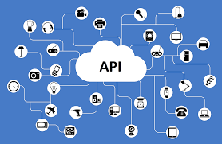

The Autonomous Carrier Assistant could have used an API to communicate between the mobile application and the Bluetooth module that will be attached on the ACA. Another name for an API could be software framework because framework is based on several libraries implementing several APIs, but the behavior is different because the framework is mediated by extending its content with new classes plugged into the framework itself. APIs are also used to specify the interface between an application and an operating system. An example of this is Microsoft, they are very committed to using a backwards compatible API so older applications can run on newer versions of Windows. There are many different types of APIs that are available and each one is designed for different devices.

# Remote APIs

A Remote API is for developers to manipulate remote resources through protocols, it is also so they can change standards for communication that allow different technologies to work together. They are particularly useful for object-oriented programming languages because they are useful in maintaining the object abstraction which is a method call that is executed locally on a proxy object. Remote APIs are not nearly as popular as Web APIs.

# Web APIs

Web APIs are interfaces through which interactions happen between an enterprise and applications that use its assets. They provide a program interface to a set of services to different applications serving different types of users. When it comes to web applications, they serve a lot of purposes like connecting the back-end database to the front end. Another example is they define specifications like Hypertext Transfer Protocol request messages and the specifications for response messages. Hypertext Transfer Protocol is an application protocol for distributed, collaborative, hypermedia information systems and is the foundation of data communication for the World Wide Web. It defines these specifications in either a JavaScript Object Notation (JSON) or an Extensible Markup Language (XML). Web APIs also allow the combination of many APIs into new applications also known as mashups. A mashup is a web page that uses content from more than one source to create a single new service displayed in a single graphical interface.

# API Design

A good design of an API provides the user with only the tools that the user expects to find. The design definitely affects the usage of it because if it is not correctly designed then it will be very confusing for the user to accomplish their goal. The principle of information hiding is when you enable modular programming by hiding the implementation details of the modules so that users of modules only see the simple side of the program and not the hidden complex details. It also affects the software architecture of the application because the application is depending on the API to complete tasks with it and another software. Software architecture is fundamental structures of a software system and the discipline of creating such structures and systems. The Autonomous Carrier Assistant will not require us to design an original API for it because there are plenty of available APIs to use to create the mobile application and implement the Bluetooth module with it. They are one of the most common ways technology companies integrate with each other and when someone provides one, they are considered members of a business ecosystem. A very common API is known as the RESTful API Modeling Language and it provides all the information necessary to describe RESTful APIs.

# REST API

REST is short for Representational state transfer is a software architectural style that defines a set of constraints to be used for creating Web services. These services that use REST architectural style provide interoperability between computer systems on the Internet. Web resources are any identifiable thing, whether digital, physical, or abstract and the use of these resources is very important for a Web application. In a RESTAPI, requests made to a resource's URI gives a response that has a payload formatted in the standard formats like HTML, XML, or JSON. The Autonomous Carrier Assistant will not have to use a RESTAPI because it will not require a Web application integrated with its mobile application. Because it will not require users to create accounts with it so there will be no need for any database or Web service.

# REST Constraints

There are some constraints that hold back a RESTful system because they restrict the ways that the server can process requests so that the system gains the needed nonfunctional properties, for example simplicity, performance, portability, and modifiability.

* One of the constraints is Client-server architecture and the constraint is the separation of concerns. The separation of the front-end user interface concerns and the back-end data storage concerns is very important to improve the portability across many platforms. Also, another very big benefit is that it allows the components to evolve independently and this supports the scale of the Internet across multiple organizational domains.
* Another constraint is Statelessness which is when the communication between the client and the server is constrained by no client context being stored on the server between requests. There is a state called the session state which tells the status of what is being transferred to a from the client and the server. This back and forth exchange starts with the client sending a request and when it is ready to transition to a new state and one or more requests are outstanding the client is in transition.
* Another constraint is the Layered system, which is a system in which components are grouped, layered, in a hierarchical arrangement, such that lower layers provide functions and services that support the functions and services of higher layers. This hierarchy does have an advantage because it can add a security level to the web services to separate business logic from security logic.
* One of the biggest constraints of a RESTful system is uniform interface which is imperative towards the design because it simplifies and decouples the architecture which enables each part to become independent. There are four parts to this constraint, and they are:

1. **Resource identification in requests**: Which is when resources are identified in requests. These resources are conceptually separate from the presentations that are returned to the client.
2. **Self-descriptive messages:** Which is when each message in the client-server communication contains information to describe how to process each message.
3. **Resource manipulation through representations:** This is when the client side is representing a resource and has enough information to delete or change the resource’s state.
4. **Hypermedia as the engine of the application state:** The final part is when the client has accessed an initial URI for the REST application and then the REST client should then be able to use server-provided links that change to find all available resources that it needs.

These are all the constraints of a RESTAPI application and another very important concept is the relationship between URI and HTTP methods which is how Web services APIs adhere to the REST architectural constraints. The three things that are essential for Web services are: a base URI, standard HTTP methods, and a media type which defines state transition data elements. The media type also shows what the representation of the client is and how it composes requests for the transitions of all the next available application states. There is a list of commands that the HTTP can use to manipulate the RESTApi.

These are some of the most common HTTP methods that are still used today to command Web services. These services can be called upon any Web API and are essential to any developer that wishes to use APIs that are using the client-server type of communication. The Autonomous Carrier Assistant did not have to use any of these methods because we will not require a website or a server to be able to service our users. But in the case that if the Autonomous Carrier Assistant is picked up by a company that wishes to have user accounts associated with it and store those accounts on a server then these methods will most definitely be used to set up the client-server communication.

|  |  |
| --- | --- |
| **HTTP METHODS** | **Description** |
| POST | This invokes the operation provided by the resource. |
| GET | This can either retrieve the representation of the data in the response body or it can retrieve the status of an asynchronous operation in the response body. |
| PUT | This operation stores the representation inside of the request body as a new state of the resource. |
| PATCH | This operation simply updates a part of the resource’s state using instructions that were inside of the request body. You can say that this method edits parts of the resource state. |
| DELETE | As the name says this operation can delete the state of the resource or it can cancel an asynchronous operation. |

# XML

XML or Extensible Markup Language is a markup language that defines a set of rules for encoding documents in a format that is both human and machine readable. XML is as common as JSON and similar to it because they are both markup languages and they convert code for the machine and human. The goals of XML are simplicity, usability, and generality across the Internet. XML is widely used for representation of arbitrary data structures that are most common in web services. Data structures is data organization and storage format that enables efficient access and modification. Just like JSON the Autonomous Carrier Assistant might use this if it were to require Web services which is a high possibility if it were to be picked up by a company that wants user accounts.

# Sensors

A sensor is a device or a system which converts a given physical quantity into electrical signals. Sensors are also known as transducers. The primary purpose of a sensor is to measure or gauge the variations in a physical quantity.

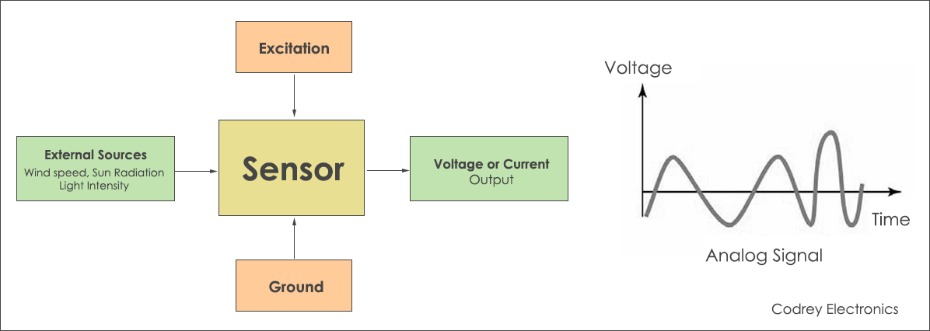

Figure 18 Sensor Block Diagram

# Types of sensors

There are many different ways in which sensors can be classified. One major way of classifying the sensors is according to their output signal type. On that basis there are mainly two types of sensors.

1. Analog sensors
2. Digital sensors

Analog sensors provide analog electrical voltage/current at their output whereas digital sensors provide digital electronic signals at their output. Digital sensors are particularly useful for interfacing with microcontrollers and digital processors. In order to interface analog sensors with digital controllers, ADCs (analog to digital converters) are required.

Another classification method for sensors is based on the method of excitation. On that basis there are also two types of sensors:

1. Active sensors
2. Passive sensors

Active sensors are the one which require external power source for their operation whereas passive sensors do not require any external power source for their operation.

The existence of modern machines, devices and gadgets is difficult to comprehend without sensors. From smart phones and kitchen appliances to aircrafts and large turbines, sensors are found everywhere. It is through the sensors, that the machines interact with their environment and gain feedback for course correction.

The importance of sensors has increased manifold with the advent of modern technologies like internet of things which are heavily dependent upon high level automation and smart sensor networks.

Although there are hundreds of different types of sensors in every domain of science and technology, some of the common sensors include: temperature sensors, pressure sensors, level sensors, flow sensors, color sensors, proximity sensors, gas sensors, accelerometers, gyroscope, and humidity sensors.

# How sensors work?

The input side of the sensor gets in touch with the physical quantity which needs to be measured. The sensor then produces an output electrical signal in proportion to the magnitude of the measured physical quantity.

For example, the leads of a temperature sensor are connected to the object whose temperature needs to be measured. The temperature sensor then produces an electrical signal which is proportional to the magnitude of measured temperature.

Modern sensors, apart from measuring the physical quantities, also incorporate signal conditioning and compensation circuitry. These circuits allow the sensor to produce an accurate and error free output. Ambient noises, lags, hysteresis and dead bands can cause a sensor to produce erroneous output. Hence, the signal conditioning and calibration circuits eliminate such problems.

Moreover, with the growing popularity of IOT, sensors are being manufactured with on-board Wi-Fi connectivity so that these sensors can be easily integrated with the cloud system.

# HC-SR04 ultrasonic sensor

The HC-SR04 is a popular and widely used ultrasonic distance sensor. The sensor is Arduino compatible and therefore is used in a large number of hobby and academic projects. This sensor offers excellent range detection capabilities with high degree of accuracy.

Some of the salient features of this sensor include:

1. Power supply: 5VDC
2. Working current: 15mA
3. Effectual angle: <15 degrees
4. Ranging distance: 2cm – 400cm
5. Resolution: 0.3cm
6. Measuring angle: 30 degrees

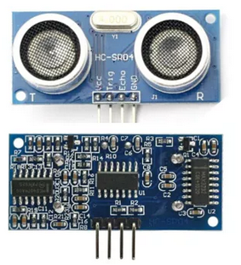

Figure 19 : HC-SR04 Ultrasonic Sensor

The HC-SR04 is a 4-pin sensor with two power and two signal pins. This sensor basically employs Doppler Effect for the measurement of distance and detection of objects. The transmitter of the sensor sends out ultrasonic waves. These waves collide with the target object and are reflected back to the sensor. The receiver of the sensor catches these reflected waved and Calculates the time between the transmission and reception. This time is then translated into the distance to that particular object.

# Maxbotix LV-EX3

The Maxbotix LV-EZ3 is an ultrasonic range finder. The purpose of an ultrasonic range finder is to determine the distance between the current location and the nearest obstacle.

These types of sensors are particularly useful in mobile robotic applications where the robot needs to get a situational awareness of the obstacles and hurdles within its environment. This feat is achieved using the ultrasonic range finding sensors which help the robot in Calculating the distance to a particular obstacle.

Like the HC-SR04, this sensor also works on the Doppler Effect principle. High frequency ultrasonic waves are emitted from the sensor which collide with the obstacle and create an echo. The reflected echo is captured by the sensor’s receiver and the elapsed time between transmission and reception is Calculated. This elapsed time provides us a measure of the distance between the current location and the obstacle.

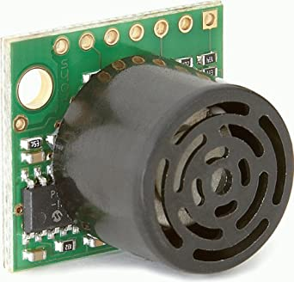

Figure 20 : Maxbotix LV-EZ3 Ultrasonic Range Finder

One great thing about this sensor is that apart from other objects it can also detect humans, which is very useful for autonomous robot applications like autonomous luggage carrier. This is crucial for implementing a robotic system which is safe to interact and collaborate with humans.

# Arduino KY-032 Infrared Sensor

This model of (IOAS) Infrared Obstacle Avoidance Sensor returns a signal once it become aware of an object in range. The range scale of the module is about two-forty cm in distance. It works at 3.5 to 5 volts at around twenty 20mA. The Obstacle Avoidance Sensors offer two types - with 3 and 4 pins. The 3-pin module does not have the capability to get enabled/disabled. The 4-pin module has a pin which Enables. Infrared obstacle avoidance sensor is built and design to notice or detect obstacles or the dissimilarity in reflective services. One asset of this sensor is to help a wheeled robot avoid obstacles with a sensor to react to adjustable distance settings. In addition, this module has an infrared transmitter and receiver, that configure the sensor pair. The LED of the transmitter discharge a definite frequency of infrared, which the receiver LED can notice. The LED of the receiver detects some of the signal back and participate in the digital on/off “signal” function pin when a particular threshold “distance” has been detected. This module is able to sense a solid object within a fixed range and ideal for robotics because of its properties. This could be feasible option for our design dur to its very helpful features. Specification of this design is given below

* + Working voltage: DC 3.3V-5V
  + Working current: ≥ 20mA
  + Operating temperature: -10 ℃ - +50 ℃
  + detection distance :2-40cm
  + IO Interface: 4-wire interfaces (- / + / S / EN)
  + Output signal: TTL level (low level there is an obstacle, no obstacle high)
  + Adjustment: adjust multi-turn resistance
  + Effective angle: 35 °
  + Size: 28mm × 23mm
  + Weight Size: 9g

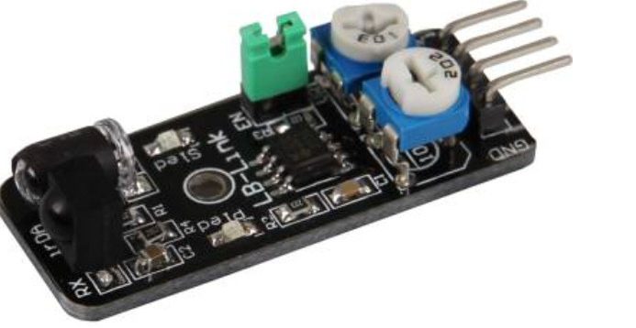

Figure 21 KY-032 Infrared Obstacle Sensor

There is a lot of advantages of using infrared sensor, their low power consumption makes them suitable for any design. They also have an ability to detecting motion in presence/ absence of light almost with same reliability. There is no leakage of data due to beam directionality IR radiation which makes it a reasonable design to choose from. On the other hand, the transmission data rate is slow and can get effected by environmental condition i.e. rain, fog, or dust.

# Parallax Ping ultrasonic distance sensor

Parallax’s PING))) Ultrasonic Sensor provides a very low-cost and easy method of distance measurement. This sensor is perfect for any number of applications that require you to perform measurements between moving or stationary objects. This ultrasonic distance sensor is widely used in robotics applications and is also useful in security systems or as an infrared replacement. Another ultrasonic sensor which is used for distance measurement and range finding is the Ping sensor from Parallax. This sensor is ideal for the stationary as well as mobile applications. The Ping sensor is designed for simplicity and easy integration with microcontrollers. This sensor only requires one I/O pin for ultrasonic transmission and reception.

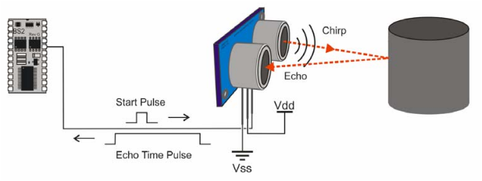

Figure 22 : Parallax Ping Sensor Operating Principle

The key features of this sensor include:

1. Range of 3cm to 3m
2. Non-contact distance measurement
3. Single microcontroller GPIO
4. 3-pin header
5. 40kHz high frequency operation

The Parallax Ping sensor is ideal for applications in the areas of security systems, parking assistant systems, autonomous robots and interactive animation systems.

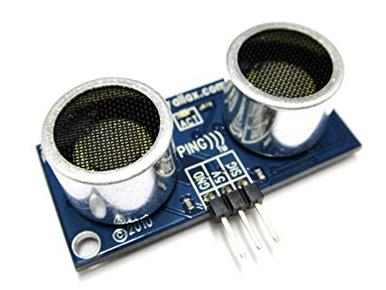

Figure 23 : Parallex Ping Sensor

# Sensor Selection

|  |  |  |  |  |
| --- | --- | --- | --- | --- |
| **Sensor** | **Model** | **Range** | **Performance** | **Cost** |
| **Ultrasonic** | **HC-SR04** | **2cm – 400cm** | **Very good** | **$2.80** |
| Maxbotix | LV-EZ3 | 0cm – 645cm | Good | $24.95 |
| Parallax | PING | 2.5cm – 304cm | Excellent | $29.99 |
| Arduino | KY-032 Infrared Sensor | 2-40cm | Fair | $5.99 |

We kept safety in mind while designing this autonomous carrier assistant and sensor will play a big role when it comes to safety. This module is built to detect any obstacle or object and respond. The HC-SR04 sensor has two ultrasonic transducers. First one works as a transmitter which changes electrical signal into frequency ultrasonic sound pulses. The receiver waits for the transmitted pulses. If it gets them it provides an output pulse whose width can be utilized to calculate the space the pulse travelled. According to the above comparison table, ultrasonic HC-SR04 is the best option for the autonomous luggage carrier which will prevent any collision and avoid any obstacle in its way. It was clear during the testing period that we made a good choice of using the ultrasonic HC-Sr04 sensors. Its accuracy rate for collision detection is magnificent and work like a champ. It showed that we did not compromise on safety and it was one of our goal to keep it as safe as possible.

# Motors

A motor is an electrical machine which converts electrical energy into mechanical motion. All motors utilize magnetic fields in order to convert electrical energy into mechanical motion.

# Types of motors

There are dozens of different types of motors and they can be classified in a number of ways. The most common way of motor classification is through the type of input electrical power. On that basis there are two main types of motors.

1. AC motors
2. DC motors

AC motors require AC electrical power as input whereas DC motors need DC electrical power for their operation. The AC and DC motors further have many different types depending on their construction, application, or mechanism. Some of the popular motor types include AC induction motors, AC synchronous motors, brushless DC motors, permanent magnet DC motors, stepper motors and servo motors.

# Working principle of motors

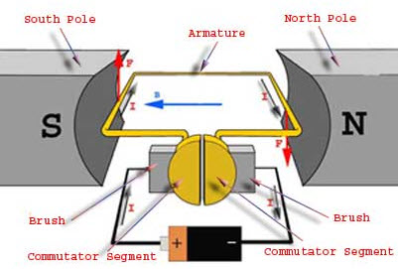

Figure 24 Working Principle of Motor

The working principle of the motor is summarized using the law: “whenever a conductor is placed within a magnetic field, it experiences a mechanical force”. The electrical power provided to the motor is used for the generation of magnetic field. The rotor of the motor consists of windings which experience mechanical force due to the magnetic field and start rotating.

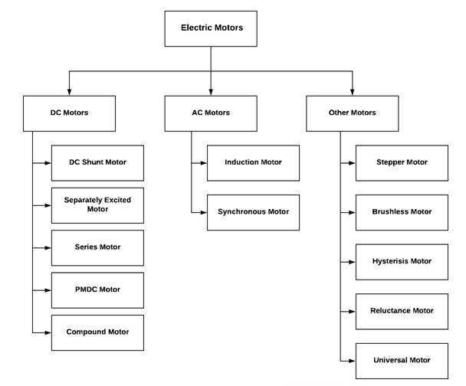

Figure 25: Different Types of Motors

# Actuators

Actuators are an integral part of modern control systems and machines. An actuator is a device which actuates a motion based on a control signal. Basically, any device which creates a motion in the system is known as an actuator. There are many different types of actuators such as hydraulic, pneumatic, magnetic, mechanical, and electrical actuators.

Some examples of actuators include comb drives, hydraulic cylinders, screw jacks, servo motors, solenoid valves, stepper motors, and pneumatic actuators.

Since, robotics is a sub-domain of automation and control systems therefore actuators are crucial for the implementation of any robotic system. The robot is dependent on the motors and actuators in order to achieve the desired motion. Servo and stepper motors are widely used for actuation in robots, automation systems, and control systems.

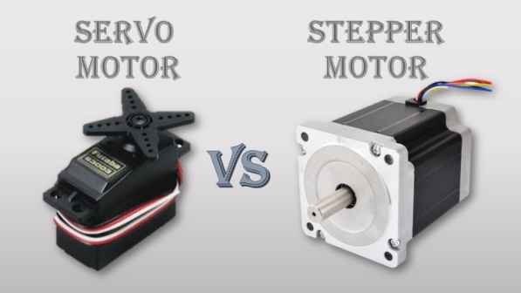

Figure 26 Servo and Stepper Motor Actuators

# DC motors

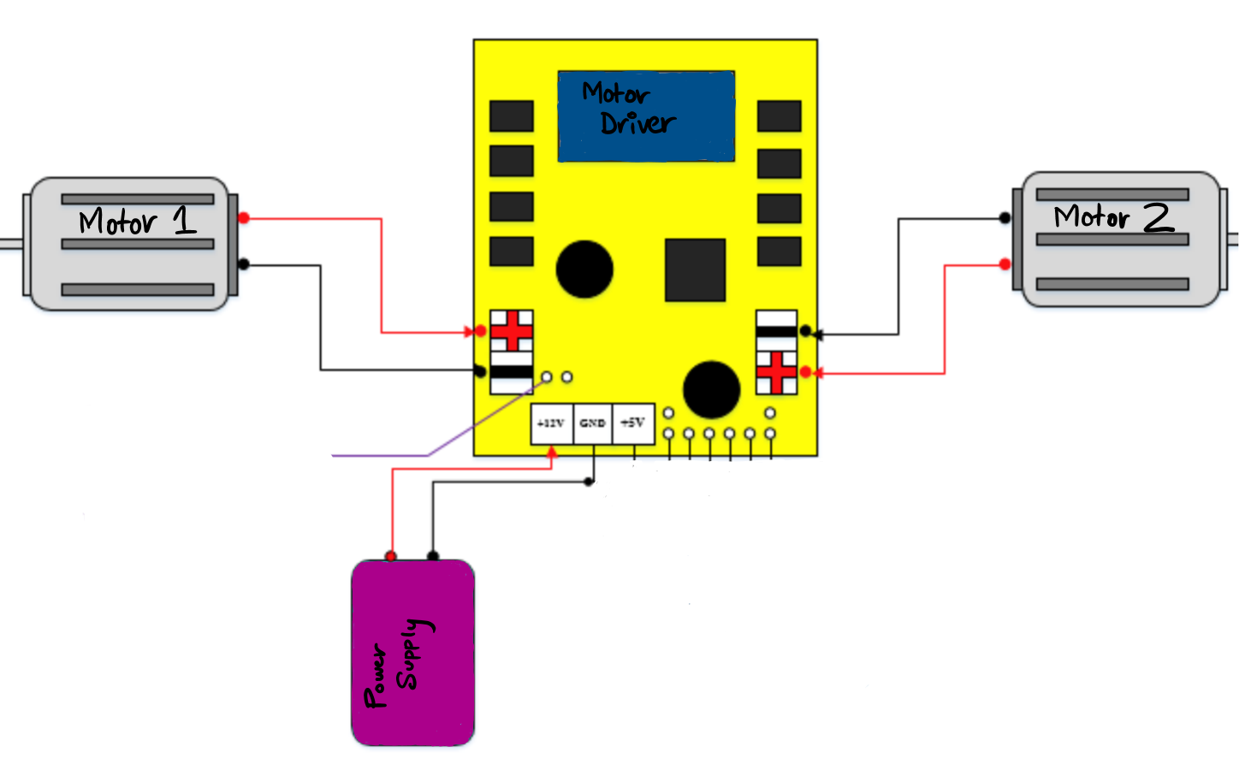

Figure 27 Motor Configuration

Both DC and AC motors have their own sets of advantages and disadvantages. One of major advantages of DC motors is that their speed can be controlled much easily than an AC motor. The design of DC motor drives is also much simpler and cheaper as compared to AC motor drives.

Another advantage of DC motor is low voltage operation and portability. Most of the AC motors are designed to operate on 120/230VAC single phase or 440VAC three phase power. This makes AC motors bigger in size and less portable. On the contrary, DC motors can be operated on voltages as low as 2-3V. This makes them highly practical for portable applications such as shavers, toys, handheld instruments, and portable consumer electronics.

The autonomous luggage carrier robot is a mobile robotic system and therefore it cannot operate on AC power. Since, the system must operate on DC power through batteries therefore the use of DC motors is intuitive. By using small-size high-torque DC motors, the weight of the robot is reduced, and its mobility is improved. Additionally, the speed and direction control of DC motor using a DC drive controlled by microcontroller is quite straightforward. There are a number of DC motors which are under consideration for use in the ACA system. The description of these motors is provided as following:

# Comparison of Motors

Choosing a good motor for our project was an essential part because the whole design is dependable of driving motor which will run the autonomous carrier assistant. Since there is two different option for motors AC and DC, it was not a daunting task for us to choose which one is better for our project. As we can see below what made us choose the DC motors for our design. DC motor are highly recommended for any robotics project due to those reasons given below.

|  |  |
| --- | --- |
| **DC Motor** | **AC Motor** |
| * higher starting torque | * lower power demand on start and minimal maintenance |
| * quick start, stop, & reverse | * Less efficient () |
| * variable speeds with voltage input | * Poor positioning control |
| * easier and cheaper to control than AC | * challenging to find AC solutions with fractional horsepower ratings |

# LMioETool DC gear motor

The first motor considered for ACA is the high-torque DC gear motor from LMioETool. This motor has high-temperature resistance, high abrasion resistance, strong loading capacity, and high durability.

The rated voltage is 12V and the rated current is 0.37A for this motor. The no load speed is 10 RPM. This motor is capable of driving loads as heavy as 15kg. The speed of this motor can be controlled using a motor controller drive circuit.

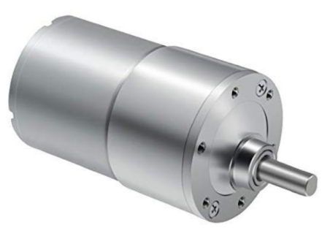

Figure 28 LMioETOOL DC Gear Motor

# Greartisan DC gear motor

The second motor considered for ACA is the 12V 30 RPM DC gear motor from Greartisan. This motor also depicts high temperature and abrasion resistance, strong loading capacity, and high durability. High hardness steel is used in the construction of this motor which makes it rugged and durable. This motor is also capable of driving loads up to 15kg. With all other parameters being identical, this motor is better in terms of RPM than the previous one.

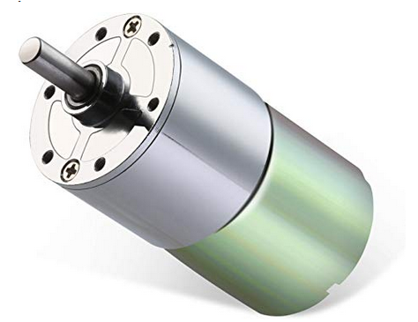

Figure 29 Greartisan DC Gear Motor

# BBT permanent magnet DC motor

The third motor considered for ACA application is the PMDC motor from BBT. This is a high speed and high torque motor. The motor speed is 3000 RPM whereas the torque is 2 kgFcm. The speed of this motor is adjustable through the use of an external motor drive. This type of motor finds its application in small generators, drill machines, cutting machines, and small water pumps.

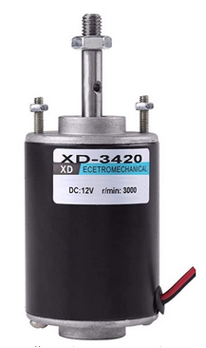

Figure 30 BBT PMDC Motor

# Magnolora DC gear motor

The fourth motor and perhaps the strongest contender in the list of selected motors is the 12V 130 RPM DC gear motor from Magnolora. The no load speed of this motor is 130 RPM, rated voltage is 12 VDC, weight is 100g, and no-load current is 100mA. Therefore, when compared with other motors in its category, this motor provides highest torque with lowest weight. Hence, this motor is the most suitable one for the ACA project

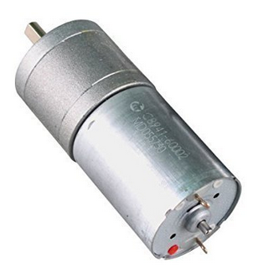

Figure 31 Magnolora 12V DC Gear Motor

# Motor Selection

|  |  |  |  |  |  |
| --- | --- | --- | --- | --- | --- |
| Motor | Power Consumption | Performance | Weight Load | Prices | Reviews |
| LMioETool | Excellent | Fair | Not Good | Cheap | Fair |
| **Magnolora** | **Excellent** | **Good** | **Good** | **Reasonable** | **Excellent** |
| BBT permanent | Not Good | Good | Excellent | Expensive | Fair |
| Greartisan | Fair | Fair | Excellent | Cheap | Good |

An electric motor converts electrical energy into physical movement which is why it is a significant part of any design. We did a lot of research about the different motors and chose one of the best options for our design. Magnolora 12V DC 25MM 130RPM Powerful High Torque Motor. The Magnolia motor offers a ton of excellent features which make the design very reliable and efficient. There were a number of characteristics that we needed pay attention to while deciding a motor but voltage, current, torque, and velocity (RPM) were the most important once and Magnolora is the best option for the autonomous carrier assistant according to it features. The implementation of motors is given below, in which we can see two motors connected with a motor driver.

# Motor finalization

During the motor testing we got to know that the first selection of motor was not the best choice for the ACA therefore, we had to change the motor at the last minute before completion of the project. We picked a 12V DC gearmotor by Kennwell after some calculation for torque, speed and load. This 12V dc gear motor made our design more reliable and efficient form its performance.

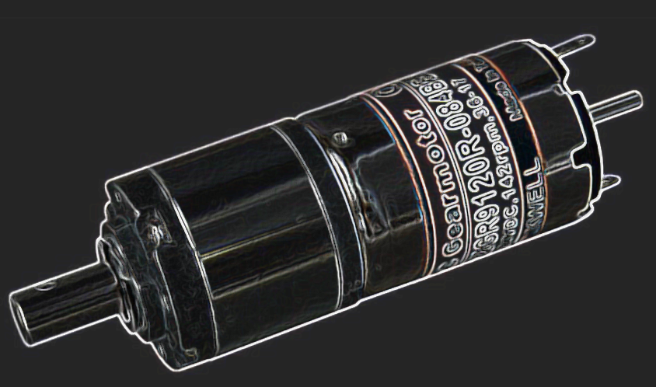.

# L298 Motor Control Drive Board

The advent of Arduino has made the life of engineer very easy with the availability of open source hardware designs, tons of ready-made shields, pre-written firmware libraries and excellent documentation. All these qualities make Arduino the ideal prototyping and development platform for embedded control projects.

DC motors are very widely used in all types of electrical projects and therefore a large number of DC motor related hardware and software components are available for the Arduino platform. All robots use different types of DC, servo and stepper motors for the motion of their joints.

The ACA robot also makes use of DC motors for the motion of its mechanical elements. For the effective and efficient motion control of DC motors, a DC control drive is required. The primary purpose of DC drive is to manage the speed, torque, and direction of a DC motor. The DC drives employ PWM (Pulse Width Modulation) techniques in order to control the speed of the DC motor. The electronic circuit of such drives commonly consists of dual H-bridge configuration.

One of the most well-known DC motor drivers is the L298N dual H-bridge motor driver. This driver allows the circuit designer to control the speed as well as the direction of the DC motor very easily using a microcontroller such as Arduino. The L298 driver also consists of heat sinks for high current loads. It also incorporates motor direction LED indicator. Most of the DC motors lie within the operating voltage range of 5 to 35VDC. Therefore, this driver is ideal for all such motors.

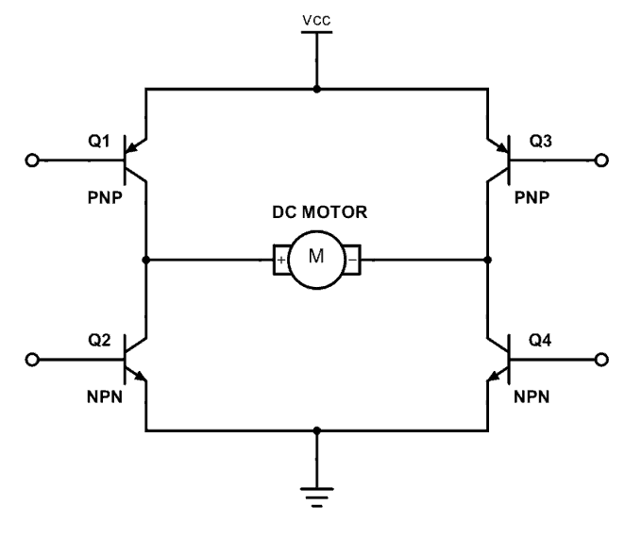

Figure 32 H-Bridge Circuit for Motor Control

The driver uses PWM (pulse width modulation) technique for the control of supply voltage of DC motors which in turn controls the speed and direction of motors. The driver also incorporates filters and protection diodes for reducing noise and providing circuit protection.

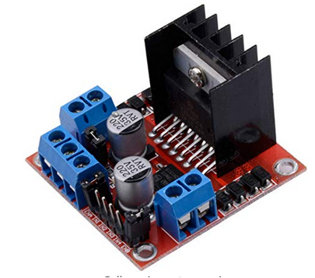

Figure 33 Qunqi L298N dual H-bridge Motor Control Drive

# L293 Motor Drive Shield

We basically use a motor driver in order to drive motors in robotics or in embedded projects. This L293 Motor driver is also called L293D expansion module since it has two L293D integrated circuits. Each L293D IC has 16 pins that that replace the basic idea of transistor and also this IC was built in with 2 H-bridge driver to control to DC motors at the same time. This module also gives us one of the best advantages that it can rum the motor in both direction (clockwise and anti-clockwise). This module can either support 4 Dc motors, servo, or stepper which is a really great feature of this motor driver module. this module has a connection incase if we want to use an external power Supply. In order to use the external power supply option there is a jumper that we have to take it out from the board. We will be using Dc motors in our design so this driver module could be one appropriate selection for our design

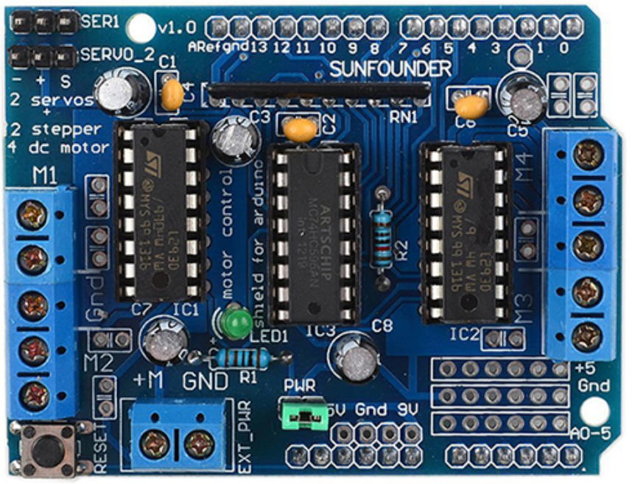

Figure 34 L293 Motor Driver Shield

The 293D is designed to pass bidirectional drive current maximum of 600-mA at voltage from 4.5V to 36V. It is compatible with different controllers. The pin organization of this integrated circuit is given below.

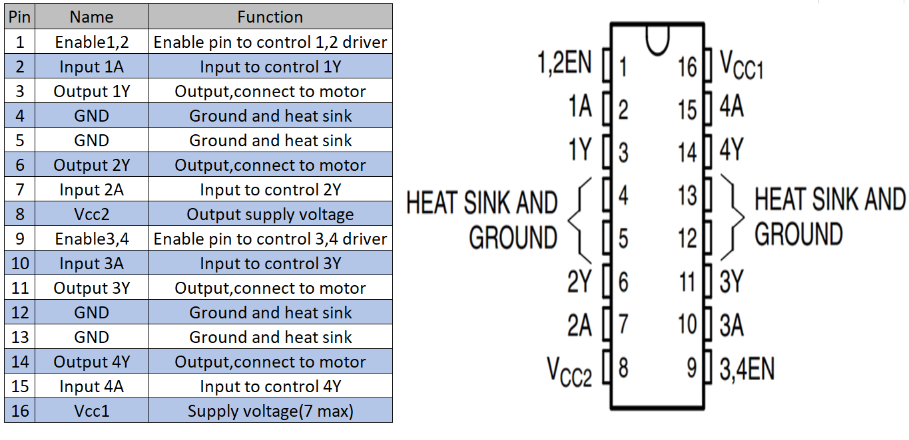

Figure 35 L293 Pin Configuration

# Sparkfun Motor Driver TB6612FNG

This Sparkfun motor driver is easy way to handle motors. The motor driver TB6612FNG is a dual motor control driver which is capable of running two motor momentously. It has an ability to handle up to 1.2 ampere of constant current per motor. The integrated circuit in this driver, provide us a 2 standard H bridge on a chip which allow us to control speed and direction of our motor as well as stop and brake. This Motor Driver has 2 I/P signals (IN1 and IN2) can be utilized to handle the motor in one of four function modes: CW, CCW, short-brake and stop. The two motor outputs (A and B) can be independently restrained, and the velocity of every motor is controlled via a PWM (Pulse Width Modulation) input signal with a frequency up to hundred kilo hertz. The STBY pin should be pulled high in order to take the motor out of standby mode. Logic supply voltage (VCC) of this driver can be in the range of 2.7--5.5VDC, while the motor supply (VM) is limited to a max voltage of 15 VDC. The O/P current is rated up to 1.2A per channel (or up to 3.2A for a short, single pulse). This is very reliable and affordable controller in the market which can be used in our design.

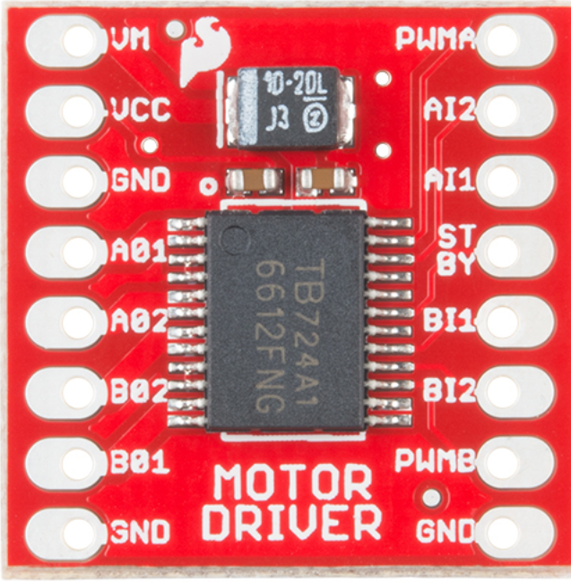

Figure 36 Spark fun Motor Driver

Features

• Power supply voltage: VM = 15V max, VCC = 2.7--5.5V

• Output current: Iout = 1.2A (average) / 3.2A (peak)

• Standby control to save power

• CW/CCW/short brake/stop motor control modes

• Built-in thermal shutdown circuit and low voltage detecting circuit

• All pins of the TB6612FNG broken out to 0.1" spaced pins

• Filtering capacitors on both supply lines

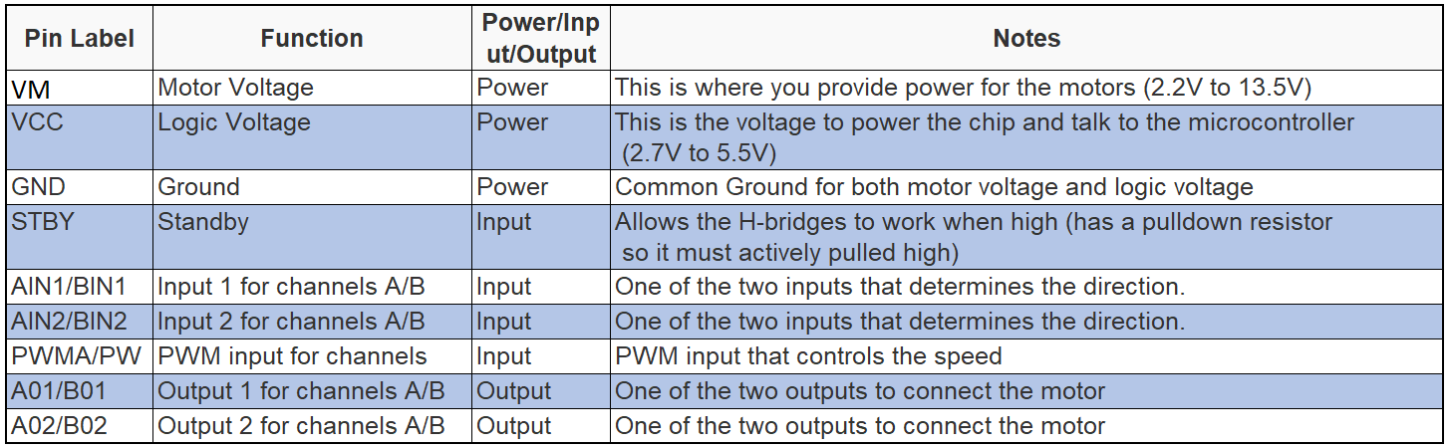

# Voltage regulator and DC power supply

The electronic chips and components such as microcontrollers are very sensitive devices. These electronic components require stable voltage for their operation. If the supply voltage has fluctuations and sudden variations in it then it can cause component failure.

The most common power supply circuits make use of bridge rectifiers for the purpose of AC to DC conversion. However, the voltage obtained from the bridge rectifier is not a stable DC signal rather it contains high amount of ripple content. The common bridge rectifier circuit and its associated voltage waveform is shown as following:

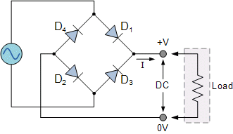

Figure 37 Full-Wave Bridge Rectifier Circuit

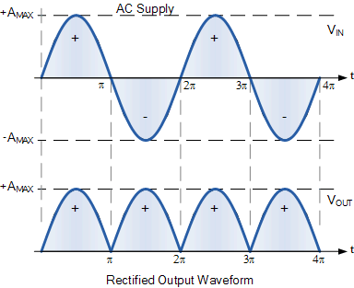

Figure 38 Input and Output Waveforms of the Full-Bridge Rectifier

As it can be seen from the above waveform that the output voltage obtained from the bridge rectifier contains a large ripple component. In order to eliminate this ripple, a large capacitor is commonly used in parallel with the load. This capacitor definitely improves the voltage waveform however the results are not ideal. Even with the capacitor, some ripple still remains in the DC voltage. The voltage waveform after the capacitor is added to the power supply circuit is shown in the following figure.

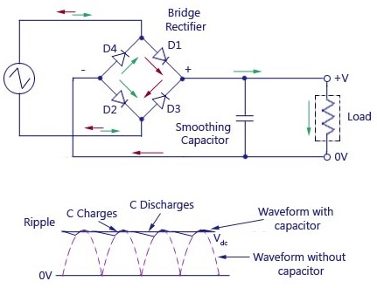

Figure 39 Voltage Waveform with and without Smoothing Capacitors

From the above waveform it is obvious that even after the addition of smoothing capacitor, the voltage waveform still contains ripple. Hence, in order to get a completely stable waveform, a voltage regulator is needed.

# Voltage regulator

A voltage regulator is a solid-state semiconductor device which is used in electronic power supply circuit in order to keep the voltage constant and stable. The common DC voltage regulator integrated circuits include 7805 and 7812. The 7805 provides stable 5VDC whereas 7812 provides 12VDC at its output.

The bridge rectifier circuit-based power supply design with voltage regulator is shown in the following figure.

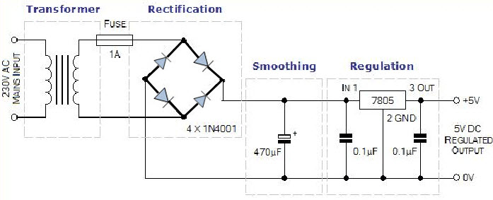

Figure 40 Power Supply with Voltage Regulator IC

# How voltage regulators work?

The voltage regulator IC usually consists of three pins. These three pins include input, output and common pins. Input power supply is provided through the input pin, output voltage is obtained through output pin and common provides the ground reference.

The input voltage range of a voltage regulator IC is typically quite wide i.e. up to 35VDC. Despite the input voltage level, the regulator IC maintains stable voltage at its output. However, the voltage difference between the input and output voltage results into access power and the regulator needs to get rid of that access power. This access power is dissipated by the regulator in the form of heat energy.

Therefore, during its operation the voltage regulators tend to get very hot. Access temperatures can lead to chip burning out. Hence, voltage regulators are almost always used with appropriately sized heat sinks which save them from burning out.

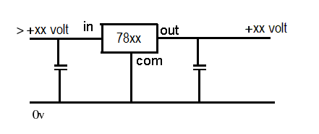

Figure 41 Voltage Regulator Pinout

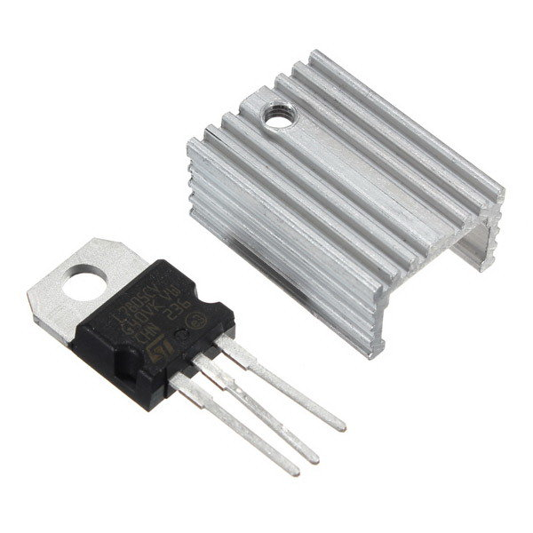

Figure 42 Voltage Regulator IC with Heat Sink

The design of 78xx voltage regulators is fairly simple which requires only two external capacitors for its operation. Therefore, these regulators are very commonly used by power supply designers and engineers.

# Type of voltage regulator

A voltage regulator can be change by having different component or different circuit design. So, the voltage regulator is being classified in two types

1. Linear regulators
2. Switching regulators

# Linear voltage regulators

The linear voltage regulators have a relatively simpler design compared to the switching regulators. Linear regulators make use of transistor with negative feedback loop in order to maintain constant voltage at the output.

The primary advantages of linear regulators are simple design and low cost. The switching regulators are more complex and expensive.

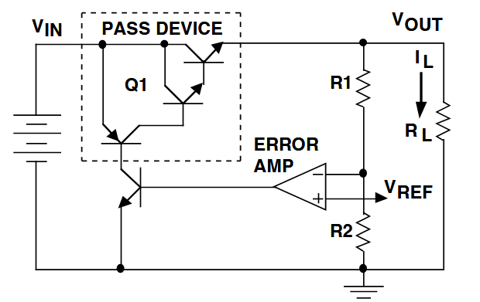

Figure 43 Internal Circuit of a Linear Regulator

The linear regulator is named so because the transistor or the pass element in the regulator circuit operates in its linear region. In switching regulators, the transistor operates as a switch rather than a linear device.

In the above schematic diagram, the pass element consists of transistors. The operational amplifier acts as the sensing element in the circuit and provides feedback to the pass device. Based on the feedback, the output voltage is regulated.

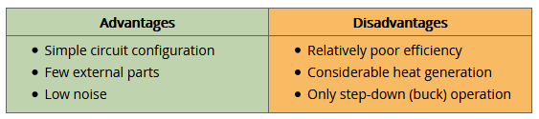

Figure 44 Pros and cons of linear regulators

# Types of linear regulators

There are three main types of linear regulators which are listed as:

1. Standard (NPN Darlington) regulator
2. Low dropout (LDO) regulator
3. Quasi LDO regulator

The main difference between these three regulators is the dropout voltage. Dropout voltage is defined as the minimum voltage difference required across the regulator in order to maintain constant output voltage. The lower the dropout voltage, the higher is the regulator efficiency.

The standard regulator makes use of Darlington pair as a pass device with an op-amp based feedback loop. This type of regulator has the highest dropout voltage whereas the ground pin current is lowest amongst the three types of regulators. The schematic is shown as following:

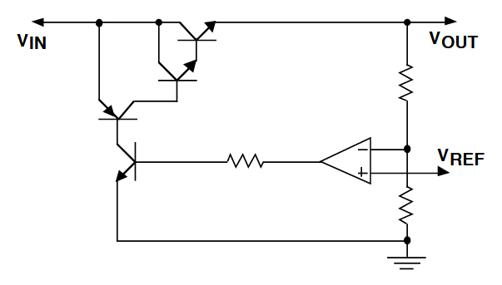

Figure 45 Standard NPN Darlington Voltage Regulator

The pass device in the LDO regulator consists of a single PNP transistor as opposed to an NPN Dralington pair in the standard regulator. The LDO regulator has the best dropout voltage characteristics and the worst ground pin current characteristics amongst the three regulator types.

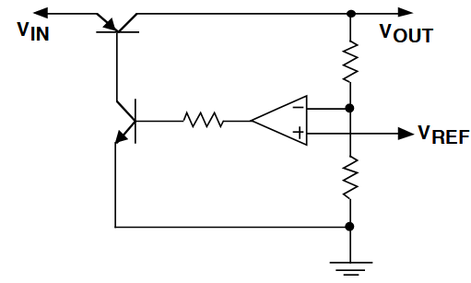

Figure 46 Low Dropout Voltage LDO Regulator

The third type of voltage regulator is the quasi-LDO voltage regulator. This voltage regulator is a hybrid of standard and LDO regulators. The pass device in this regulator consists of a combination of NPN and PNP transistors. The voltage and current characteristics of this regulator lie in between the standard and LDO regulators.

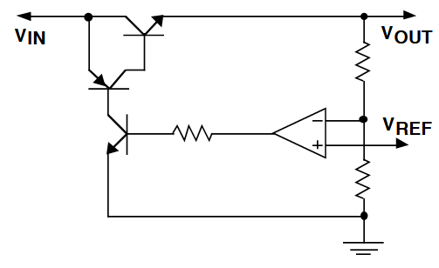

Figure 47 Qausi-LDO Voltage Regulator

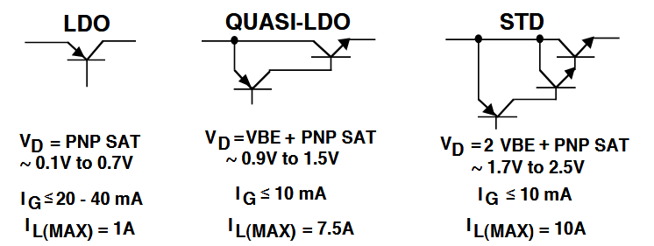

Figure 48 Comparison of Standard, LDO and quasi-LDO Voltage Regulators

# Switching voltage regulator

As described in the previous section, the switching voltage regulators are the ones in which the transistor operates as a switch. These types of regulators have high efficiency but have complex design and higher cost.

In a switching regulator the switching operation of the transistor converts the incoming voltage signal into high frequency pulses. The switch is controlled by a control circuit which usually uses PWM (pulse width modulation) technique for voltage regulation. The voltage pulses are converted to smooth DC voltage using output stage filter circuits consisting of capacitors and inductors.

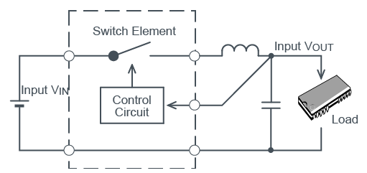

Figure 49 Switching Voltage Regulator Circuit

Switching regulators are highly efficient devices which generate very less heat. Another great advantage of these regulators is that they can be used in buck-boost configuration whereas the linear regulators can only provide buck functionality. However, one of their major drawbacks is the noise generation and EMI due to high frequency switching operation. They also cost more than the linear regulators.

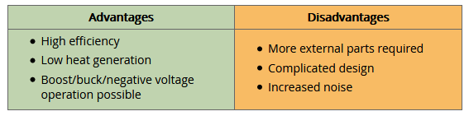

Figure 50 Pros and Cons of Switching Regulators

# Types of switching regulators

There are three main types of switching regulators on the basis of their function.

1. Buck regulators
2. Boost regulators
3. Buck-boost regulators

The buck regulator is basically a step-down regulator which means that it can only provide an output voltage lower in magnitude than the source voltage. The buck switching regulator is shown in the following figure.

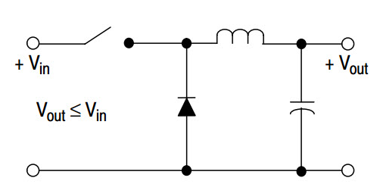

Figure 51 Buck Switching Regulator

The boost regulator is a step-up regulator which means that the output voltage of the regulator is higher than the source DC voltage. The boost converter topology is presented as following.

The boost voltage regulator is a regulator to generate the input Dc to a high Dc output voltage that is why they call it step up. So during the rime of the switch is on in the step up voltage regulator the inductor is getting charge by the current passing through to a certain level, and when the switch is opened the energy stored in the inductor is transferred to the load by the diode. The boost voltage regulator is in the continuous mode of operation and by the condition that the current never go to zero the disadvantages of boost voltage regulator: the is no isolation from input to output which is very bad in many application such as power supply of gate driver. This control is difficult to control, and that because the transfer function of this converter contains a right half zero which introduces. This converter cannot provide a larger limit of maximum power point tracking.

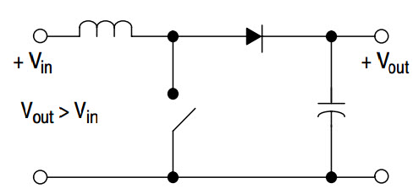

Figure 52 Boost Switching Converter

The third type of switching regulator is the buck-boost converter. This is an adjustable regulator which can provide step-down as well as step-up functionality. The circuit topology is given as following.

Step down voltage regulator or what is call the buck boost regulator. It takes the input and reduce the voltage to a lower value to a fixed output voltage while allowing for a continuous input current. As we know that the actual integrated circuit switching contains the switch control circuit it may or may not contain switch and that depending upon the output current requirement. There are many ways to control the switch, however most of the switch is controlled by a pulse width modulator PWM at fixed frequency.

* the advantage of step down of voltage
* It has less component in the circuit
* Low cost to build the step-down voltage really low.
* Disadvantage of the step down:
* the charge current of the capacitor is discontinuous
* resulting in large filter size and more EMI issues.
* there is no isolation from the input to output which is very critical in many applications.
* also, the converter is difficult to control.

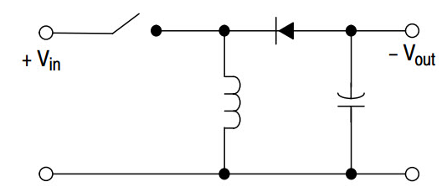

Figure 53 Buck-Boost Switching Regulator

# Voltage Regulator Selection

We decide to use switch regulator beside the linear regulator, and that because switch regulator provide High efficiency, low heat generation, Boots/ buck/ negative operation possible.it also generate output voltage that high than the output voltage. On the other hand, linear voltage regulator inefficient, and it also dissipate the power as heat. The switching voltage regulator circuit is using a switch to transfer the input power supply into pulsed voltage and in the circuit is using capacitor, inductor, and other components. So, the switch MOSFET keep switching on until the desired voltage is reached. This voltage regulator is become more advance and worldly know because of the semiconductor devices is getting advance faster and smaller. We used Texas Instrument Webench to design switch voltage regulator with proper DC-to-DC output converter and by input a maximum voltage and get low voltage output.

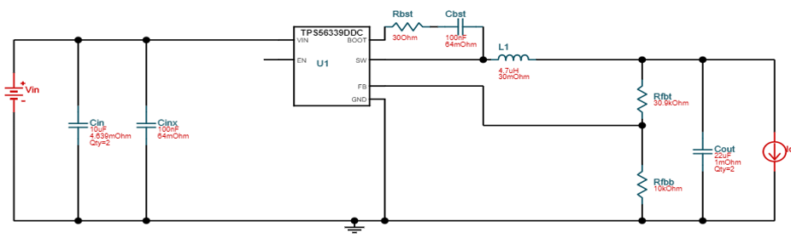

Figure 54 Voltage Regulator Circuit

Now a day with advance technology we have and the advance research they do in the semiconductor. It is easy to design switching voltage regulator with more efficiency, low cost, and small size and not that heavy. The switching voltage regulator has many types

# Batteries

A large portion of the electrical and electronic devices used in the world today run on battery power. All the electronic and electrical systems which need to be portable rely on battery power. From mobile phones, laptops and toys to cars, generators, and solar power systems, batteries are used everywhere.

The battery is made of several electrochemical cells that each one contains of two electrodes. This tow electrodes have an electrolyte in between. So how the battery can produce electricity? As we know the electricity is energy that is produce by the movement of electron. For the battery the electron flow from the anode which is the negative electrode to the cathode which is the opposite (the positive electrode). with this movement the batter generate energy.

We have to keep inconsideration that each battery needs to provide enough energy to supply the needs of our project for all the electrical component. We will use two batteries to get more power. one battery will energies the motors and the second battery will connected to the controller system, sensor, lights, and Bluetooth.

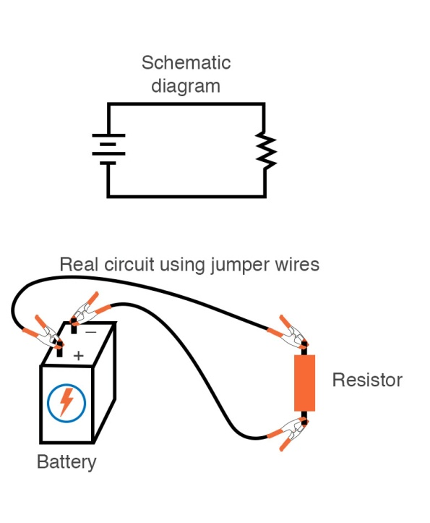

# Types of batteries

Figure 55 Battery Circuit Diagram

Since batteries are widely used devices and are used in all types of applications, therefore there are many different types of batteries suited for different application areas. On the basis of recharging capability, there are two types of batteries:

1. Primary batteries
2. Secondary batteries

Primary batteries are the ones which once depleted cannot be recharged. These batteries are commonly used in remote controls, toys, and torches. There are dozens of different types of primary batteries. Some of the common ones include alkaline batteries, dry cell batteries, galvanic cells, lithium batteries, silver-oxide batteries, and zinc-carbon batteries.

Secondary batteries are the rechargeable batteries. The chemical reactions within these batteries can be reversed by application of external voltage. These batteries are commonly used in mobile phones, cars and robots. Based on the chemistry, there are four different types of secondary batteries:

1. Lithium-ion batteries
2. Nickel Cadmium batteries
3. Nickel-Metal Hydride batteries
4. Lead acid batteries

# Lithium-ion batteries

Currently, Lithium ion batteries are one of the most used batteries in the world. The main reason behind their mass adoption is their use in mobile phones and tablets. Other than consumer electronics, the use of Li-ion batteries is also spreading into military, automobile, and aerospace applications.

In lithium ion batteries, the positive terminal is made of Lithium compound whereas the negative terminal is made of carbon. There are several advantages of using Lithium ion batteries which are listed as following:

1. Li-ion batteries are more eco-friendly compared to other types of secondary batteries. These batteries do not contain lead, cadmium and mercury which makes them relatively harmless and non-toxic compared to other batteries. However, proper disposal and recycling of Li-ion batteries is still required.
2. Li-ion batteries offer high energy density which is a significant advantage is portable and compact electronic devices. High energy density means that the battery has a high energy storage capacity for lesser weight. The reason for high energy density of these batteries is that Lithium is a highly reactive element which has the capability to store and release large amounts of energy.
3. Absence of memory effect is another advantage of Li-ion batteries. In normal batteries, when the battery is repeatedly partially discharged before recharging then over the time the energy delivery of the battery would downgrade. This memory effect is not present in Li-ion batteries.
4. Another huge advantage of Li-ion batteries is their low self-discharge rate. When the batteries are stored or not used then they tend to discharge over the course of time. The discharge rate is higher in some types of batteries. However, in Li-ion batteries the discharge rate is low.

Some of the major disadvantages of Lithium-ion batteries are as following:

1. These batteries are not as robust as other types of batteries. These batteries require very tight voltage and current control. Protection circuitry must be present which saves the battery from being overcharged and over-heated.
2. Another disadvantage of these batteries is ageing. The Li-ion batteries age with usage. These batteries typically last for around 1000 charge-discharge cycles. Hence, the users might need to change the batteries after some time.
3. Another disadvantage of Li-ion batteries is their relatively higher cost. These batteries cost around 40% more than the NiCad batteries.

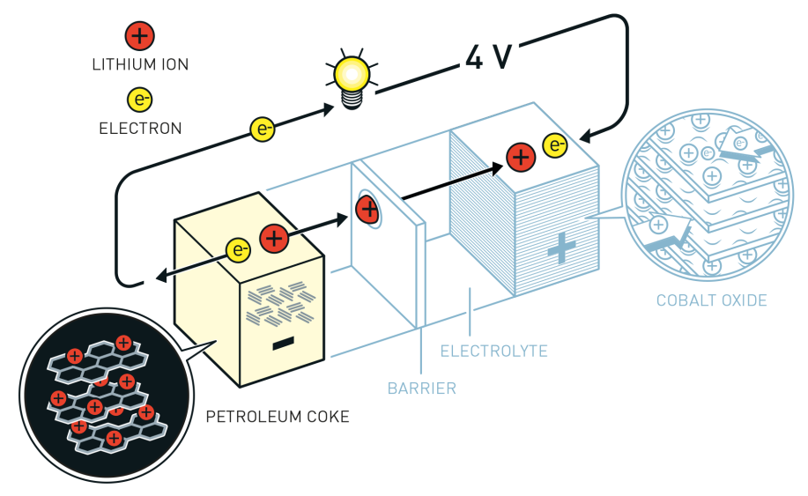

Figure 56 Lithium-ion Battery Composition

# Nickel Cadmium batteries

NiCad batteries are another type of popular secondary batteries. These batteries were widely used a while back however with the advent of Li-ion batteries the growth of NiCad batteries has plummeted. One of the major reasons for their reduced usage is the use of cadmium in these batteries which is a toxic substance. Hence, the disposal of these batteries is hazard.

The nominal voltage of a NiCad battery cell is 1.2V which is lower than many other batteries. The positive terminal of the battery is made of Nickel-oxide-hydroxide whereas the negative terminal is made from Cadmium. The electrolyte is Potassium-hydroxide.

Some of the advantages of NiCad batteries are listed as following:

1. These batteries have a rugged construction and they offer significantly higher cycle count compared to other battery types.
2. These batteries have an excellent recharging time. These batteries can be charged at very fast speeds without stress.
3. These batteries have a long shelf life and can be stored for longer periods of time in discharged state.
4. These batteries are very economical and have the lowest cost per cycle when compared to other batteries.

Some of the disadvantages of NiCad batteries are as following:

1. Cadmium is a toxic material and therefore the disposal of these batteries requires special treatment. Due to toxicity, they are not eco-friendly and can contaminate the environment.
2. These batteries suffer from memory effect. Due to memory effect, their power delivery capacity can degrade over time.
3. These batteries have lower nominal voltage compared to other batteries. The Li-ion battery cell has a nominal voltage of 3.6V whereas the NiCad battery cell has a nominal voltage of mere 1.2V.
4. The discharge rate of NiCad batteries is quite high and therefore they need to be charged after being retrieved from storage.

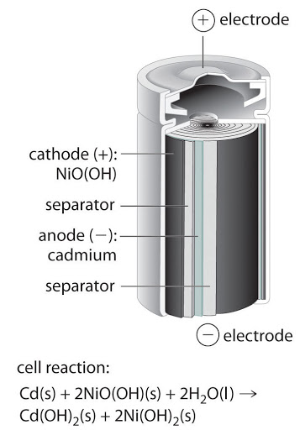

Figure 57 Nickel Cadmium Battery Construction

# Nickel Metal Hydride Batteries

NIMH is another secondary battery type which means that it is a rechargeable battery. The positive terminal of this battery is made from Nickel-Oxide-Hydride whereas the negative terminal is made from hydrogen absorbing alloy. This battery is better than NiCad battery in terms of energy density and capacity.

The advantages of NIMH batteries are listed as following:

1. NIMH batteries have 30-40% more capacity than a NiCad battery.
2. The energy density of this battery is quite high and is comparable to Li-ion in some cases.
3. The memory problem is less severe in NIMH batteries as compared to NiCad batteries.
4. These batteries do not contain toxic Cadmium and therefore are more environment friendly. The disadvantages of NIMH batteries are as following:
5. They have shorter service life of around 200-300 recharge cycles. The performance starts to degrade after some time.
6. These batteries have a longer charging time compared to NiCad batteries and generate more heat during the charging process.
7. The discharge rate of NIMH batteries is around 50% higher than that of NiCad batteries.

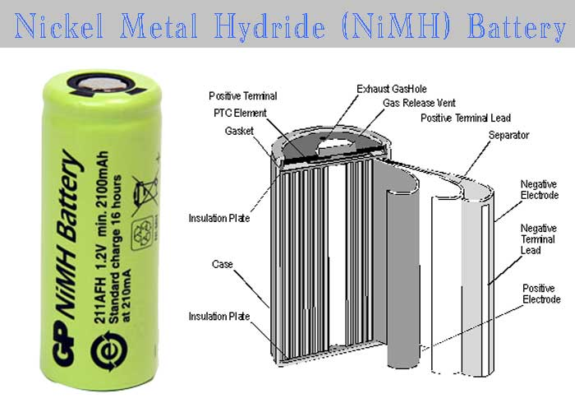

Figure 58 NIMH Battery Construction

* [**Charge/discharge efficiency**](https://www.google.com/search?rlz=1C1CHBF_enUS798US798&sxsrf=ALeKk00wy9fuuvlO3HEO0Mn3ahum-IP-sQ:1587333706425&q=nickel%E2%80%93metal+hydride+battery+charge/discharge+efficiency&sa=X&ved=2ahUKEwj7jNjtvvXoAhUqZN8KHWx1CPsQ6BMoADAdegQIDxAC)**:**66%–92%
* [**Nominal cell voltage**](https://www.google.com/search?rlz=1C1CHBF_enUS798US798&sxsrf=ALeKk00wy9fuuvlO3HEO0Mn3ahum-IP-sQ:1587333706425&q=nickel%E2%80%93metal+hydride+battery+nominal+cell+voltage&sa=X&ved=2ahUKEwj7jNjtvvXoAhUqZN8KHWx1CPsQ6BMoADAeegQIEBAC)**:**1.2 V
* [**Cycle durability**](https://www.google.com/search?rlz=1C1CHBF_enUS798US798&sxsrf=ALeKk00wy9fuuvlO3HEO0Mn3ahum-IP-sQ:1587333706425&q=nickel%E2%80%93metal+hydride+battery+cycle+durability&sa=X&ved=2ahUKEwj7jNjtvvXoAhUqZN8KHWx1CPsQ6BMoADAfegQIERAC)**:**180–2000 cycles
* [**Specific energy**](https://www.google.com/search?rlz=1C1CHBF_enUS798US798&sxsrf=ALeKk00wy9fuuvlO3HEO0Mn3ahum-IP-sQ:1587333706425&q=nickel%E2%80%93metal+hydride+battery+specific+energy&sa=X&ved=2ahUKEwj7jNjtvvXoAhUqZN8KHWx1CPsQ6BMoADAgegQIEhAC)**:**60–120 Wh/kg
* [**Energy density**](https://www.google.com/search?rlz=1C1CHBF_enUS798US798&sxsrf=ALeKk00wy9fuuvlO3HEO0Mn3ahum-IP-sQ:1587333706425&q=nickel%E2%80%93metal+hydride+battery+energy+density&sa=X&ved=2ahUKEwj7jNjtvvXoAhUqZN8KHWx1CPsQ6BMoADAhegQIExAC)**:**140–300 Wh/L
* [**Specific power**](https://www.google.com/search?rlz=1C1CHBF_enUS798US798&sxsrf=ALeKk00wy9fuuvlO3HEO0Mn3ahum-IP-sQ:1587333706425&q=nickel%E2%80%93metal+hydride+battery+specific+power&sa=X&ved=2ahUKEwj7jNjtvvXoAhUqZN8KHWx1CPsQ6BMoADAiegQIFBAC)**:**250–1,000 W/kg

This table compare the capacity, voltage, self-discharge, and runtime

| **Battery type** | **Capacity AA cell** | **Voltage** | **Self-discharge Capacity after 1-year storage** | **Runtime Estimated photos on digital camera** |
| --- | --- | --- | --- | --- |
| **NiMH** | 2,700mAh, rechargeable | 1.2V | 50% | 600 shots |
| **Eneloop\*** | 2,500mAh, rechargeable | 1.2V | 85% | 500 shots |
| **Regular alkaline** | 2,800mAh; non-rechargeable | 1.5V | 95% 10-year shelf life | 100 shots |
| **Reusable alkaline** | 2,000mAh; lower on subsequent recharge | 1.4V | 95% | 100 shots |
| **Lithium** (Li-FeS2) | 2,500–3,400mAh (non-rechargeable) | 1.5V | Very low 10-year shelf life | 690 shots |

# Lead acid batteries

The last type of secondary battery in our list is the lead acid battery. Along with Li-ion battery, this is one of the most widely used batteries in the world. The lead acid batteries are mainly used in automotive, backup power systems, cell phone towers, solar systems and wind turbines. Their widespread acceptability is due to their simple construction and low cost.

The advantages of lead acid batteries are as following:

1. The high nominal voltage and wide temperature range makes this battery ideal for automotive and high-power storage applications.
2. The materials used in this battery are relatively inexpensive and the technology is very mature due to which this battery can be manufactured with higher voltage and current ratings.
3. These are low cost batteries and are significantly cheaper than NIMH and Li-ion batteries. The disadvantages of lead acid batteries are listed as:
4. These batteries have a low energy density due to which they tend to be bulkier and heavier compared to other batteries.
5. They have shorter life cycle as compared to Li-ion batteries. Their life span is 1/3rd that of Li-ion batteries.
6. They contain toxic lead material which poses environmental challenges.

# Charging

This is one of the most important for the battery to powered of which mean to charge every time we have a low battery; we do not want to change the battery each time. If we don’t use the right type of charge to the batteries that will badly impact the devices and other controller and the costs will be more expansive because certain batteries is expansive and that will impact the batteries life and efficiency. However, we have to understand how battery get charge and which types of charging is the best for the batteries we are using in our project.

# Constant Voltage charging

Constant voltage charge maintains the same voltage input to the battery throughout the charge process.  Constant-voltage chargers provide a high initial current to the battery because of the greater [potential difference](http://nuclearpowertraining.tpub.com/h1011v1/css/Potential-Difference-29.htm) between the battery and charger.  A constant-voltage charger may return as much as 70% of the previous discharge in the first 30 minutes.

A typical example would a low-cost auto battery charger for home use or basic back up power systems.  This method enables fast charging rates and is suitable for lead acid types, but not for Nickel Metal Hydride (Ni-MH) or Lithium-Ion (Li-ion) types.

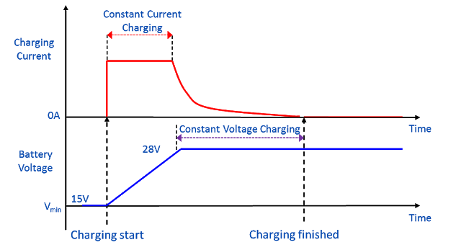

Figure 59 Battery System Diagram

However, the constant voltage charging has many disadvantageous that affect the battery and that because of its long period of chagrining and that after fully charge of the batteries. That will cause overheated, overcharge, and reduce battery life.

# Float charging

The floating charging which is also knowing as floating lien. The floating charge is one of the comment charge types use to charge battery, and that will charge the battery without any negative impact. Floating charge and that which where the battery is maintained and that after is getting charge with compensating with self-discharge of the battery. Which mean the voltage charge in battery will remain constant after a 100% fully charge for the entire duration of charge. The floating charge may be kept connected indefinitely without damage the batter. so why this overcharge does not happen with floating charge, the answer is that the floating charges are in fact constant voltage and that by having a low operation voltage which prevent the battery of overcharge and get damage.

The Float mode follows the constant current mode. Float mode is where the battery voltage is maintained at approximately 2.25 volts per cell, or 13.5 volts for a 12V battery. This charger will maintain the battery indefinitely without boiling out electrolyte or overcharging the battery.

The charge is also depending of the battery type. Of we are using the floating charge for the lead acid battery we need to take precaution such as the voltage should be set at around 2.25V per cell, and the current should also be set less than 1 amp. If this action is not taking it will lead to overheating and that will cause the battery to melt and catch on fire.

# Battery Selection

We decide to choose the Nic battery because it has many advantages. This type of battery is common consumer and industrial type battery. we need a battery that we give us along charge for long duration and the Lithium iron Phosphate battery and is durability and flexibility. They offer a higher specific energy. We also chose it because It can with small size. So, we are looking for battery that can have a lower self-discharge and we can have this description by using the NiCad battery, and that because it has an appropriate energy density that we need for our design.

Characteristic:

• Voltage: 12V

• Capacity: 4200mAh

• Maximum continuous discharge: 4.3Amps

• Charge Current: 0.2C (standard) 1C (rapid)

• Maximum charge current: 4200mA

• Discharge (Output) Leads: Deans connector 12AWG silicon wire, 100mm long.

• Charging (Balancing) Lead: JST/Align/E-Flite style connector. 24AWG PVC wire, 40mm Long.

• Dimension: 105mm x 36mm x 26mm (Max.)

• Product Weight: 20g (Max.)

# Printed Circuit Board (PCB)

the way that technology advance now a day is really rapid. That because of the advance of in the electronic system and that is due to many factors, the two important factors are component integration and the assembly. More law is another factors and that by making the transistors and other component more smaller, and the by perception that the number of transistors on a microchip doubles every two years now we can’t makes the transistors more smaller because we get to the maximum size we can. However, is not the end the researcher they always looking for another component that we do the same job and also smaller like QCA and other new technology coming.

The electronic industry changes a lot today you can have a small computer board that can preformed faster than the old computer that occupied the whole room in 1950. The printed circuit board (PCB) or printed wired board (PWB) , so after build the IC which is the integration circuit that can perform a large set of functionality in small area the connection between the different IC it called the PCB. The PCB will provide the mechanical thermal support as well as the electrical interconnection between different ICs. The PCB are used in every electronic devices or equipment that is using several components that is connected to each other use the PCB to interconnect these components in protected way and in small size.

# The types of PWBS

There are 4 types of the PWBs.

* PCB printed circuit Board: The board is made of glass epoxy, and have thicknesses starting from 0.4 mm and up according to the number of layers used. These PCBs can be seen in Calculators, computers, cell phones, (copy from the source)
* Chip carriers: These are single chip substrates that hold the die in flip-chip technology and carry the wires that map the die pads into the package pins. Polymer (glass epoxy) and ceramic based substrates are used for this application. Chip carriers are encapsulated within the chip package. copy from the source
* Flexible circuit carriers: these PWB are made of flexible polymer based thin films than can be conformal to device shapes. A thin film metal is deposited to act as the conducting wire. copy from the source
* Metal based boards: these types of boards use metal as their core. Insulating material is deposited on top of the metal core. Such boards are used in applications where high temperatures are to be dealt with such as in automotive applications. copy from the source

In our project we are going to build the PCB printed Circuit Boards because the PCB are the mostly used for interconnecting the electronic components each other’s and we can see it every electronics equipment.

# Joystick

# Adding more feature into one design is a recipe of success. We added a joystick in our design which was the very last thing for us to implement for the design of ACA. We added this feature which can be used in many different conditions. Low GPS signal was one of the major reasons to include this option because there is area where it is hard for the GPS to locate and guide during too bad signals or bad connectivity. Another reason to add a joystick is senior citizen since they do not like technology too much and are very reliable on thing that they have already used and as we know that almost everybody has used a joystick somehow. It is a feature that can be used conditionally or on demand of someone who would like to take an advantage of this feature.

# Assembly Design

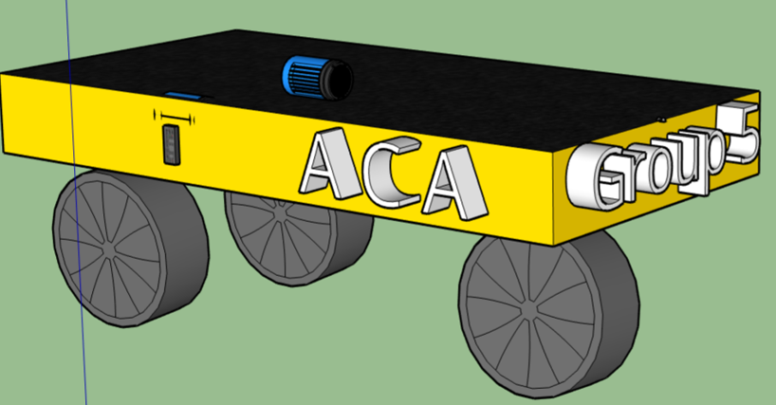

Figure 60 Assembly Model

The platform implementation of our model design was vital part of our project. We have to keep certain things in our mind while designing the model such as it can hold a specific wait and the load will stay stable while in motion. The platform will be made of steel. We have different ideas in our mind when we design the platform. First idea to have four wheel and the second idea to have three wheels installed in the platform. We picked the three-wheel platform idea because of the turning mechanism. In order to build the platform, we will need all the mechanical parts the wheels with standard rubber coating to provide traction for easy navigation, but they have to be at least 6 inches. The ball bearing swivel We need additional parts to build it which are given below.

PARTS:

* 6” Heavy Duty Wheels (2pcs)
* 4” Heavy Duty Wheel, (1pcs)
* 12” Aluminum Channel (1pcs)
* Hub Adaptor D (2pcs)
* 6mm Bore Set Screw Hubs, (2pcs)
* 1/4” x 2.25 D-shaft (1pcs)
* 1/4” Collar (2pcs)
* 1/4” ID x 1/2” OD Flanged Ball Bearings (2pcs)
* Swivel Hub (1pcs)
* 45 Degree Channel Bracket (1pcs)
* Clamping Aluminum Motor Mounts (2pcs)
* Aluminum Hub Spacers (1” thick) (1pcs)
* 1/4” Shafting & Tubing Spacers (1pcs)
* 1/4” x 6-32 Socket Head Screws (25pk),
* 1/2” x 6-32 Socket Head Screws (25pk),
* 3/8” x 6-32 Socket Head Screws (25pk),
* 1/4” Bore Set Screw Hub (1pcs)

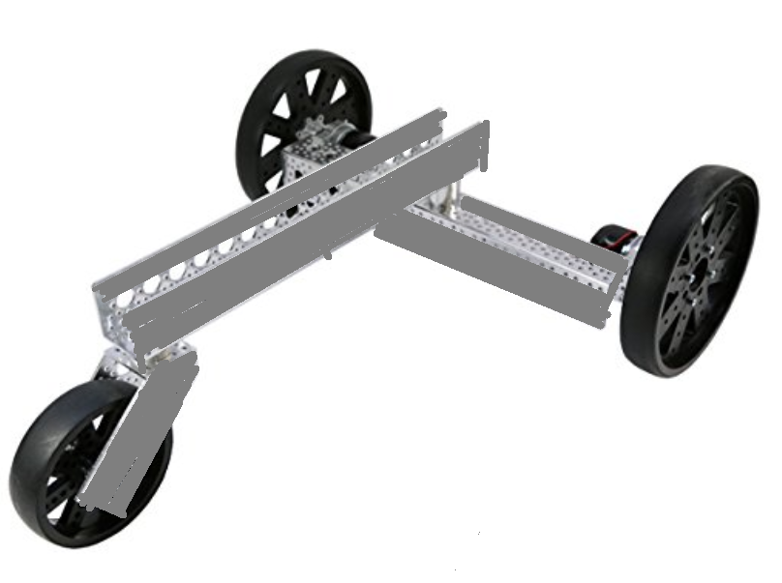

Figure 61 # # Assembly Base

Once the platform is done then we will be making a square wooden model which will be attached to the platform. we have to make sure that the ACA (Autonomous carriers assistant) is stable and safe therefore, we will hook up sensor on three sides on the wooden model, which is front, right, and left for collision avoidance.

# Wheel

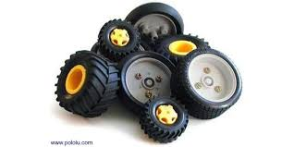

Figure 62 Different Types of Wheels

Wheels came about in an era of a primitive, caveman-level technology. Still, they are so ingenious that it took until the Bronze Age circa 3500 B.C. for someone to invent them. During that time humans were already casting metal alloys, constructing canals and sailboats, and even designing complex musical instruments such as harps. The wheel alone is not that impressive but add an axle and a platform and you change the course of history. Whoever invented it must have had a difficult time coming up with and implementing the wheel and axle concept. Luckily for human civilization it was a success and its rapid widespread has allow our civilization to take that concept and roll with it.

When someone usually thinks of wheel they think of transportation. Wagons, carriages, cars trucks, but the wheel has many applications from mills to pottery and in engineering gears. The wheel and axle concept that allow a motor to function. Add a few gears and attach an actual wheel, axle and platform and now we have motored vehicle. The ACA is a motor ran vehicle that will carry stuff for you. But this motorized cart will be taken a step further by being able to run autonomously. By adding an MCU, Bluetooth and a lot of coding this can all be possible but none of it can happen unless we have wheels. Selecting the proper wheels is very important to the success of this project. We will take a closer look at different wheel designs for transport platforms.

# Wheel vs Continuous track

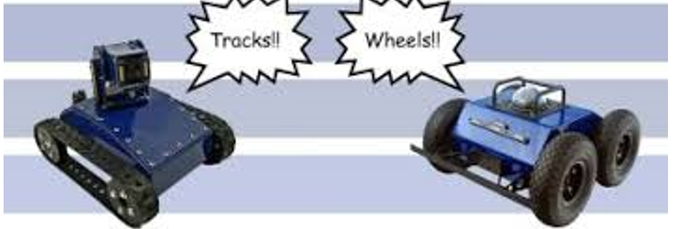

Figure 63 Wheels Vs Tracks

Choosing between wheels and track in robotics all depend on the application of the vehicle in question, each system provides certain features and performances. Traction is one important aspect to consider when making your chose. Tracks provide better traction than wheels. If you want to use less ground pressure, you should choose the tracks. Tracks have lower ground pressure than wheels and perform better on soft surfaces like sand and snow. Tires can be made larger to be better on soft surface but there is a limit to their performance. Wheels have a significant advantage in steering compared to tracks, and this can be translated into a good maneuverability for the wheels.

Other advantages wheels have over tracks include cost as wheels are cheaper than track and required less complicated suspension. Compared to tracks wheels can provide more speed with the need for less torque to move from a stationary position. Wheels are lighter in weight and a much simpler design with less moving parts. Tracks have more weight and are more complex leaving more room for something to go wrong. Tracks have shorter life span and require more repairs on average.

On the other hand, tracks have some advantages over wheels. depending on the terrain, a robot needs to pass small or large obstacles. For a wheel to get over a vertical obstacle, it must be at least twice as tall as the vertical obstacle. With continuous tracks bands of treads can even ascend and descend stairs, drive over obstacles or even cross ditches. These advantages are why tanks were made with tracks and not wheels. Compared to wheels trucks have more power efficiency due to high performance and traction system. The traction can be high even on wet concrete or snow and ice. A vehicle with continuous track can also support more weight which would be an advantage in this project allow for more weight to be added to the cart.

# One-wheel Concept

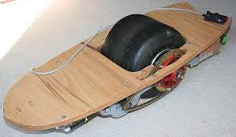

Figure 64 One Wheel Concept

The one-wheel design has risen in popularity in the last few years. The smartphone has made it easier to source gyroscopes and accelerometer giving us the monowheel of one-wheel board. This design would be very difficult to implement for this project given the time and money constraints. Although it would be very impressive to see a package being balance and following someone around, there is a more efficient form of wheel design that we can incorporate.

# Two wheels Concept

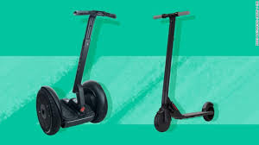

Figure 65 Two wheels Concept

Two-wheeled designs are simple, they have their wheels parallel to each other and has a platform I between. They are called dicycles, or one wheel in front of the other. The majority of these designs come with at least two sensors. The tilt sensor is used to determine tilt angle & wheel encoders keep track of the position of the platform of the robot. Two-wheel robots are extremely popular nowadays due to its efficient design. The Segway and others like it have made it a fun and efficient form of transport. All you need is a couple of motors & two wheels to move around, but they also have their own drawbacks. Two-wheeled robots are hard to balance. They use two wheels, so they need to keep moving to maintain its upright position. For better stability the power source is usually placed directly under the platform between the wheels.

# Three Wheels Concept

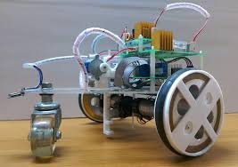

Figure 66 Three Wheels Concept

Many robots are designed with 3 wheels, 2 motors & 2-speed controllers. The three-wheel design allow for quick movements. They are easily controlled and have the ability to spin on the spot or turn around in small places. These features are an advantage in crowded place and is also good when trying to avoid obstacles and collisions. These features make the 3 wheeled system a good contender for this project. There are of two types of three wheeled robotics based on the steering system used. The first type comes with two wheels that are separately powered and the third wheel is free rotating purely for balance. The second type is designed with two wheels that are powered by the same source and a different source for the third wheel. The direction of the robot can be altered by changing the relative rate at which the two powered wheels are rotating. If the two wheels have the same rate of rotation and the same direction it will go straight. The center of gravity has to lay inside the triangle formed by the three wheels. If too much weight is put outside the triangle to the side of the free rotating wheel, the robot will tip over.

# Four wheels Concept

Four wheels are a bit of a norm for transportation nowadays with cars. For this project the question would be what steering method would be used for a four- wheel design. A four-wheel drive cart can have 2 pairs of powered wheels. Each pair can turn in the same direction. One disadvantage is If the pairs do not run at the same speed the robot will slow and will not be able to drive very straight. A good design will have to incorporate some form of car-like steering. Differential Steering for example is a method that allows the cart to turn in the same way the car does. There is also Crab Steering which allows a four-wheel drive vehicle to translate at an angle horizontally. With this method wheels can all turn in for point turns. Of course, the complexity involved in the design increases. This design would require that all wheel be actuated to spin and turn with up to 8 motors. Although it could be accomplished with less than eight motors. Another downside is that it can be unstable on hills.

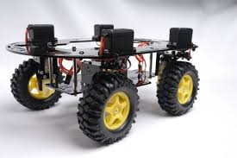

Figure 67 Four Wheels Concept

Independent all wheel steering is another option. This style of transport provides lots of flexibility for motion. A downside to this choice is the complexity of mechanism and large number of motors as each wheel would have its own motor. This would need more coordination for turns and avoiding collisions. That means more coding and more room for error.

# Wheel Diameter

The wheels main function to for mobility and the right wheel is very important and care should be taken to choose the right one for each specific application of the motorized vehicle. A tank has track so that is can navigate over obstacles with more ease. A race car’s wheels are made to have the maximum traction to accelerate and maintain speed. One aspect of selection in regard to the right wheel is it size. The right size will with give this project the maximum efficiency to carry out its application of being able to carry a consumer’s goods or belonging. The Two main equations that need to be considered are:

Velocity = angular velocity (of the wheel) x radius (of the wheel)

This means that both the radius of the wheel and the angular speed at which it is turning will affect the forward velocity. The second equation to be considered is:

force (exerted by the wheel on the surface) = torque (of the motor) / radius (of the wheel)

For a wheeled cart to move or climb an incline the wheel exerts a horizontal force on the surface. If we need to exert a high force due to the cart having more weight, then we need to increase either the torque or decrease the radius of the wheel. From a marketing perspective increasing the torque usually increases the cost of motor and increasing the radius usually means an increasing the weight of the wheel which will require more torque. This in turn will also reducing the maximum speed. Depending on the application having a very small wheel diameter may not allow us to implant our target application of the cart.

# Different Tread Types

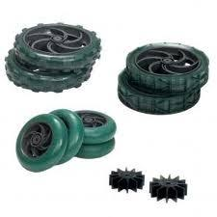

Figure 68 Different Treads

Having the right tread or grip on the wheel is also an important feature to consider for the wheels. Getting the maximum contact area with the terrain that the cart is traveling will affect it speed and ability to maneuver. If the cart will be travelling on a ceramic or wood floor, a flat rubber tire will provide the maximum grip because both surfaces are very flat. If the cart must maneuver on carpet, then having wheels with small tread that is not too deep would be more effective. Now if we want the cart to go through deep mud and dirt, we should choose a tire with deep grooves to scoop the mud away to move forward.

Using the wrong tread for can have negative affect on performance. For instance, using a wheel with deep tread on a flat surface will result in less traction because there will be less surface area on the wheel that will be in contact with surface of the floor. The cart will have problem making quick moves which are essential to this project as we want to avoid collision. Let also consider the deep mud scenario again. If we use a flat wheel in deep mud there will be a lot of contact between surfaces, but this will result in the tire spin in place and render the cart useless for our purposes. The wheel of the ACA will have to be balanced so that they can travel over a wide variety of surface both indoor and outdoor. The ACA will need to travel on flat surfaces as well as carpeted environments. It will need to travers outdoor environments as well.

# Wheel Selection

The Colson Wheel 5" x 1-1/4", 29/32" Bore is an excellent quality wheel at a good price. These wheels are constructed with a thermoplastic rubber tread and a polypropylene core which makes them light weight and durable while also providing excellent traction. This wheel is produced by Banebots.

The AndyMark HiGrip wheels provide superior traction for robot movement. HiGrip wheels feature a medium tread pattern providing maximum transfer of gearbox power to the ground. A robust core means these wheels are up to the challenge for high impact and speed applications. HiGrip wheels have a long life and provide good traction. The bolt pattern and bore of these wheels allow for convenient bearing placement and easy attachment to other motion parts such as sprockets and pulleys.

Nexus Robot is the manufacturer of the 145mm clear (transparent) Polyurethane wheels, which are designed for optimum performance and durability. The 145mm clear (transparent) PU wheels can handle the highest impacts and the PU will stay smooth for months of hard riding. Clear PU wheel with Polypropylene core.

Table: Wheel Comparison

|  |  |  |  |
| --- | --- | --- | --- |
| Brand | Nexus Robot | AndyMark | Banebots |
| model | Clear PU Wheel | HiGrip Wheel Rev II | Colson Wheel |
| Diameter | 5.7 inches | 6 inches | 5 inches |
| Width | 1.18 inches | 1 inch | 1.25 inches |
| Tread type | Flat | Medium tread | flat |
| Tread material | Polyurethane | Thermoplastic polyurethane | Thermoplastic Rubber |
| Price (4) | $9.04 | 24.00 | $12.12 |
| Load capacity | 110 lbs. | 90 lbs. | 100 lbs. |

Of the three choices of wheel for this project the The AndyMark wheel is the best choice. It comes down to a choice between Thermoplastic Rubber and Thermoplastic Polyurethane, both have their advantages, both offering unique properties to each other. It is common to find equipment which is used outdoors or on rough surfaces to be fitted with Rubber, while equipment which is used indoors on smooth floor surfaces are commonly fitted with Polyurethane. This primarily due to the flooring surface, which is an important consideration for this project. Thermoplastic Rubber provide higher grip, better traction and a softer ride over rough terrain compared to Polyurethane. Polyurethane provide higher Load Capacity, wear resistance and roll Resistance compared to Thermoplastic Rubber. For the purposes of this application the AndyMark wheel was chosen for its wider range of terrain and its durability. The diameter of the wheel also played a key role in the decision as the clamps for the motors stuck out on the bottom of the platform. The AndyMark provides enough clearance for the clamps, which makes it the best option for the ACA.

# Scale

Weighing scales have been around since ancient times and have become very high-tech devices. There are bathroom scales with Wi-Fi connection and ultra-precise devices used in research and industry. Modern scales are instantly able to provide very accurate measurements whether it be in your bathroom standing in front of a mirror or in the lab standing in front of some future breakthrough. This, however, was not always so.

# History of Scales

As trading developed in civilized societies during ancient times, merchants needed a way to assess the value of goods that could not simply be counted by each individual piece. For example, irregular-shaped gold nuggets and precious stones. The most ancient relics of a weighing scale were discovered in the Indus River valley, near present day’s Pakistan, around 2,000 B.C. Those first weighing scales were actually balances, using two plates attached to an overhead beam. Which was itself fixed on a central pole. The measurement was taken by putting the object measured on one plate and weight-setting stones on the other, until equilibrium was reached. Although this system was very accurate it pales in comparison to what we have now in modern times.

The weighing scale did not have any huge technological improvements until the industrial era. It was in the late 18th century that a new way to measure mass evolved that did not rely on the counter-weights system. Enter the spring scale, which was invented by Richard Salter, a British balance maker around 1770. The spring scale measures the pressure, or the tension exerted on a spring to calculate the weight of an object. Spring scales are still common today because they are very cheap to make. They are not quite as accurate as the electronic systems designed and perfected during the 20th century.

# Digital Scales

The modern scale relies on electronics to measure the weight the object or user. Using electrical resistances on deformable materials and running a current through them makes it is possible to detect variations in the conductivity of the resistances. Those variations are correlated to the amount of pressure exerted on the material and the weight of the person or the object on the scale is calculated. The most high-end body scales also act as impedance meters and are able to calculate the ratio of fat mass and lean mass in the body. Almost every household in America has some sort of digital scale. They are used in the kitchen measure ingredients for recipes, as well as in measuring food portions for those who are trying to lose weight. In the bathrooms they are used for those who want to monitor their weights. Just like there ancient predecessors the digital scale is useful to those in the jewelry and precious stones trade. There are even used to measure the weight of large trailers on the side of highways.

To discuss how a digital scale works we will discuss its main components. These components include the structure, a load cell, and signal conditioner. Let us begin with structure which is the physical outlook of the weighing machine and is the surface that bears the load. This physical structure is where all the electronic circuits behind the function of the scale as well as the load cell will be located usually hidden for design and aesthetic purposes. It is important to have the structure sit on the load cells especially when measuring heavier loads. An example is the digital scales used on truck weigh in stations and industries dealing with heavy loads. Many digital scales come with an LCD screen where the measurements of the weight obtained are displayed

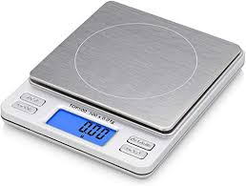

Figure 69 Scales

.

The Load Cell is a transducer which has the function converting the force exerted by the object of measurement into an electrical signal. Some digital weigh scales have more than one load cells. Small or low capacity scales have only one load cell. Floor or dormant digital weighing machines comprise of four cells. Those with high rating capacity such as truck scales may have between 4 to 8 load cells. Notably, the load cells determine the recommended capacity of the weigh scale. Even if the mechanical structure is strong enough to withstand higher loads, the load cell determines the rated capacity when considering accuracy of results.

The signal conditioner is the electronic component of the digital scale. The functions of this component are powering the load cell, receiving electrical signal by the load cell and converting it into intelligible numbers and is electronically referred to as the digital output. Modern digital scales are programmed to display the digital output in different units of measurements to fit the needs of users.

This embedded system that is called a digital scale works by the principle of the Wheatstone bridge. Inside the load cell is a set of strain gauges arranged like the resistors in a Wheatstone bridge. When a load is placed on these strain gauges, they compress. The level of compression corresponds to the amount of force exerted on the strain gauge. The compression changes the resistance of the gauges just like in a Wheatstone bridge. There will be a voltage output corresponding to that change from the stressed gauges. The output from the strain gauges is then converted from analog to digital format before it is fed into a microprocessor for further processing. The Microprocessor Control Unit is simply a microchip within the digital scale electrical circuit. The MCU of this embedded system analyzes the data and converts it into numbers that can be viewed in the weigh scale display. The results can be altered to get results in the desired unit of measurement. For this project it will be crucial to calibrate the equipment properly before use. Understanding the different components used in the digital scale enhances the chances of attaining accurate calibration for proper read outs of the objects or belongs of the consumer that will be weighed.

# Load Cell

For this project we considered interfacing a load cell with an Arduino board to get accurate weight measurements of the items being placed in the A.C.A. Arduino boards like the UNO have a 10-bit ADC, which means that the resolution of the analog input pins is 5V/1024 ≈ 4.9mV. For this reason, variations less than 4.9mV will not be recognized by the Arduino board without the appropriate amplification and filtering. Instruments like load cells provide small signal values and need to be amplified for processing, so without additional electronics, these sensors cannot and should not be connected directly to an Arduino's I/O pins. There are some options for interfacing a load cell with an Arduino. One is to Amplify the load cell's output voltage signal using a pre-packaged instrumentation amplifier IC to be processed by the Arduino's ADC). Another solution would be to use a High-resolution ADC which can be interfaced with the Arduino.

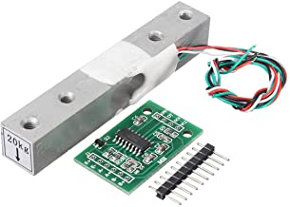

Figure 70 Load Cell

There are modules that can make this part of the project a lot easier. The HX711 module could have been used to amplify the signal from a 20Kg load cell and it can be interfaced with the Arduino Uno to display the weight on an LCD. For around $10.00 both the load cell and module can be purchased. This feature could be useful for airport setting or a commercial use, for example in a produce shopping store where items are charged by weight.

# Display

An electronic display is a device for presentation of images, text and video transmitted electronically, without producing a permanent record. Electronic visual displays include television sets, instrumentation and digital signage. Electronic visual displays present visual information according to the electrical input signal which can be analog or digital. They can work by emitting light and they are called active displays. Alternatively, they can work by modulating available light during the process of reflection or transmission, light modulators are called passive displays.

# Segments

Some displays can show only digits or alphanumeric characters. They are called segment displays, because they are composed of several segments that switch on and off to give appearance of desired glyph. The segments are usually single LEDs or liquid crystals. They are mostly used in digital watches and pocket calculators. There are several types he common segment displays are 7-segment which are the most common type, 9-segment, 14-segment and 16-segment displays. Some of the technologies of segment displays are Incandescent filaments, Vacuum fluorescent display, Cold cathode gas discharge, Light-emitting diode (LED), Organic Light-emitting diode (OLED), Liquid crystal display (LCD), and Quantum dot display (QLED).



For the purposes of this project we considered a segmented LCD. A segmented LCD is an ideal solution for products that require a cost-effective, low-power display option. This type of LCD panel is easily customizable to meet our display requirements. There are many advantages to using a segment display for the A.C.A. LCD solution. These include low cost compared to other LCD screen technology, segmented displays offer a low-cost custom solution for high volume applications. High contrast as by design, a segmented display screen showcases dynamic contrast between visible and hidden elements. Low power consumption The display type being considered requires minimal power making it ideal for battery-powered devices such as the A.C.A. Segmented LCDs and graphic displays are a popular choice among products such as thermostats, kitchen appliances, medical devices, industrial meters, and much more.

# LCD

Liquid crystals can modulate light. They do not emit light, but when oriented properly by and subject to an electric potential, they can be used to change the state of light passing through or reflecting from the liquid crystal depending on an applied electric potential. On the most basic level, most LCDs change the polarization state of light passing through a layer of liquid crystal material. The geometry of that layer is controlled between boundary conditions and an applied electric field. Usually, for this type of LCD, nematic liquid crystals are used with special coatings applied to the rear and front substrates. The coatings serve to create the boundary conditions and to apply the required electric field. On the outside of the LCD cell, optical films and polarizer films are attached. They translate the change in polarization of the light into a bright and dark contrast. The display structure gets assembled in such a way that zero applied field gives one extreme brightness state and fully applied field results in the other extreme. An intermediate field creates an intermediate brightness level. The combination of these allows for many different applications from a basic calculator to a high definition television. LCD technology has been around for many years and has help advance other forms of technology like computer and smart phone. Although there are newer technologies on the horizon LCD have made their place and will continue to be used for many years to come.

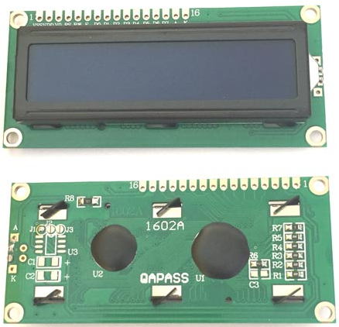

Figure 71 LCD 1602 A

The LCD1602A, or 1602 character-type liquid crystal display, is a kind of dot matrix module to show letters, numbers, and characters. It is composed of 5x8 dot matrix positions; each position can display one character. There is a dot pitch between two characters and a space between lines separating characters and lines. The model 1602 refers to its ability of displaying 2 lines of 16 characters. Each character has 5×8=40 Pixels and for 32 Characters we will have 32×40 = 1280 Pixels.

The LCD should also be instructed about the position of the pixels. This is a difficult task, to handle all the instructions with the help of MCU. A solution to this is an Interface IC like HD44780, which is mounted on the backside of the LCD Module itself. The function of this interface IC is to get the commands and data from the MCU and process them to display meaningful information onto our LCD Screen.

The LCD1602A has parallel ports that control several pins at the same time. LCD1602 can be categorized into eight-port and four-port connections. If the eight-port connection is used, then more digital ports will be occupied on the Arduino Uno board. To have more connection available for more sensors, the four-port connection should be used here for better application. This module is a basic staple in the electronics community. There are many brands available at very low cost.

# OLED

Organic Light Emitting Diodes or OLED is a flat light emitting technology that is made by placing a series of organic thin films between two conductors. When electricity is applied, light is emitted. OLEDs are organic because they are made from carbon and hydrogen. It has nothing to do with organic food or farming. With that said OLEDs are very efficient and do not contain any bad metals. In the spirit of organic farming OLED’s are a real green technology.

OLEDs do not require a backlight which allows them to be thinner and more efficient than LCD displays, which require a backlight to function. There is more to the OLED than being thinner and more efficient. They provide much better-quality display and they can also be made transparent, flexible, foldable and even be rolled up and stretchable in the future. This technology will usher in a new future for displaying abilities.

OLED and LCD are often used in DIY project. OLED have certain advantages over LCD one of which is improved image quality. Improvements with better contrast, higher brightness, fuller viewing angle, a wider color range and much faster refresh rates made it a strong contender for this project. The advantages continue with lower power consumption. It also has a simpler design that enables ultra-thin, flexible, foldable, and transparent displays. In terms of durability the OLED wins again due to them being very durable and can operate in a broader range of temperature.

All these advantages are due to the technology that goes into this display format. Let us take a look at the engineering behind this wonderful futuristic technology. The main component in an OLED display is the OLED emitter which is an organic carbon-based material that emits light when electricity is applied. The basic structure of an OLED is an emissive layer sandwiched between a cathode which injects electrons and an anode which removes electrons. Modern OLED devices use many more layers to make them more efficient and durable, but the basic functionality remains the same. An OLED panel itself is made from a substrate, backplane that house the electronics, the driver, front plane which contain the organic materials and electrodes and an encapsulation layer. OLEDs are very sensitive to oxygen and moisture and so the encapsulation layer is critical.

The substrate and backplane of an OLED display are like those of an LCD display, but the front plane deposition is unique to OLEDs. There are several ways to deposit and pattern the organic layers. Currently most OLED displays are made using vacuum evaporation, using a Shadow Mask, Fine Metal Mask (FMM) to create the pattern. This is a relatively simple method, but it is inefficient causing a lot of material to be wasted and very difficult to scale up to large substrates. Some OLED materials are soluble, and these can be deposited using printing methods like ink-jet printing. OLED makers hope that ink-jet printing may be a scalable, efficient and cheap way to deposit OLEDs

When it comes to OLED there are two distinct methods of driving the OLED display. These methods are AMOLED and PMOLED. A Passive-Matrix OLED or PMOLED usually has a maximum resolution around 128x128 which limits its size. This make it cheaper and easier which is why a lot of DYI project are made with them and they usually have very small displays. When compared to an Active-Matrix OLED or AMOLED the price and difficulty go up. An AMOLED uses an active-matrix TFT array and storage capacitors. While these displays are more efficient and can be made large, they are also more complicated to make. PMOLED displays are used in small devices or secondary displays while AMOLEDs are used in smartphones, tablets and TVs.

An OLED that was considered for this project is the Liobaba OLED Display Module. This is a 2.42-inch OLED display module of 128x64 resolution in which the emissive electroluminescent layer is a film of organic compound that emits light in response to an electric current. Working without backlight, the OLED display module could give out light by itself. In low ambient light conditions such as a dark room, an OLED screen can achieve a higher contrast ratio than an LCD. OLED display module also has a much faster response time than an LCD. The display with small dimension is suitable for our purposes of display time battery power and others feature like letting the consumer know they are connected with the A.C.A.

# TFT

TFT is a type of LCD with a thin film transistor attached to each pixel. All computer LCD screens are TFT since early 2000, older ones had slower response times and poor color. It must be manufactured out of glass. TFT displays or thin film transistor displays utilize simple chemical and electrical properties to create a visible image on a screen. Utilizing an electrical charge that causes the liquid crystals to change their molecular structure allowing various wavelengths of backlight to pass-through much like a regular LCD. The active matrix of the TFT display is in constant flux and changes rapidly depending upon the incoming signal from the control device. The display panel uses several layers of filters sandwiched between two glass panels. Polarizer filters, color filters and alignment layers determine exactly how much light is allowed to pass and which colors are created. The TFT layer controls light flows a color filter displays the color and a top layer houses your visible screen. The pixels of TFT displays are determined by the underlying density of the color matrix and TFT layout. The more pixels the higher detail is available. Available screen size, power consumption needs, and product needs define the TFT displays for this project. Standard TFT displays utilize a back-light of white bright light to generate the picture. Newer panels utilize LED or light emitting diodes to generate their light and therefore utilize less power and require less depth by design. The Geekcreit 3.5 Inch TFT Color Display Screen Module with 320 X 480 resolution was considered for this project.

# Display selection

|  |  |  |  |
| --- | --- | --- | --- |
| Brand | Sunfounder | Liobaba | Geekcreit |
| Type | LCD | OLED | TFT |
| Cost | 8.99 | 22.49 | $8.49 |
| Dimensions | 2.5 inches | 2.42 inches | 3.5 |
| Power consumption | Low | Low/Medium | High |
| Resolution | 32x40 | 128x64 | 320x480 |

For this project the LCD 1602 would have been a great choice, due to its flexibility and that we only need to display basic features, but a display was not implemented in the final design of the project

# Charge Controller

Charge controller or what we called also charge regulator or battery regulator.it is connected to all power system that charge batteries, and that either with photovoltaic, wind, fuel or utility grid. The used of this advice is to limit or control the rate of the current that is adding up or losing from the batteries that is using in the devices. The charge controller it prevents overcharging that will protect the batteries and keeping it at 100%, that will protect the batteries of reducing performance, life reduce, and safety risk.

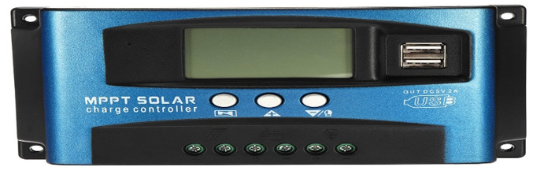

Figure 72 MPPT Charge Controller

There are different types of charge controller that we will explain or defined some of them.

# PWM Pulse Width Modulation

PWM is stand for Pulse Width Modulation. PWM charge controller so the current coming from the solar panel to the battery condition and reaches the regulation set point. The PWM is slow and reduces the charging current to the battery to avoid heating and the overcharge yet charging continues to return the maximum amount of energy to the battery in the shortest time. The voltage of the array will be pulled down to near that of the battery.

* The PWM has advantages:
* Higher charging efficiency
* Longer battery life
* Reduced battery over heating
* Minimizes stress on the battery
* Ability to do sulfates a battery

# RENOGY 12V Charge Controller

This is a waterproof charge controller which is suitable for 12V off-grid applications. It can charge up to 7 different batteries which is way more than our demand. It has an efficient special 5-stage battery charging algorithm which ensures the batteries longevity. The key features of this controller are given below.

* high efficiency and smart PWM technology
* 7 Battery Type Compatible – Lithium-ion, LiFePO4, LTO, Gel, AGM, Flooded, and CACAium
* Easy to read error codes and operating information due to backlit LCD displaying system
* Waterproof design, suitable for indoor or outdoor use.
* 5 Stage PWM charging: Soft-Start, Bulk, Absorption. Float, and Equalization
* Protection against reverse polarity and battery connection, reverse current from battery to solar panel protection at night, over-temperature, and over-voltage

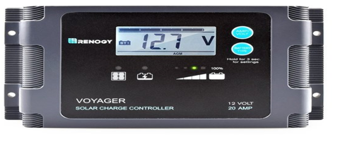

Figure 73 Voyager Charge Controller

# Dual Battery PWM:

This dual battery PMW is capable to handle to batteries with its advanced PWM charging technology. It also gives a battery protection feature, which means a battery will be protected from over-charging or discharging. This controller Is design to accommodate 12/24 V auto recognition. This controller is constructed for off-grid applications supporting 12V deep cycle different batteries such as sealed lead acid, gel, and flooded. The key features of this design are given below.

* Dual battery charging
* 12V / 24V auto recognition
* Micro controller digital accuracy
* Different batteries option such as Sealed, Gel, and Flooded
* Highly efficient Pulse Width Modulation charging
* Expand the battery life period
* Adjust the charging and discharging parameters automatically based on temperature compensation
* Short circuit protection and Battery reverse polarity protection

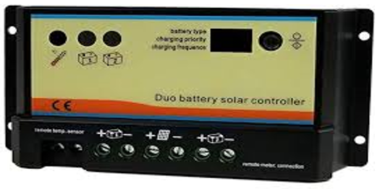

Figure 74 Dual PWM Charge Controller

# PCB Implementation

# Eagle

Eagle program is a software that applicable to build schematic capture, printed circuit board PCB. The Eagle is stands for Easily applicable Graphical Layout Editor. We are using eagle software because it contains a schematic editor to design circuit. this software is available for free to student. Is available in two version standard and premium. The table below it shows what is the different between standard and premium

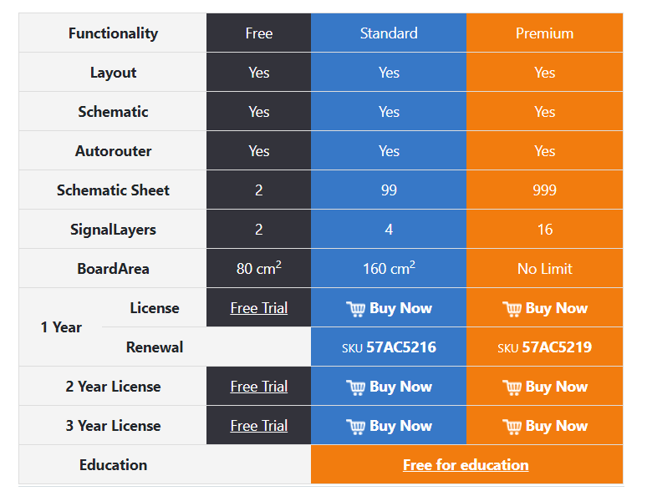

# Prototype PCB

PCB (Printed circuit board) is the most heard name but may also be called "printed wiring boards" or "printed wiring cards". Before the arrival of the PCB circuits were built through a laborious process of point-to-point wiring. This conduct to frequent lack of success at wire junctions and short circuits when wire insulation began to life.

this schematic will contain the motors, ultrasonic sensors, Bluetooth, controller, motor controller and magnetometer. The schematic will be utilized to print the PCB. We will think about to take some component from the Arduino uno R3 that we will not use to not get complicated. The Autodesk Eagle Software is a program that we will use to design our PCB. The figure below shows the eagle CAD schematic that we design.

In this design we did not decide for this project if we are going to use single side PCB or double PCB because we still need to put other part and also check if the PCB is working.

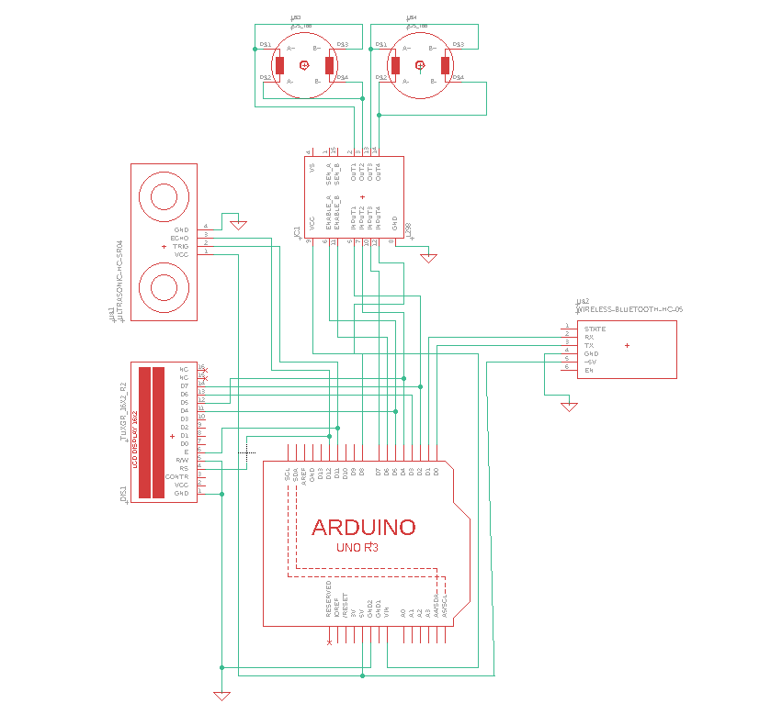

Figure 75 PCB Schematic

# PCB’s First Design

The PCB that we design is the first draft that would be utilized in order to create a PCB and we can modify this to get better results later. The PCB design below is the first drift of the design. This design will change and update for Senior Design two. We need to add more components such as the voltage regulator, battery, and other devices that we will have in the second and final draft. Using the EAGLE software is one of the programs that is use from most of the student to design the PCB. The cost to build the PCB draft is between the range of $80 and $500.

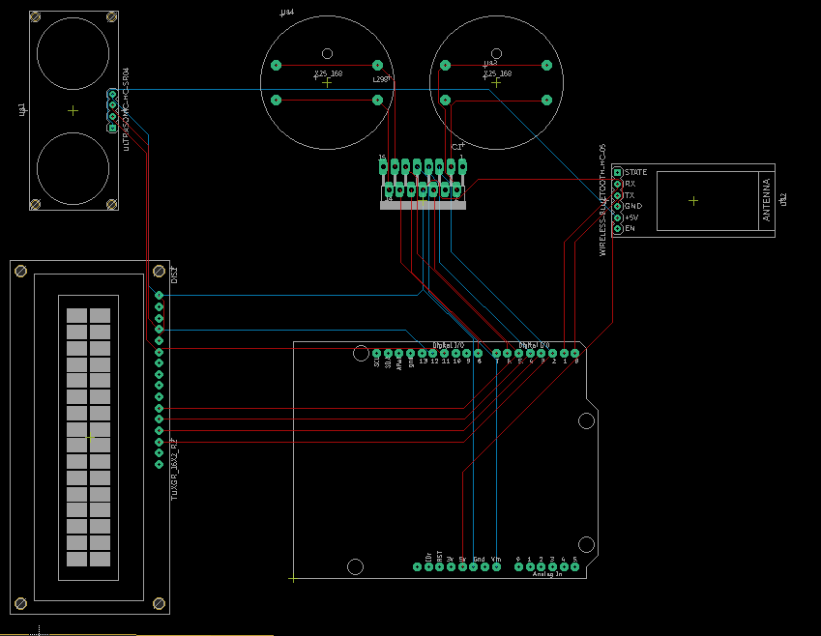

Figure 76 PCB Prototype

# Second PCB Design

For the Print Circuit Board (PCB) we used Eagle from the beginning of the project. In the first design for senior design 1 the PCB was not finished during the semester. During the senior design 2 we made some changes and added some component to make the Print Circuit board (PCB) works. So during this situation that the whole world live with COVD19 many companies were closed and some of them start to open in Jun 20.so we had a lot problem about the ordering and shipping that made us waiting to get all the components and started working in our project. The total cost of the PCB and all the components that were used in PCB was around almost $200. Our first PCB was not successful we made some short circuit and also, we got some element that were wrong. We built a new design for the PCB and fix all the issues that we had in the first try. we received the second one in 07/14/2020 it took us almost 2 weeks to receives it. The picture below shows the PCB schematic. The PCB is composed of ATmega328p-pu, linear regulator with LM7805 that will give us 5V and 1A at the output pin , we have input information from the ultrasonic sensors, Bluetooth HC-05, GPS ,compose, the output that we have is to the L289 motor driver.

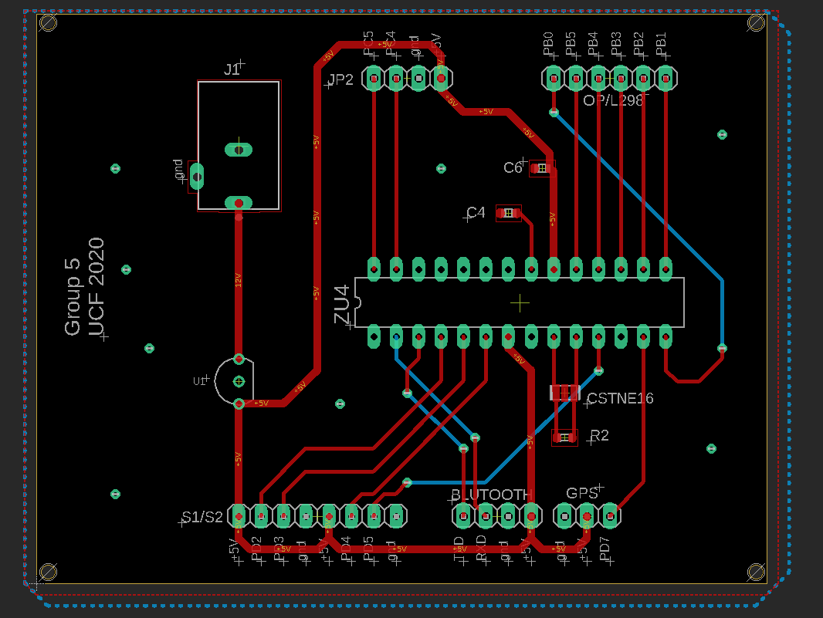

# Standards

There are literally millions of engineering products manufactured worldwide. From needles to aircrafts, these products range from rudimentary to extremely sophisticated. However, there is one thing common in all manufactured products and that is they all go through some sort of engineering process to get to their final shape.

Even for a single product, there are dozens of different processes and methods which can be employed for its manufacturing. Hence, the manufacturing process of same product differs from manufacturer to manufacturer. Apart from that the quality of used materials and components has a direct impact on the quality of the finished product.

Due to all the aforementioned issues, it is very important that the buyer gets the products which are of high quality and are safe to operate. This is the responsibility of the government authorities and regulatory bodies to devise the rules and regulations for the products offered to the end consumers.

Standards are the primary guidelines and regulations which bind the manufacturers to produce the products which meet certain quality and safety criterion. Standards are basically published documents which specify the procedures and methods to ensure the reliability, efficiency, quality, and safety of materials, methods, and services offered to the end consumers. Standards also deal with protocols which ensure the functionality, compatibility, support, and interoperability of a given product of service.

There are several key benefits of using standards. Some of the salient ones are listed as following:

1. They provide an effective means to measure and evaluate performance

2. They ensure the interoperability of sub-systems manufactured by different companies

3. The protect the interest of end users in regard to product safety, quality, and reliability

4. They protect the end users against potential hazards and risks caused by poorly designed products

5. They keep check on the various types of emissions and ensure the suitability of the product for the immediate environment

Without standards, there is no proper and universal way of measuring the effectiveness of a process or a method. In absence of standards, different manufacturers would use different criterion for the measurement of performance. Hence, standards bring all the manufacturers on the same page and provide a universal common language for performance evaluation. This brings simplicity and systemization to the processes which benefit all the stakeholders including manufacturer, regulator, and end user.

Within the industries and manufacturing setups, one of the biggest challenges has been the interoperability of equipment. Before the standardization of protocols for industrial equipment, each manufacturer used to have their own set of drivers for their products which made it impossible for that product to be compatible with the systems of other manufacturers. One prime example of this problem were the PLCs which are the most widely used type of industrial controllers and are found in virtually almost all the industries on the planet. There are several major manufacturers of PLCs and in the past their PLCs would not be able to communicate with the motor drives or HMIs (human machine interfaces) from the other manufacturers. This posed a great challenge and distress for the engineers. However, with the standardization of industrial communication protocols such as PROFIBUS, MODBUS, and RS-485, the interoperability of equipment has become much easier. Today, integrating a sub-system from one manufacturer with the system of another manufacturer is not as painstaking as it used to be in the past. Hence, standardization of protocols is one of the greatest benefits of standards.

This is a known fact that an overwhelmingly large portion of end users do not possess the proper technical knowledge in order to assess the quality of a product. In the absence of proper rules, regulations, and standards it is imperative that the manufacturers would produce low quality and poorly designed products in order to reduce costs and hence would deceive the users with low quality products. Such substandard products would not only cause financial loss to the consumers but would also jeopardize their health and safety. With the advent of standards, the product manufacturers and service providers are bound to provide such products and services to the consumers which meet a certain level of quality and safety standards. The protection of interest of the consumer has been the mainstay for the development of standards.

Machines and devices always have some degree of risk and hazard attached to them. There are many different types of hazards such as electrical shock hazards, fire hazards, corrosion hazards, explosive hazards, and mechanical hazards. Therefore, it is the responsibility of the product manufacturer to design the product in such a way which ensures the maximum safety of the users and operators. Standards are particularly strict in this domain and ensure the compliance of manufactured products with the safety standards. Negligence in this regard might result into fines and penalties.

Today one of the biggest challenges associated with modern machines and industrial processes is that of environmental degradation. The rampant use of fossil fuels, rare earth metals, toxic materials and plastics pose a great challenge for the ecosystem. The heavy use of these materials has caused the problems of global warming, climate change and air pollution. Hence, the standards also need to evolve in the face of changing requirements and incorporate environment related guidelines. There are many standards which are now related to the greenhouse gas emissions and carbon footprints of the certain products. Keeping these parameters in check and limiting their quantity definitely has a positive impact on the environment. In addition to that electrical/electronic devices also need to comply with EMI/EMC related standards which limit the level of electromagnetic interference which a device is allowed to generate.

The autonomous luggage carrier platform falls under the category of mechatronic systems. Mechatronics is an interdisciplinary branch of engineering which deals with the development of systems which consist of electrical, electronic, mechanical, and software components. Due to this complex nature of the mechatronic systems, there are a number of standards which need to be followed to ensure the quality and safety of the ACA robot platform.

Some of the major standardization organizations include ISO (International Standards Organization), IEEE (Institute of Electrical and Electronic Engineers), ANSI (American National Standards Institute) and OSHA (Occupational Safety and Health Administration).

There are certain critical components in the ACA project which can pose a potential risk to the users or people in the immediate environment. These components include:

1. Batteries

2. Motors

3. Electrical wiring

4. Mechanical platform

The ACA is a mobile platform and therefore requires batteries for its operation. Since, the commercial version of the product is expected to be substantially large in size therefore, bigger batteries are needed. Almost all the major battery types pose one type of hazard or another. Li-ion batteries, for example, are explosive when poorly handled. The lead acid batteries contain toxic lead and also are corrosive. Hence, proper guidelines and standards were followed for the installation and operation of batteries in the ACA project.

One of the most crucial components of any robotic system are the motors. All the movements of the robot are dependent on the use of motors. There are also a number of hazards attached to the motors. Motors consist of moving parts and therefore exposed motor shafts can pose health related challenges for the operators. Additionally, the motor driver circuits make use of high frequency DC-DC converters which create electrical noise and EMI. The interference signal can interfere with sensitive electronic equipment in the environment and cause malfunction of that equipment. This becomes even more critical in the environments such as hospitals, airports, and industries. The malfunction of sensitive equipment can lead to many different hazards and risks. Therefore, the mechanical motion as well as the EMI emission of the motors and their circuit must be kept in check. The design of the motor control system was carried out according to the relevant standards.

Another challenge associated with electrical system of the ACA robot is that of electrical wiring. Faulty electrical wiring can lead to device malfunctions and fire hazards. Therefore, the electrical wiring of the robot was carried out properly in line with the appropriate standards and guidelines. In addition to that, the mechanical motions of the robot were also carefully designed so that it does not pose any harm to the people in its vicinity. A robot colliding with a human can cause severe injuries and this possibility was eliminated and ensured that it is safe at all costs.

# IPC PCB Standards

The IPC standers in Printed Circuit Boards are highly important and that when a manufacture is producing the electronic printed circuit boards. IPC stand for Institute for Printed Circuits that is association that is related to the electronics industries. The standards include this requirement:

• Material

• Board configurations

• Pc card from factors

• Improved product Quality and reliability

Some of the standers that is published by IPC, there is to many I am just going include some of them. This two is for Design specifications: IPC-2612 Sectional Requirements for Electronic Diagramming Documentation (Schematic and Logic Descriptions) and IPC-2221 Generic Standard on Printed Board Design. The second one is the Material specification: IPC-FC-234 Pressure Sensitive Adhesives Assembly Guidelines for Single-Sided and Double-Sided Flexible Printed Circuits, or IPC-4203 Adhesive Coated Dielectric Films for Use as Cover Sheets for Flexible Printed Circuitry and Flexible Adhesive Bonding Films. For the performance and inspection documents: IPC-4203 Adhesive Coated Dielectric Films for Use as Cover Sheets for Flexible Printed Circuitry and Flexible Adhesive Bonding Films.

And IPC provide the types of PCB:

• Single sided one conductive layer

• Double side two conductive layer

• Multilayer rigid and flexible material and it has multiple conductive layers

These standers that IPC gives are very important and have to be followed and that because if achieve and help to build a PCB in good condition on the highest condition and quality.

# Soldering Standards

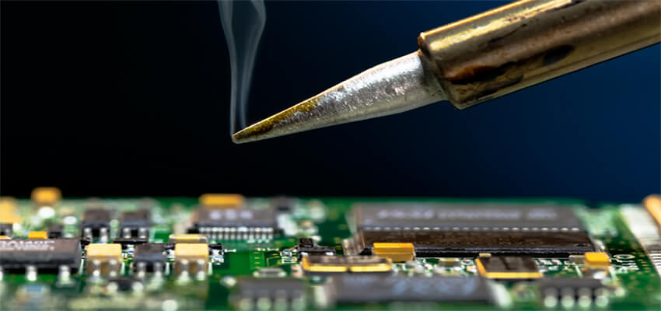

In the electronic Assembly standards is IPC J-STD-001 requirement for soldered electrical and electronic assemblies, and the IPC -A-610 which is acceptability of electronic assemblies. These standards are used as a document for the company to make sure that they are able to do the soldering in the good condition. Also, these standards provide the information about the material, and the method that is been used too, and it ensure the quality of soldering during the soldering. Is better to send the PCB and the component to a company that is professional to do soldering then do it by yourself because there is a high chance that will do bad soldering and that will make your circuit to not work.

# Project Constraints

# Design Constraints

Every product and service have a defined scope or area of operation. In other words, every product or service has a set of its limitations out of which is it is not suitable to operate. Understanding of these limitations is crucial for the safe and reliable function of that particular device.

The autonomous luggage carrier robot system also has its limitations and design constraints. The primary function of the ACA robot is to assist people in handling their luggage. Hence, one of the key factors in the design of this robot is the weight limit that this robot can handle. At present the ACA robot can carry a maximum weight of 30 pounds. Thus, if weight of more than 30 pounds is handed over to the robot then the operational reliability and safety of the robot becomes uncertain. Therefore, it is important that the robot is operated within its designed parameters.

Another design constraint for the ACA robot is the maximum speed. The robot needs to follow the user in order to reach the required destination. If the speed of the robot is too slow then it might lag behind the user and possibly loose contact. If the speed of the robot is too high, then it might have stability and braking issues. At higher speeds the collision hazard also becomes significantly higher. Therefore, it is important that the robot moves at a moderate speed which is in line with the speed of the human operator. This was one of the important design constraints in terms of safety. We kept all the aspect in mind and then designed the ACA.

The ACA robot is designed to be a general-purpose multi-role robotic platform which can assist the people with their luggage in a number of scenarios. However, it is a known fact that every sector has its own set of problems, limitations, and constraints. Hence, for every different application area, the robot must be checked for the compliance with the regulations of that particular environment. Some of the most common application areas for such robots are medical facilities, warehouses, military applications, and airports.

The ACA robot can prove to be extremely valuable in medical environments. They can help the doctors and paramedics in moving items from place to another. However, the medical facilities are filled with safety critical medical equipment. Medical devices can be very sensitive and therefore susceptible to interference and noise. Therefore, the robot must comply with the EMI and EMC standards for the medical facilities. The robot was extensively tested for compliance before being put into service in such environments.

Another major application area for ACA robot is the military applications. Military devices have a completely different set of standards as compared to medical facilities. Hence, the robot must be adapted to the military standards before deployment into military environments. The military devices are required to be tough and jagged. They must be able to withstand high pressure, shock, vibration, and heat. The components used in military applications tend to have higher thermal ratings so that they can operate at higher temperatures without burn-outs. Thus, the sub-systems and components of the ACA robot must be made to comply with military standards before putting it into military service.

One of the major industrial applications of the ACA robot is in the warehouses of industries and commercial businesses. These robots can assist the human workers in carrying their load from one place to another. The industrial requirements are very different from that of medical or military applications. In the industrial environments, safety is the primary concern. The robot must be designed in such a way that it keeps a safe distance from the human operators and avoids obstacles in the best possible way. Efficiency and productivity are also of extreme importance within industries therefore the weight carrying limit and operating speed of the robot must be properly optimized in order to maximize the productivity without compromising the safety and security.

# Financial constraints

Although the technical and design constraints are very important for the success of the project, the financial constraints are equally important. The success of a project very much depends on the cost control and financial viability of that project. Financial management is one of the most important areas of project management. The project managers must pay attention to various areas of costs and expenditures to complete the project successfully. The managers need to take in to account the original budget, approved budget, forecasted costs, and actual costs in order to create an efficient financial management plan.

The financial constraints of the project help us in comparing the planned performance to the actual performance. The creation of a comprehensive and realistic project budget is of extreme importance before the commencement of the project. Failure to develop a cost plan might lead to the project failure or closure due to unforeseen and unbearable costs. Also, it must be noted that no matter how carefully the project budget is planned, there are always overheads and unforeseen costs. However, the aim of effective budget planning is to minimize the volume of overheads.

Apart from the actual costs of materials and components, the timeline of the project also affects the project costs in a big way. If a project takes significantly longer time than the planned duration, then the cost overheads also increase. Therefore, the schedule planning goes hand in hand with financial planning. The slow progress of the project results into increased costs of rental equipment, labor costs, and opportunity costs.

In the ACA project, the major costs include the costs of components, materials and structures. The major components used in the project include motors, motor drivers, microcontroller board, cables, mechanical structures, sensors, and software packages. Although these costs constitute the majority of the project budget, the opportunity costs and cost overheads were not neglected. It is beneficial to include a percentage of the costs as the unforeseen expenses during the project budgeting phase.

# Safety constraints

Safety is one of the most important considerations in all types of machines. It becomes even more important in case of automatic machines. The devices which do not fulfill the safety requirements can prove to be dangerous for the operators and other humans in the vicinity of the machine.

Robots are perhaps the most sophisticated type of automatic machines. Since, last 2-3 decades robots have been serving in industries in various capacities and roles. The industrial robots are maintained in a very safe environment and they are enclosed in cells with limited access. However, despite all the safety and precautionary measures, a number of industrial accidents have happened due to the industrial robots. Hence, the lesson is that a system can never be 100% safe and secure. Nonetheless, continuous development of safety systems ensures that no undesirable events occur. Safety systems have evolved into an entire field of engineering within itself and modern industries employ specialized personnel whose sole task is to ensure the safety of the machines and processes.

When compared to industrial robots, the autonomous robots are much more sophisticated and complex. Most of the industrial robots are pre-programmed. However, an autonomous robot has to do path navigation and obstacle avoidance without any external help. This makes the challenge of safety even more complex in case of autonomous robots. With ergonomic design and smaller dimensions, the risk can be mitigated to some extent. However, this would be a hurdle for the creation of larger more useful autonomous robots. Unlike industrial robots, the autonomous robots are designed to mobile and interactive and hence, interact frequently with humans. Therefore, the safety considerations and measures in autonomous robots need to be taken much more seriously.

Since autonomous robotics is a nascent field and the research in this area is still going on, therefore, the availability of appropriate safety standards is scarce at the moment. The only safety standard available for the autonomous robots right now is the ANSI/RIA R15.06-2012 Industrial Robots and Robot Systems – Safety Requirements.

Currently efforts are being made towards the development of appropriate standards specific to the field of robotics. RIA (Robotic Industries Association) is working in cooperation with ANSI (American National Standards Institute) to develop relevant robotic safety standards.

The biggest safety concern in the ACA robot is the collision with humans and objects. Due to the substantial weight of the robot, the collision must result into injuries and financial loss. Hence, it is extremely important that the distance sensors and robot algorithms work as intended. All the sensors and the code logic must be extensively tested in order to ensure safe operation of the robot. The mechanical movement of the robot should also be constrained while interacting with humans. Safe operation of autonomous robots is the key in their adaption at larger scale.

Since, the primary function of the ACA robot is the carrying of luggage therefore the weight of the luggage is the primary factor affecting the safety rating of the robot. The weight limit of 75 pounds is selecting in consideration of the safety requirements. If the weight of the object is too large and the robot collides with a person then the chance of injury is very high. However, if the weight carrying limit is too low then the robot is virtually useless. Hence, a middle ground had to find a reasonable weight limit of 75 pounds was selected.

Another safety factor in the design of the ACA robot is the speed. If the robot speed is too high, then the chances of injury are too high upon collision. Therefore, just like the weight, a reasonable limit for the speed has to be determined for the ACA robot. If the speed is too low, then the robot might lag behind and loose contact. If it is too high, then the risk factor is enhanced.

Another safety risk in the project is the batteries. Batteries are charge storage devices and their charging needs to be carefully controlled using power electronic converters for safe operation. Improper charging of Lithium ion batteries can result into explosion and fire hazards. Excessive load currents and improper ventilation can cause battery overheating. This is also a hazardous situation which can initiate fires. Therefore, batteries in the ACA project are deemed safety critical components and must be handled accordingly. Proper cooling and ventilation of batteries must be ensured. Also, the charging and discharging of batteries should be done using efficient power electronic circuits.

# Environmental constraints

The structure of modern civilization is standing on the modern technologies without which the life in 21st century is hard to imagine. The driving engine of all these modern technologies is the energy. An overwhelming percentage of modern industries and machines run on fossil fuels. Apart from the fuels, the very existence of these machines requires a large number of sophisticated materials and resources.

The rampant use of fossil fuels and mining of earthly resources is causing great distress to the environment. From bikes and cars to ships and airplanes, all types of machines need fossil fuel for their operation. The combustion of fossil fuels results into emission of greenhouse gases which are causing global warming, climate change and air pollution.

One of the most important technologies of all is the electronics technology. The entire technological revolution has only happened due to the advancement in electronics and computer technology. The electronics devices make use of specialized plastics, resins, rare earth metals, and chemicals for their construction and assembling. The high mining and production rate of these materials will eventually lead to the scarcity of these materials. Also, many of these synthetic materials are not bio-degradable and therefore contaminate the environment. The improper recycling practices result in the ever-increasing problem of e-waste which is hard to handle.

The consumer led growth and the negative consumer behaviors are contributing to the amounts of e-waste generated annually. Devices which are perfectly functional are discarded only because the newer models are available. All of these factors are leading to the environmental disaster.

The modern society cannot afford to cut down the consumption of technology. However, with proper management and planning of resources, this problem can be curbed to a great extent. With effective recycling and reuse practices, the resources can be conserved. Also, the advent of renewable energy resources promises green and clean energy for the industries. The machines and processes are also made more energy efficient in order to lower the power consumption and the carbon footprint.

The ACA project does not use any type of fossil fuels and completely runs on clean electric power. This is a positive feature which is environmentally friendly. The batteries used in the project, however, pose some degree of environmental challenge as they contain toxic materials. However, with proper recycling strategy, the impact of this problem can be minimized. Other ACA components such as motors mostly consist of steel and copper which are very easy and profitable to recycle. Therefore, the recycling of motors is not an issue at the end of life cycle.

A significant portion of the ACA project consists of electronic circuits. These circuits consist of ICs and electronic components which make use of rare earth metals and other solid-state materials. These circuits can potentially become e-waste at the end of product life cycle. Hence, it is important that these circuits and components are reused and recycled in accordance with the appropriate standards and guidelines.

Apart from the materials used, the design of the project itself has a great impact on the power consumption and efficiency of the project. Therefore, the ACA project is designed in such a way that the sub-systems run on minimal possible power and conserve energy. This increases the efficiency and also reduces the operational costs.

# Social constraints

The autonomous robots designed to function in the environments inhabited by humans are bound to have social impacts. Such robots are designed to exist side by side with the humans within the society and therefore have an impact on the social structure.

One of the greatest social impacts of social autonomous robots is the enhancement of quality of life. With laborious jobs being taken over by the robots, the humans no longer have to do the tedious work and can dedicate their time to more productive things.

The primary motive behind the invention of any machine is to increase the comfort and convenience level. Hence, when the autonomous robots take over the tedious jobs or assist humans with their work, the quality of life gets improved.

However, the picture is not entirely green and there are growing concerns among the population regarding the increasing levels of automation and robotics. One of the greatest concerns is the loss of jobs. The concern is that when machines take over the humans’ jobs, people would have no work and hence no source of income. However, the history proves this concern to be wrong.

This fear has always been present whenever automation systems have been introduced in the industries. However, the time proves that with the advancement in technology, new job roles are being created which did not existed before. Hence, it is safe to say that more job opportunities will be created as the result of employment of robots and not the vice versa. This idea seems counter-intuitive however the data is in favor of this thesis.

With the creation of the new job roles for humans and robots, the existing social structure will also evolve accordingly. In this regard, the robots will have a great impact on the human society. Apart from the social impacts, robots also have their impact on business models, psychology, behaviors, and environment.

The social impact of the ACA project is expected to be very positive. The ACA robot is a collaborative robot which shares the burden of the humans and therefore the concern of job loss does not apply to this robot. This robot has extremely positive applications in the areas of medicine and industry. Hence, it is safe to say that the overall social impact of the ACA project is quite positive.

# Time constraint

Time is one of the most important factors in the development of any project. Along with finances, resources, and technology, time is the deciding factor in the failure or success of a project. Creation of timelines and schedules regarding various phases of the project is one of the most important activities in the project management.

The project scheduling provides a mechanism to the team member as to which tasks need to be done at what time. The allocation of timeframe and deadlines ensures the completion of project phases within the desired time period.

If the project timeline is not met and the project takes significantly longer time for completion, then there are financial consequences to that as well. Delay in project completion leads to overhead costs. These costs might determine the success or failure of the project.

For effective time management, the project management needs to develop list of activities, estimated time frames, project dependencies, and resource allocation plans. Without effective time management, resources cannot be used to their fullest and risk of project failure increases.

# Administration

# Marketing

The Autonomous Carrier Assistant (A.C.A) will be a motorized platform that will follow the user with collision detection, it will also be able to lead users to specific locations and have a scale to display how much weight it is carrying. This device’s demographic will be targeted towards elderly people and people with disabilities because we believe that the Autonomous Carrier Assistant would be the most beneficial towards that specific demographic. It would be able to assist that demographic the most because it would allow them to not worry about carrying any type of baggage which they would normally struggle with. Also, they would not have to push or pull any type of cart like they would in a store because the Autonomous Carrier Assistant follows them around wherever they go in the specified location that it is programmed to be in. The user would only have to be able to operate the mobile app that is designed to control the various functions that the Autonomous Carrier Assistant is made to complete. The Autonomous Carrier Assistant’s goal is to make sure that the user does need to not worry in the slightest about having to carry any possible baggage that they have with them.

There will be various locations that the Autonomous Carrier Assistant could function in. For example, it could be used in an Airport, a grocery store, or an outside market. ACA does not need to be limited to one location; it can be used for any type of location that involves people needing to have their baggage carried for them. The only limitations for the location and ACA are that the location needs to be able to have a good connection wirelessly because the user has to use a mobile app that connects to ACA. This type of location should not be hard to find considering most of today’s places use wireless connections with various devices. If it were to be used in a grocery store, then it would essentially serve the purpose as a grocery cart that would follow you around. It could also lead you to certain spots in the store using the lead mode feature that it will have. All the user would have to do is switch it to lead mode on the mobile app that they will have and also they would possibly be able to look up different food items if they ACA would be specified for a specific grocery store. Other locations like a garden store outside, it would be able to carry the plants that a customer is trying to buy, or it could lead a customer to where certain plants are in the store to buy. But overall, the Autonomous Carrier Assistant can easily be adapted to different locations depending on the quality of the wireless connections in the area.

The pricing of the Autonomous Carrier Assistant would possibly vary for how long the customer would be using it. It could be charged for how many minutes the customer uses it or maybe by the weight of the baggage that the ACA is carrying. The ACA would have to be reasonably priced so the cost of it does not outweigh what the customer is buying if the ACA is used inside of a store. The pricing would maybe be around 25 cents a minute and would be activated at the front of the store near a charging station. Overall, the pricing of the Autonomous Carrier Assistant is aiming towards being an affordable solution to those that require its services. The focus demographic group for the Autonomous Carrier Assistant is most likely the elderly or people that have. disabilities

# Marketing strategies

It requires a combination of multiple skill sets in order to start and run a successful business. An overwhelming percentage of the engineering activity conducted globally is driven by the primary motive of generating revenue.

Within engineering and technology business, it is not sufficient only to have a great product or an innovative solution. Without effective marketing, the target audience might remain unaware of the existence of the solution. A product or a solution only becomes successful when it is accepted and adopted by the target audience. Therefore, apart from the technical acumen, marketing is extremely vital for a technology business. In fact, marketing is essential for any type of business.

In the age of internet, apps, social media, and search engines, the traditional marketing methods are proving to be inadequate. More and more people are spending time with their smart phones and tablets instead of radio, newspapers and TV screens. Hence, with these social changes, the marketers are also aligning their methods in line with these latest technologies.

Following are some of the marketing strategies which can be prove beneficial for growing our ACA robotics business and to create user awareness amongst our target audience.

# Video content and YouTube

It is no hidden fact that video content is gaining more and more traction with each passing day. Right now, YouTube is the second biggest search engine in the world after Google. This depicts the scale of population which is using YouTube on a daily basis. Whether it is tutorials, DIY, music or entertainment, billions of people come on YouTube to watch video content. The engagement of video content is also far higher than text or image-based content. Therefore, YouTube is an excellent platform for promoting businesses and technology products.

When it comes to YouTube, there are two main methods which can be employed to market our solution. The first method is a free method which costs nothing. It simply entails producing excellent informational content about the product or service and uploading it on the YouTube. However, this method needs a lot of time and patience. Also, there is a great chance that your content might never reach the appropriate audience.

The second method is paid method which involves running ads on YouTube. In this way, your content can reach large number of specifically targeted audiences. The selection of either method depends on the available budget and funding.

# Facebook and SMM

Just like YouTube, Facebook is another internet giant and is the biggest social media platform in the world. According to recent stats, there are more than 2 billion active users on Facebook and the number is constantly growing. This huge audience opens up doors in terms of customer outreach and business development.

Just like YouTube, the Facebook marketing strategy can be free or paid depending on the marketing budget and funding. User awareness can be created by means of Facebook groups, Facebook business pages, and content sharing. The paid strategy revolves around ad campaigns which are one of the most effective in the current social media marketing paradigm. The ad campaigns can be highly targeted and optimized in order to reach the right audience.

# LinkedIn Marketing

LinkedIn is an excellent platform for professionals of all industries. The platform has a large number of developers, CEOs, CTOs, CFOs, and other professionals on board. Hence, this makes LinkedIn an ideal platform for marketing new startups and products. LinkedIn marketing and promotion strategy is excellent for B2B purposes. It can help new startups in expanding their network and increase their product outreach.

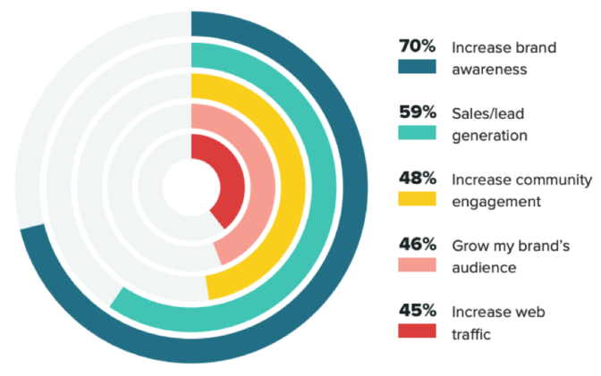

Figure 77: Goals of social media marketing

# Market requirements

Before the development of a product, service or a solution, it is very important to conduct the market research. Without conducting proper market research, it is impossible to assess the acceptability, adoption and success of a product. The primary purpose of market research is to assess and determine the market requirements.

Market research is a crucial component of overall marketing strategy and it informs us about the target audience which would be potentially interested in buying our solution. Another motive of market research is to evaluate the competition within a given market segment. If the market is saturated with similar solutions, then it becomes hard to compete in such a market. If the solution is very innovative and novel, then the user awareness and adoption might be a problem. Therefore, proper market research is necessary to assess the user requirements, market competition, market trends, risks, and adoptability. Market research is a complex process which involves many process steps. Following are some of the common steps involved in the market research process.

# Defining buyer person

The first step in market research is to define and understand the target audience. Buyer person can be defined as generalized representation of ideal customers. Some of the key elements of buyer person include:

1. Age
2. Gender
3. Location
4. Job title
5. Family size
6. Income
7. Pain points

# Persona engagement

The second step in market research is identifying the persons who actually fit the defined persona. This helps in identifying the traits, habits, and patterns of these customers. The engagement with ideal customers can be done in the following ways:

1. Focus groups
2. Online surveys
3. Individual interviews

# Preparation of research questions

Interviewing and surveying are primary methods used for conducting market research. Hence, in order to conduct efficient and effective survey, it is crucial to ask the right questions. Hence, the preparation of research question is of utmost importance. Open ended research questions are found to be the most effective for market research purposes. Following are the generic categories of questions asked during market surveys.

1. Background information (Name, title, education, etc.)
2. Awareness (Challenges, existing solutions, pain points etc.)
3. Consideration (Sources, searched websites, searched keywords etc.)

# Competition analysis

One of the main purposes of conducting market research is to analyze the market competition. Understanding the competition has a great impact on the success or failure of a product. Following methods can be used to analyze the market competition:

1. Market reports and case studies
2. Social media research
3. Market surveys



Figure 78: Market research methodology

# Use case scenarios

The autonomous luggage carrier robot platform finds its applications and uses in many industries and social segments. In fact, such an autonomous robot can be used in all scenarios where user needs assistance with carrying objects around and finding their way to the desired location.

Some of the common use cases and application areas of the autonomous luggage carrier are as following:

1. Medical industry: The ACA can be used as an assistant for the nurses and paramedical staff. It can help the humans in carrying around objects within a hospital premises or medical facility. The robot can also handle medicines in a more secure and sanitary way than the humans.
2. Airports: The ACA can prove to extremely useful on airports especially the large ones. Passengers face a lot of difficulty in transporting their luggage from one part of the airport to another. This is especially a significant challenge for the elderly. In such situations, ACA can be of great help. Not only it can carry the luggage of the passengers, but it can also provide navigation and guidance services to the passengers.
3. Manufacturing: The ACA can also be of great use in industrial manufacturing environments. On large shop floors, a lot of parts need to be transported from one area to another during the assembling and manufacturing process. Relying on humans for the transportation of parts makes the process slow, inefficient and error prone. Taking help from the autonomous robots on the shop floors to transport the parts will boost the process efficiency and save time.
4. Warehouses: Today the large retail chains and online stores manage huge warehouses across the globe. The people working at these warehouses need to pick and place a lot of packages. This is a tedious task and mistakes are often made by the human operators. The employment of ACA robots in such warehouses will assist the human operators greatly and it will reduce the burden on their shoulders. It will also increase efficiency and order processing times.

# Financial Plan and Budgeting

|  |  |  |  |  |  |
| --- | --- | --- | --- | --- | --- |
| **Financial Plan** | | | | | |
| **Sr #** | **Components** | **Discription/ Model** | **Amount** | **Quantity** | **Total Amount in** |
| **in USD** | **USD** |
| 1 | Base Model | Assembly | $40.00 | 1 | $40.00 |
| 2 | Battery | Miady Recargable Lithium | $29.99 | 1 | $29.99 |
| 3 | PCB | Printed Circuit Board | $160 | 1 | $160.00 |
| 4 | Voltage Regulator | MP1584EN DC-DC | $7.75 | 1 | $7.75 |
| 5 | Tires | Colson Wheel | $3.03 | 4 | $12.12 |
| 6 | Ultrasonic Sensor | Ultrasonic Ranging Module HC-SR04 | 0.7 | 4 | $2.80 |
| 7 | LCD Display | LCD1602 Module | $5.03 | 2 | $10.06 |
| 8 | Microcontroller | Arduino Uno | $2.08 | 2 | $4.14 |
| 9 | GPS Module | PMOD GPD Receiver | $39.99 | 1 | $39.99 |
| 10 | Resistors | Different values | 0.1 | 50 | $5.00 |
| 11 | Capacitors | Different values | 0.1 | 25 | $2.50 |
| 12 | Bluetooth | HC-05 Module | $8.00 | 1 | $8.00 |
| 13 | Motor | LMioETool DC | $14.99 | 2 | $29.98 |
| gear motor |
| 14 | Motor Driver | L298D | $2.62 | 1 | $2.62 |
| 15 | Extras | Material | $100 | 1 | $100.00 |
|  |  |  |  | **Total in USD** | **$454.95** |

As per our financial plan given above in the table, we should end up spending less than five hundred US dollars for this project. We do not have any sponsors for this project; therefore, this amount has been divided equally into four of us in order to implement this design. We are keeping 100 USD for extra material or any other extra expenses in our budget, in case we need to add more components for this design. We tried our best to cut down the amount by 20-30% from the previous report. We did enough research to find the best appropriate item for our design within our budget. We could have done that more, but we do not want to compromise on the safety of our model which is our number one priority. We decided first what we want and then we started our research according to our plan while keeping budget in our minds. When setting a finance, it is one of the most important principle that we rank our financial goals in order of significance. When budgeting, it may be easier to focus on one goal at a time, then working your way down the list. By following these simple and easy rules we did not have a hard time to stay in our budget goal and get accomplished in buying the best choice for our design.

# Testing Equipment

# Sensor Testing

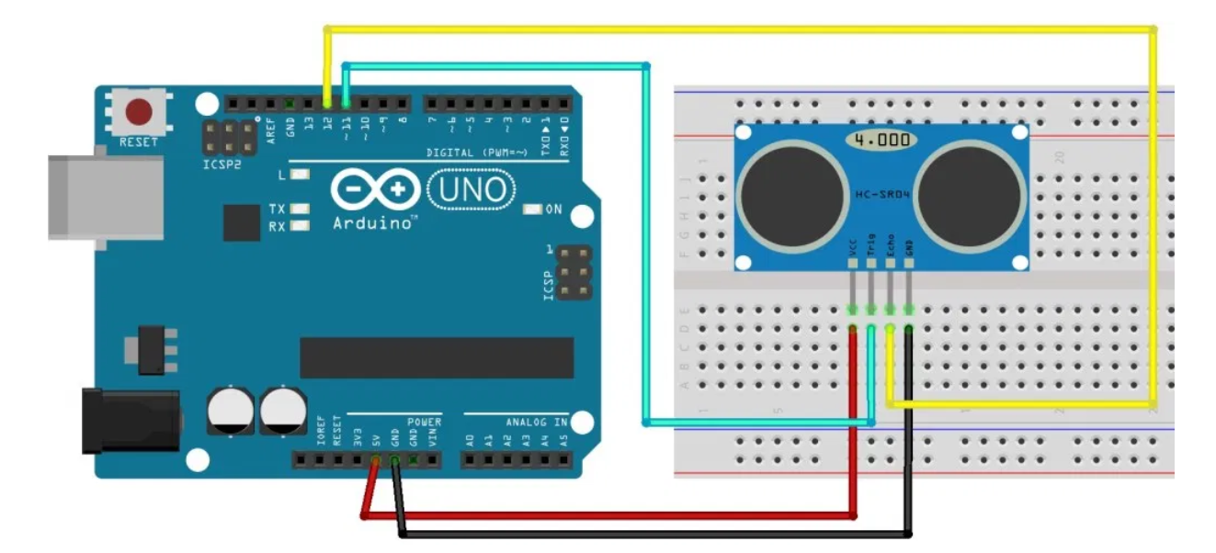

Figure 79 Sensor Schematic

There is different type of sensor for different purposes. The one we are using is a device which can detect physical objects and respond to it in a particular way. We picked the HC-SR04 ultrasonic sensor module and we will be using it with an Arduino controller. The HC-SR04 ultrasonic sensor utilizes sound to calculate the range between itself and the closest object. It is very serviceable in robotics project due to collision avoidance because we do not want any robot to hit a wall or any solid object. The HC-SR04 ultrasonic device has sensor, one is a transmitter and the other one is the receiver. For functioning, the transmitter shoot-forth a series of ultrasonic pulse and if an object and surface catch a pulse. It will reflect back to the receiver. The tile delay in signals will calculate the distance from the sensor to the object. In order to holed up the sensor we needed a breadboard and a microcontroller for the testing segment. The HC-SR04 ultrasonic sensor has 4 pins VCC for 5-volt power connection, TRIG for trigger (Input), Echo for output and GND for ground.

**Distance calculation**

The equation for distance calculation is D = (∆t/2) x c

∆t = Time Delay

C = Speed of sound (343 m/s in dry air @ 20 degrees Celsius)

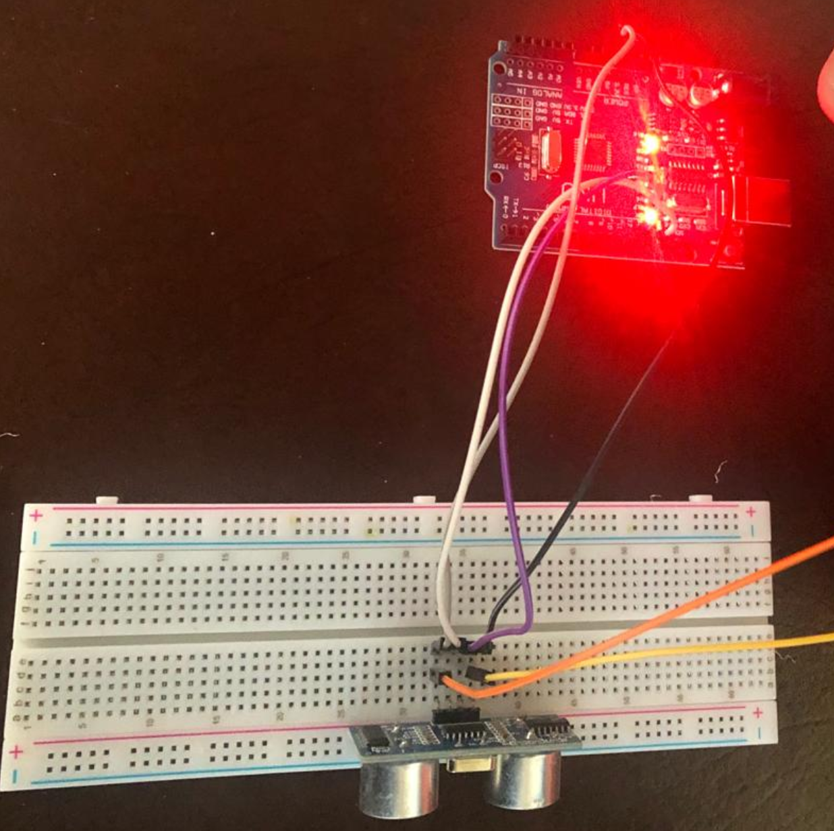

Figure 80 Sensor Testing

# Motor and Motor Driver Testing

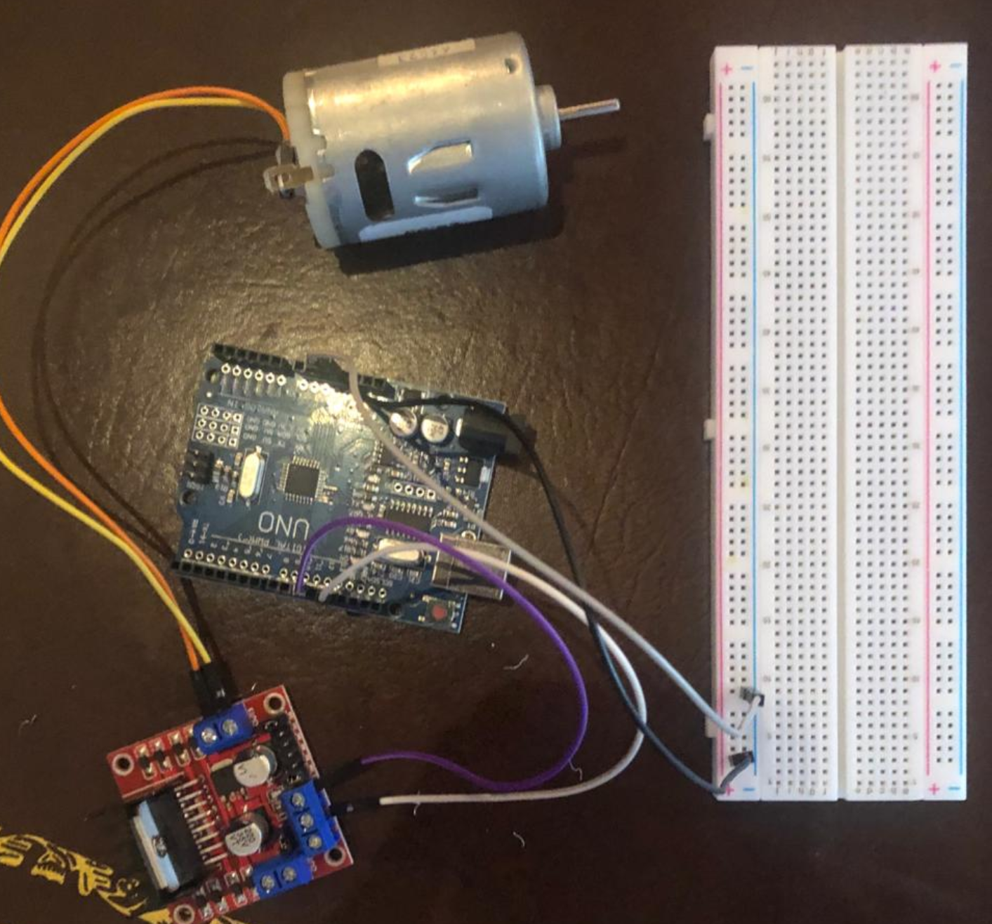

Figure 81 Motor Testing

Dc motor are suitable for many application designs. The working principal of a DC motor is simple an electric utilizes the force generated by magnetic field to produce a rotating motion. If we have a piece of wire in a magnetic field and pass a dc current through it, then the wire will start moving. It is called motor effect. We same important factor in our mind before picking up a motor for our project. Torque/ Power is one of the most important factors because these two parameters will determine the performance of our design. Second factor was efficiency of the motor. It is a ratio of how well the motor convert electrical energy into mechanical energy. It is measured by the input electrical power by the mechanical output power out of the motor. More efficiency of the motor means less losses. We choose Magnolora 12V DC 25MM 130RPM Powerful High Torque Motor Gear Box Electric Motor for our project. The specification of the motor is given below.

* Torque: 130 RPM
* Rated Voltage: 12V DC
* DC Motor Diameter: 25mm
* Length (excluding shaft): 52mm
* Shaft length: 12mm
* Total Length (Approx.): 68mm
* Shaft diameter: 4mm
* Weight: 100g

At Maximum efficiency

Speed: 95 RPM

Current: 400mA

We use a breadboard with L298N motor driver for this part. The L298N motor drive module is an H bridge module.  An H-Bridge circuit includes 4 switching elements, transistors or MOSFETs, with the motor at the center. By triggering 2 selective switches simultaneously we can change the direction of the current flow, therefore the rotation direction of the motor changes. We started testing by connecting the motor with the motor driver and hooked up a power supply to the motor driver. Then we connected the input of L298 to the breadboard to check the motor which can be seen in the picture below.

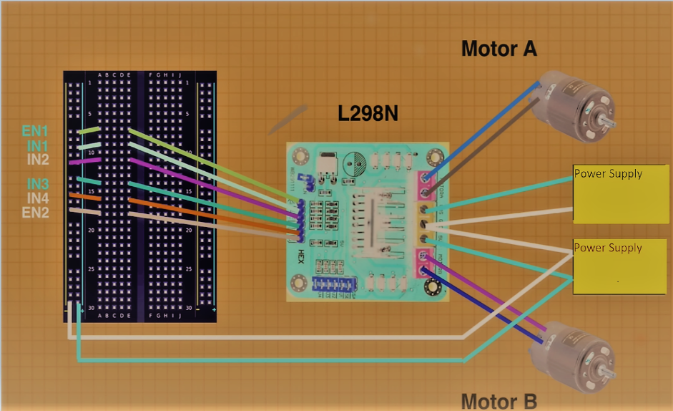

Figure 82 Motor Testing with breadboard Schematic

In second part of the motor testing, we used Arduino controller board. At this time, we put the input of the L298N driver to the digital output of the controller board. Afterwards, we connected the Driver enable pin to the pin numeber9 on the controller and input one and two of the L298 to Arduino digital pin number 7 and 8. We implemented the code for the motor to operate appropriately which can be seen below.

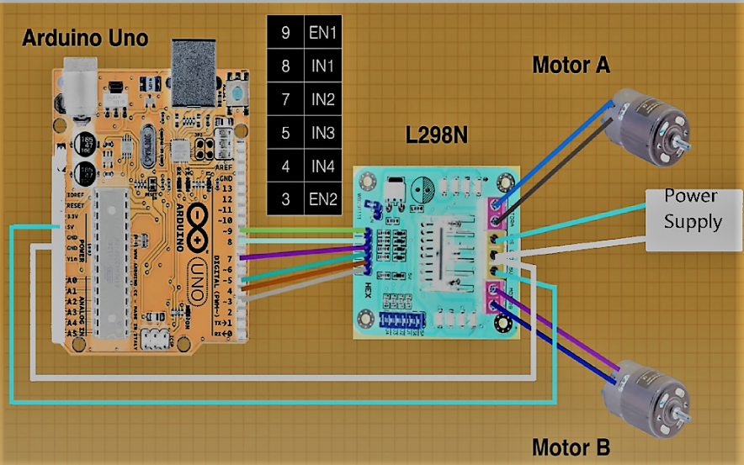

Figure 83 Motor and L298N Driver testing With Arduino

# Switch Voltage Regulator Testing

Testing voltage regulator is one of the easy parts that we have to test. Switch voltage regulator is a device that take the input voltage and adjusted or regulates it down to the voltage that is need. The first step we must know how much voltage need to be in the input and also know how much we will get at the output. so, the multimeter should measure the input and the output of the switch voltage regulator and both input and output give us the correct voltage, therefore the voltage regulator is good. If we do not read the correct voltage therefore that voltage is defective. This steps all buy using just multimeter.

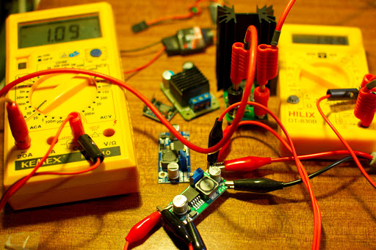

Figure 84 voltage Regulator Testing

# LCD Display Test

The LCD was tested using an Arduino Uno Rev 3 clone. The manufacturer of this clone is Elegoo. There are a reputable company that makes good quality products. Elegoo Uno Rev 3 is a clone as far as the board goes, but the actual microcontroller is the same Atmega328p that the official Arduino Uno Rev 3 has on its development board. Although it is not an official Arduino it works using the same pin lay out and the same IDE. The Figure of the schematic shows the pin lay out and connections used to implement the LCD with the microcontroller. A 10k potentiometer was also used, this potentiometer is used to adjust the brightness or contrast of the display.

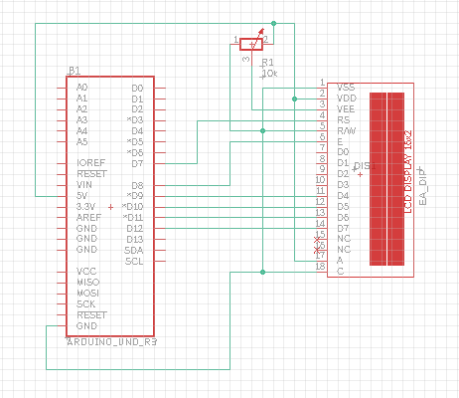

Figure 85 LCD Schematic

The breadboard was used for testing purposes. The test was successful in getting the display to show various output. Depending on the operating mode of the ACA it would have displayed different messages. In Figure 87, the message displayed is Assisting, this will be shown when the ACA is being used and on the move. While implementing this test it is noticeable that the LCD display takes up a good number of pins. If all we were doing was an LCD display that would not be a problem. For this project we also have other features that need to connect to the Atmega3258p. This makes this design not very likely to be the final one to be implemented on the ACA.

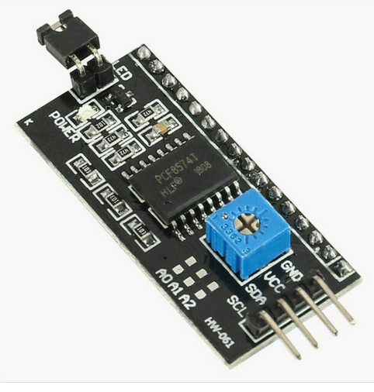

Figure 86 Adapter Module

There are other designs that can lower the number of the pins that are used on the development board and ultimately the final PCB layout. To implement the most efficient one we need to add another module to the design. The module that needs to be added is an I2C interface. This module is an adapter that will adapt the LCD to using the I2C form of communication. This allows the pin count to go from 8 pins to 4 pins. By using this design, the Arduino now has 4 less pins being used that can now be used for out sensors and modules. By using the I2C adapter the only pins needed are the VCC, GND, SDA, and SCL. SDA and SCL correspond to pins A4 and A5 on the Arduino UNO, respectively. Another convenient thing about the I2C module is it has a potentiometer built into for adjusting the contrast. This can be seen in the figure as the blue box. It can be adjusted using a screwdriver, preferably a plastic one. The Final design of the ACA did not implement any LCD.

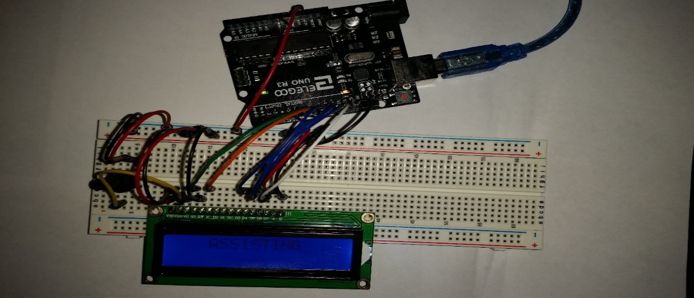

Figure 87 LCD Testing

# Load Cell Test

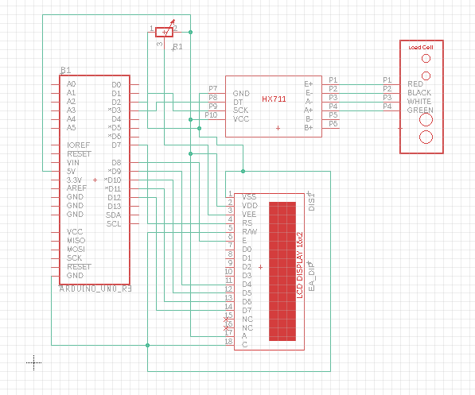

Figure 88 Schematic of Load Cell and HX711 with LCD display

The load cell that is being test has a 20 Kg max limit. That comes out to about 44 lbs. That is well within our goal which is to be able to carry around 25lbs. These types of strain load cell all wired the same. The standard is 4 wires, red, black, green, and white. The wires are connected to a full Wheatstone bridge which is located inside the white silicone glop in the middle which can be seen in the figure right above the 2 holes in the center.

The Load cell work by securing one end and having the other end take the weight. The end that takes on the weight of whatever is being measure should have some space under it so that it can flex downward when the pressure of the weight is on it. This flexing of the aluminum bar is what causes the Wheatstone bridge to vary in signal strength. As can be seen in Figure 89, the hole in the middle of the aluminum bar weaken the bar at that point which exaggerates that flex. This “exaggerated” flex is still very small. In fact, the resistors that are stretched and compressed to vary the signal have such a small variance that the Microcontroller cannot read it. It is for this reason the HX711 module needs to be implemented in this design. The HX711 is used to amplify the variation in the signal due to the flexing of the aluminum bar caused by the weight of the object being measure. That signal can then be calibrated to get a measure for the object.

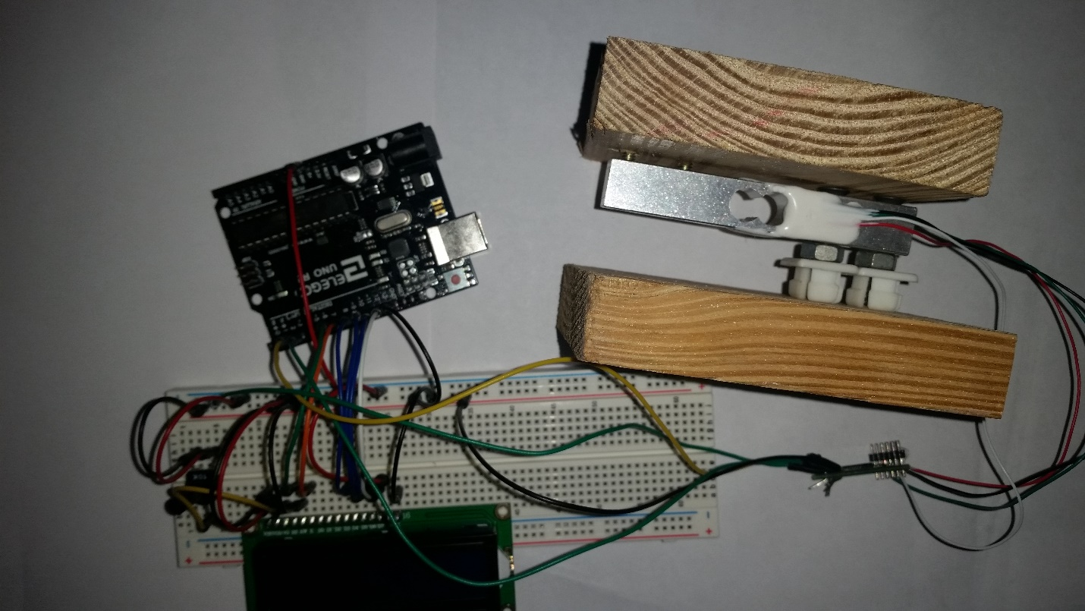

Figure 89 Load Cell Set up

The load cell is secured between to pieces of wood, as can be seen Figure 89. This design was used just to teat out the load cell. To implement it on the ACA, both top and bottom pieces would have to be replaced. Once the dimensions of the base are chosen it is as simple as cutting some material to that size. Whether it be wood, plastic and metal sheet. The material would make no different if it can be secured with enough space between both pieces so that the load cell can flex. The design tested used ¾ inch piece of wood, but something much thinner can easily be used. The code that was used to test the load cell was found online. It was very easy to implement. Combining the load cell code with the one for the LCD display was not difficult. A few adjustments were made so that the measurement would print out on the display. This was not implemented on the ACA. This is a great feature if this ACA was to be used in the proper environment for it to be useful. An airport of grocery setting would be best the best environment for this feature.

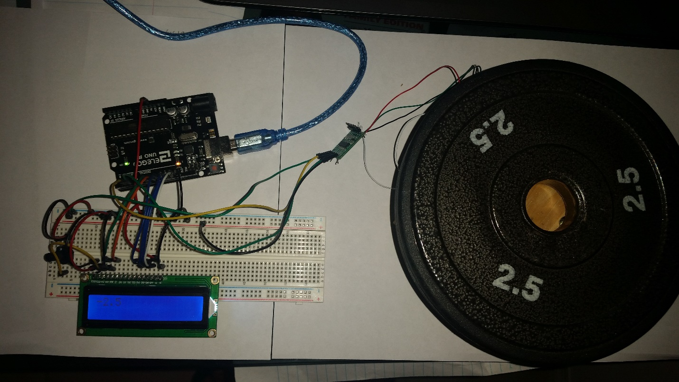

Figure 90 Load Cell Test with 2.5 lbs.

The test was a success. The load cell worked perfectly. Figure shows that the 2.5 lbs. weigh is measure at 2.5lbs. Other weight was tested. The load cell was able to weight up to 25lbs successfully. The platform to place the weight was small for the test so more weights could not be added. The test was conducted with the Elegoo which is a clone of the Arduino Uno. The load cell would have taken up 4 pins on the Arduino development board. 2 of which are ground and 5v input. The schematic shown in figure shows the load cell and LCD together. Keep in mind that an addition module will be added to the set up to lower the number of pins used by the LCD. Both these components would have taken up 4 digital I/O pins. The load cell was not implemented in the final design.

# Microcontroller Test

The Arduino Uno has been tested successfully so far for this project. It has been tested with the motors, the sensors, the display, load cell and the Bluetooth module. Although two of these components were tested using an Arduino clone, it is safe to expect the same results if not better form the Arduino in those cases. The two components tested with the Arduino clone were the LCD display and the Load cell. The Elegoo Uno Rev 3 was the clone used in these tests. This development board uses the same Atmega328p Microcontroller. Even though a clone development board is being used the actual chip is still what makes it all work and this is the actual component that will be used in the final PCB that is created to implement all the feature of the ACA .

The Atmega328p has performed very well in all the test. The next test at this point was to have all the components connect at the same time to see if the Atmega328p has the processing power to handle all the programing. A slowdown in processing speed is to be expected, but for this project preforming at top speed in not necessary. Depending on how many sensors are used this might become an issue. We were able to have it all on to the Arduino development board without any issue, this was determined in the next phase of the project.

# Bluetooth Testing

This is a picture of the HC-05 module being hooked up and tested with the Arduino board. The HC-05 module is how we are going to connect the mobile application and the Autonomous Carrier Assistant together. We could tell if the connection between our phones and the HC-05 module was working by if the LED on the HC-05 module was lighting up or not. As you can see in the picture it was turned on so that means that the connection was a success and we can test the functionality of the Arduino. We will have the mobile application be able to control the Autonomous Carrier Assistant by making it switch between different modes like either follow or lead. We might add other features to the mobile application like displaying how much weight it is carrying on the app or maybe the charge of the Autonomous Carrier Assistant. All of this requires a successful connection between the mobile device that the user will be using and the HC-05 Bluetooth module that will be attached to the Autonomous Carrier Assistant. All we had to do to test the HC-05 Bluetooth module was attach it to the Arduino and give it power. Then once we saw that the module was on, we used our phone to scan for any Bluetooth devices to pair with and we then paired with the module. The LED on the HC-05 Bluetooth module then began to flash which signals a successful pairing. The HC-05 Bluetooth module is probably the best to use because it is simple to use and it is not expensive at all to purchase.

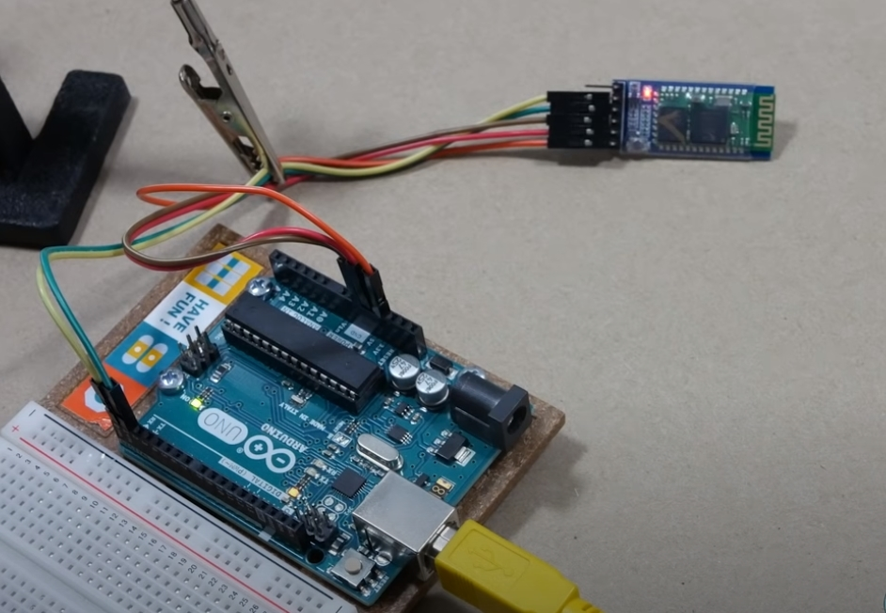

Figure 91 Bluetooth Testing

# Available Parts

In this section provide the list of parts we bought and that is available until know. As we show in price table before we get these parts with the same price that it shows in the price table. for the Arduino we also bought from amazon and we add the cost of it in the table. we bought those parts in the last minute because of COVD-19 because we were scared of buying parts from amazon or other online stores that sell parts from outside of the country. This situation that the world is going through makes our project really difficult to release. Many industries are close, and many people are losing their job. It was really scary to buy parts from amazon because we heard that there is infection on some people that work there. After getting the part we lift the part outside for 2 day to get the process working. Also, we have another problem is that really hard to meet with grope to do the testing and work in the project.

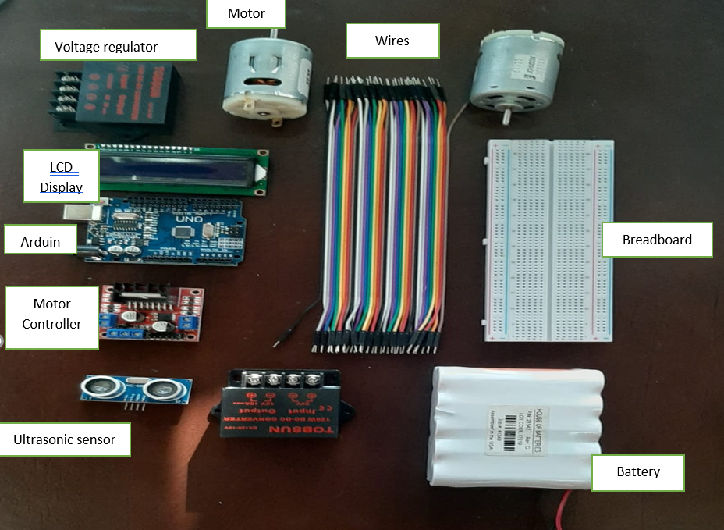

Figure 87 Parts

# ACA OPERATION

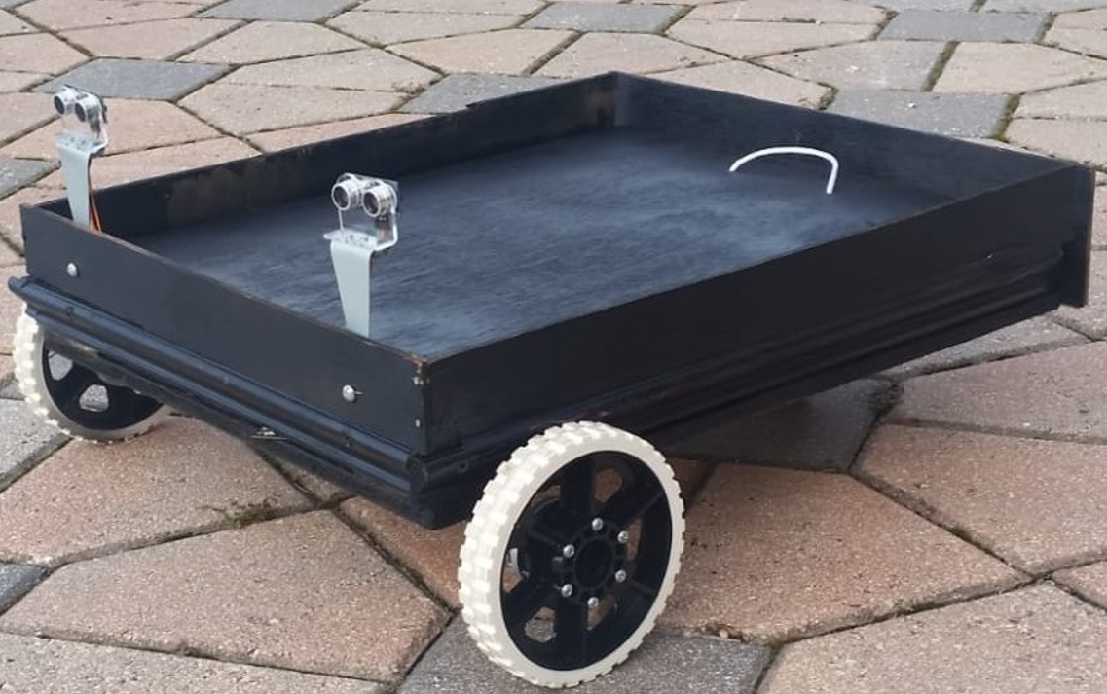

The Autonomous Carrier Assistant (ACA) project focuses to provide a user with a hassle free carrying assistant that can assist them in carrying their cargo across various distances from point A to point B. User experience is a priority, and achieving straightforward incorporation between its user and device is both exciting and rewarding. We used blynk app for mobile application which is available in android and iOS both operating systems. Blynk is an IOT platform which lets us interact with our design. This app has a bunch of different features from which we used Bluetooth and GPS. We also set up a button in blynk app to turn on and off the ACA. It provides us a simple user interface to implement and access the ACA through a mobile phone to begin, a user should approach the ACA platform with their handheld Bluetooth capable device. The user must first download the application from their desired platform application store and need to be paired with the device. The user should Immediately be able to Log in to their account on the mobile interface and start the pairing process. The ACA platform will be always ready for new devices to pair with when it is not in use, and associate links based on information relayed by the Bluetooth connection through the app. Once the pairing process is complete, the user is now on their way to burden-free travel. After the device and the user’s mobile phone are paired, the ACA will search for Bluetooth around the area to locate and initialize its following capabilities. The user will designate the follow mode and will then proceed to be closely shadowed. Travelling through crowds and obstacles, the Autonomous Carrier Assistant (ACA) should keep up with Speed and avoid any possible collisions along the way providing the user with an efficient and safe experience. Once the user has reached their destination, they will be able to disengage the device with a simple touch of a button on their handheld device and continue on with their travel. The ACA will then reset and allow for continued use by anyone else who may wish to test. There is an additional joystick option that can be used during low GPS signals through blynk app.

# Conclusion

In this report we have discussed the design and development of autonomous carrier assistant robot platform in comprehensive detail. The autonomous carrier assistant helps the users with their belongings and follows or leads the user by means of ultrasonic sensors and advanced path planning algorithms.

In the first phase of the project development, the goal and objectives are defined, and a list of requirements is compiled based on the project objectives. The objectives are set according to the SMART criterion of project management theory for effective goal setting.

In the next phase the use case scenarios for the robot are suggested. The ACA is a general-purpose autonomous robot which can be employed in a number of different sectors such as hospitals, airports, warehouses, and industries.

After the definition of use case scenarios, the marketing strategy for the ACA is developed. The aim of the project team is to introduce ACA as a commercial product in the robotics market. Hence, different modern marketing strategies and plans are developed for the ACA including social media marketing, search engine marketing, and direct consumer marketing.

All the hardware components were gathered. The main components in the construction of the ACA robot include motors, motor controller boards, power supplies, batteries, sensors, and mechanical structures. These components were purchased after careful budget planning and project cost estimation. The components were then assembled to construct the mechanical and electrical systems of the robot. After the assembly of the hardware, the software was developed for the control system of the robot. The microcontroller program interacts with all the sensors and input devices as well as controls all the actuators, motors and output devices. Extensive testing of all the hardware and software systems was performed in order to make sure that all the systems work as intended. One of the major considerations in this project was that of safety. Hence, it was ensured that all the subsystems have built in safety systems and that all potential risks are mitigated or minimized.

The ACA project is a mechatronic project which involves electrical, electronic, mechanical, and software components. Hence, the development of all the sub-systems of the ACA project was carried out in line with the relevant technical and safety standards applicable to the project.

Finally, the impacts of the autonomous ACA robot are analyzed and evaluated from different angles. The social, cultural, design, economic, and environmental impacts of the ACA project are discussed in detail towards the end of the report.

In the end, it is safe to conclude that the ACA project meets all the set requirements in a satisfactory way. It meets all the requirements while ensuring functional and occupational safety. Moreover, the project has a positive social significance and contributes positively towards enhancing the quality of life of its users.

# References

[1] Dr. August Wilhelm Scheer. (2015, September) Industry 4.0: From vision to implementation. [Online]. [https://www.researchgate.net/publication/281447305_Whitepaper_-_ Industry_40_From_vision_to_implementation](https://www.researchgate.net/publication/281447305_Whitepaper_-_%09Industry_40_From_vision_to_implementation)

[2] Illah R Nourbakhsh Roland Siegwart, *Introduction to autonomous mobile robots*. Cambridge, Massachusetts: MIT Press, 2004.

[3] Sarbjit Singh. (2017, December) Project Management and Strategic Objectives of the Organization. [Online]. <http://www.hrpub.org/download/20170228/UJIBM2-11608594.pdf>

[4] Valerio D Simone, Marco Iannucci, Maria Schiraldi Marco D Avino. (2014, October) Guidelines for e-Startup Promotion Strategy. [Online]. [https://www.researchgate.net/publication/276414685_Guidelines_for_e- Startup_Promotion_Strategy](https://www.researchgate.net/publication/276414685_Guidelines_for_e-%09Startup_Promotion_Strategy)

[5] Dr. Michael R Hyman. (2015, April) Marketing Research Process: Six Steps. [Online]. [https://www.researchgate.net/publication/273760950_Marketing_research_process_Six_st ages](https://www.researchgate.net/publication/273760950_Marketing_research_process_Six_st%09ages)

[6] Ilya Shaiderov. (2011, February) QUANTITATIVE MARKETING RESEARCH. [Online]. <https://is.muni.cz/th/j5qrs/My_diploma_1.pdf>

[7] ElecFreaks. (2020, March) Ultrasonic Ranging Module HC - SR04. [Online]. <https://cdn.sparkfun.com/datasheets/Sensors/Proximity/HCSR04.pdf>

[8] Maxbotix. (2020, March) LV-MaxSonar®-EZ™Series. [Online]. <https://www.maxbotix.com/documents/LV-MaxSonar-EZ_Datasheet.pdf>

[9] Parallax. (2020, March) PING)))™ Ultrasonic Distance Sensor. [Online]. <http://users.ece.utexas.edu/~valvano/Datasheets/PingDocs.pdf>

[10] Stephen J Chapman, *Electric Machinary Fundamentals*, 1st ed. New York, USA: McGraw Hill, 1991.

[11] Austin Hughes, *Electric Motors and Drives*, 3rd ed. Oxford, UK: ELSEVIER, 2006.

[12] Handson Technology. (2020, January) L298N Dual H-Bridge Motor Driver. [Online]. <http://www.handsontec.com/dataspecs/L298N%20Motor%20Driver.pdf>

[13] Zhu Jie, Zhou Li Guo Jian. (2012, December) Design of a linear DC power supply with adjustable voltage. [Online]. [https://www.researchgate.net/publication/257745079_Design_of_a_DC_Linear_Power_ Supply_with_Adjustable_Voltage](https://www.researchgate.net/publication/257745079_Design_of_a_DC_Linear_Power_%20%20%20%20%20%20%20%09Supply_with_Adjustable_Voltage)

[14] Joshua DuBois. (2009, April) Design of simple DC power supply. [Online]. [https://www.egr.msu.edu/classes/ece480/capstone/spring09/group06/power%20supply%2 0app%20note.pdf](https://www.egr.msu.edu/classes/ece480/capstone/spring09/group06/power%20supply%252%090app%20note.pdf)

[15] Chester Simpson. (2011, March) Linear and Switching Voltage Regulator Fundamental. [Online]. <http://www.ti.com/lit/an/snva558/snva558.pdf>

[16] Sabri Tosunoglu Melissa Morris. (2012, November) Comparison of rechargeable battery technologies. [Online]. [https://www.researchgate.net/publication/281931837_COMPARISON_OF_RECHARGEABLE BATTERY_TECHNOLOGIES](https://www.researchgate.net/publication/281931837_COMPARISON_OF_RECHARGEABLE%20%20%20%09BATTERY_TECHNOLOGIES)

[17] Varta. (2020, January) Batteries for Mobile Robots. [Online]. <http://www.inf.fu-> berlin.de/lehre/WS02/robotik/Vorlesungen/Vorlesung5/ComparisonBattery.pdf

<https://www.wholesalesolar.com/solar-information/charge-controller-article>

<https://www.researchgate.net/publication/303683238_DESIGN_AND_IMPLEMENTATION_OF_A_SOLAR_CHARGE_CONTROLLER_WITH_VARIABLE_OUTPUT>

[18] Switching Regulators by walt Kester and Brian Erisman] [Online]

<https://www.analog.com/media/en/training-seminars/design-handbooks/Practical-Design-Techniques-Power-Thermal/Section3.pdf>

[19] Mischa. (2018, March 5). How a battery works. Retrieved from] [Online]

<https://www.science.org.au/curious/technology-future/batteries>

[20] Integrated Publishing, Inc. - A (SDVOSB) Service-Disabled Veteran Owned Small Business. (n.d.). Retrieved from] [Online]

<http://nuclearpowertraining.tpub.com/hdbk1084/css/Constant-Voltage-Charging-41.htm>

[21] Guy, P. (1970, January 1). Constant Voltage, Constant Current Battery Charging. Retrieved from] [Online]

<http://power-topics.blogspot.com/2016/05/constant-voltage-constant-current.html>

[22] Battery charger basics. (n.d.). Retrieved from] [Online]

<https://chargetek.com/basic-information.html>

[23] Float Voltage in Battery Chargers. (2014, May 27). Retrieved from] [Online] <https://www.upsbatterycenter.com/blog/float-voltage-battery-chargers/>

[24] Liao, C. (2015). Low dropout, constant-current/constant-voltage 3A battery charger. Analog Circuit Design, 461–462. doi: 10.1016/b978-0-12-800001-4.00218-0] [Online]

<https://www.analog.com/media/en/training-seminars/design-handbooks/Basic-Linear-Design/Chapter9.pdf>

[25] CIRCUITS AND SYSTEMS- Assembly and Printed Circuit Board (PCB) Package – Mohammad S. Sharawi] [online]

<https://www.researchgate.net/publication/256103506_Assembly_and_Printed_Circuit_Board_PCB_Package>

[26] Marshall Brain "How Microcontrollers Work" 1 April 2000.]  
HowStuffWorks.com. <https://electronics.howstuffworks.com/microcontroller.htm> > 10 March 2020

[27] Margrette Rouse “Microcontroller”]

<https://internetofthingsagenda.techtarget.com/definition/microcontroller>> 9 March 2020

[28] <https://store.arduino.cc/usa/arduino-uno-rev3>> 9 March 2020]

[29] <https://www.digikey.com/products/en?FV=-5|37582&newproducts=1>> 9 March 2020

[30] <http://www.ti.com/product/MSP430FR6989>> 10 March 2020

[31] <https://en.wikipedia.org/wiki/Direct_memory_access>> 12 March 2020

[32] Teensy 3.5 & 3.6 Review by Sam (15 June 2017)

<https://core-electronics.com.au/tutorials/teensy-3.5-and-3.6-review.html>> 6 March 2020

[33] Why It Took So Long to Invent the Wheel by Natalie Wolchover (March 02, 2012)

<https://www.livescience.com/18808-invention-wheel.html>> 12 March 2020

[34] Wheels vs Continuous Tracks: Advantages and Disadvantages (14 May 2015)

<https://www.intorobotics.com/wheels-vs-continuous-tracks-advantages-disadvantages/>> 11 March 2020

[35] Wheeled robots’ types, uses, advantages and disadvantages by Heba Soffar (March 3, 2019)

<https://www.online-sciences.com/robotics/wheeled-robots-types-uses-advantages-and-disadvantages/>> 15 March 2020

[36] What Wheels Should My Robot Use? by cbenson (13 Dec 2019)

<https://www.robotshop.com/community/tutorials/show/what-wheels-should-my-robot-use>> 15 March 2020

[37] A Short History of the Weighing Scale (30 September 2011)

<https://blog.withings.com/2011/09/30/a-short-history-of-the-weighing-scale-2/>> 15 March 2020

[38] <https://shop.transcell.com/how-digital-scales-work/>> 17 March 2020

[39] “How Digital Scales Work” Nicholas Gerbis

<https://electronics.howstuffworks.com/gadgets/fitness/digital-scale.htm>> 17 March 2020

[40] “Weights and balances” Chris Woodford (5 Dec 2019)

<https://www.explainthatstuff.com/weights_and_balances.html>> 17 March 2020

[41] bluAir. ["Bluetooth Range: 100m, 1km, or 10km?"](http://www.bluair.pl/bluetooth-range). bluair.pl. Retrieved 4 June 2015.

[42]["Basics | Bluetooth Technology Website"](http://www.bluetooth.com/Pages/Basics.aspx). Bluetooth.com. 23 May 2010.

[43]["Bluetooth Experience Icons"](https://www.bluetooth.org/DocMan/handlers/DownloadDoc.ashx?doc_id=46091) (PDF). Bluetooth Special Interest Group. Retrieved 21 October 2016. Bluetooth Experience Icons borrow two of these three features: the blue color and the rune-inspired symbol.

[44]["History of the Bluetooth Special Interest Group"](http://www.bluetooth.com/Pages/History-of-Bluetooth.aspx). Bluetooth.com.

[45]["DailyTech"](https://web.archive.org/web/20141207093853/http:/www.dailytech.com/Bluetooth+42+Promises+Faster+Connections+Better+Security+to+Stop+Snooping/article36960.htm). Archived from [the original](http://www.dailytech.com/Bluetooth+42+Promises+Faster+Connections+Better+Security+to+Stop+Snooping/article36960.htm) on 7 December 2014.

[46]["Bluetooth for Programmers"](http://people.csail.mit.edu/rudolph/Teaching/Articles/PartOfBTBook.pdf) (PDF). MIT Computer Science and Artificial Intelligence Laboratory.

[47]"GPS: Global Positioning System (or Navstar Global Positioning System)" Wide Area Augmentation System (WAAS) Performance Standard, Section B.3, Abbreviations and Acronyms. [[1]](http://www.gps.gov/technical/ps/2008-WAAS-performance-standard.pdf)[Archived](https://web.archive.org/web/20170427033332/http:/www.gps.gov/technical/ps/2008-WAAS-performance-standard.pdf) April 27, 2017, at the [Wayback Machine](https://en.wikipedia.org/wiki/Wayback_Machine)

[48]["Global Positioning System Standard Positioning Service Performance Standard : 4th Edition, September 2008"](http://www.gps.gov/technical/ps/2008-SPS-performance-standard.pdf) (PDF). [Archived](https://web.archive.org/web/20170427025348/http:/www.gps.gov/technical/ps/2008-SPS-performance-standard.pdf) (PDF) from the original on April 27, 2017. Retrieved April 21, 2017.

[49]["A Guide to the Global Positioning System (GPS) – GPS Timeline"](https://web.archive.org/web/20100213100725/http:/support.radioshack.com/support_tutorials/gps/gps_tmline.htm). Radio Shack. Archived from [the original](http://support.radioshack.com/support_tutorials/gps/gps_tmline.htm) on February 13, 2010. Retrieved January 14, 2010.

[50]["United States Updates Global Positioning System Technology"](https://web.archive.org/web/20131009161500/http:/iipdigital.usembassy.gov/st/english/article/2006/02/20060203125928lcnirellep0.5061609.html). America.gov. February 3, 2006. Archived from [the original](http://iipdigital.usembassy.gov/st/english/article/2006/02/20060203125928lcnirellep0.5061609.html) on October 9, 2013. Retrieved June 17, 2019.

[51][National Archives and Records Administration](https://en.wikipedia.org/wiki/National_Archives_and_Records_Administration). [U.S. Global Positioning System Policy](http://clinton4.nara.gov/textonly/WH/EOP/OSTP/html/gps-factsheet.html) [Archived](https://web.archive.org/web/20060406125528/http:/clinton4.nara.gov/textonly/WH/EOP/OSTP/html/gps-factsheet.html) April 6, 2006, at the [Wayback Machine](https://en.wikipedia.org/wiki/Wayback_Machine). March 29, 1996.

[52] Pogue, David (November 4, 2009). ["A Place to Put Your Apps"](https://www.nytimes.com/2009/11/05/technology/personaltech/05pogue.html?pagewanted=all). New York Times. Retrieved January 22, 2013.

[53]"SAGE Journals: Your gateway to world-class journal research". [doi](https://en.wikipedia.org/wiki/Digital_object_identifier):[10.1177/0735633117727599](https://doi.org/10.1177%2F0735633117727599).

[54]["Mobile apps revenues tipped to reach $26bn in 2013"](https://www.theguardian.com/technology/appsblog/2013/sep/19/gartner-mobile-apps-revenues-report). The Guardian. 11 October 2013. Retrieved 19 September 2013.

[55] Chris Bracken. ["Release v0.0.6: Rev alpha branch version to 0.0.6, flutter 0.0.26 (#10010) · flutter/flutter"](https://github.com/flutter/flutter/releases/tag/v0.0.6). [GitHub](https://en.wikipedia.org/wiki/GitHub). Retrieved 2018-08-08.

[56]["Flutter SDK releases"](https://flutter.dev/docs/development/tools/sdk/releases). Flutter.dev.

[57]["unity.com Traffic, Demographics and Competitors"](https://www.alexa.com/siteinfo/unity.com). [Alexa Internet](https://en.wikipedia.org/wiki/Alexa_Internet). Retrieved October 1, 2019.

[58]["Mobile game developer survey leans heavily toward iOS, Unity"](http://www.gamasutra.com/view/news/169846/Mobile_game_developer_survey_leans_heavily_toward_iOS_Unity.php). Gamasutra. May 24, 2012. [Archived](https://web.archive.org/web/20140703233046/http:/www.gamasutra.com/view/news/169846/Mobile_game_developer_survey_leans_heavily_toward_iOS_Unity.php) from the original on July 3, 2014. Retrieved July 14, 2014.

[59] Batchelor, James. ["Unity dropping major updates in favour of date-based model"](http://www.gamesindustry.biz/articles/2016-12-14-unity-dropping-major-updates-in-favour-of-date-based-model). GamesIndustry.biz. [Archived](https://web.archive.org/web/20170319022436/http:/www.gamesindustry.biz/articles/2016-12-14-unity-dropping-major-updates-in-favour-of-date-based-model) from the original on March 19, 2017. Retrieved March 18, 2017.

[60]["Unity – Multiplatform"](https://unity3d.com/unity/features/multiplatform). Unity. [Unity Technologies](https://en.wikipedia.org/wiki/Unity_Technologies). [Archived](https://web.archive.org/web/20180612185354/https:/unity3d.com/unity/features/multiplatform) from the original on June 12, 2018. Retrieved June 27, 2018.

[61]["React Native · A framework for building native apps using React"](https://facebook.github.io/react-native/). Retrieved 2019-11-06.

[62] Windows Apps Team (April 13, 2016). ["React Native on the Universal Windows Platform"](https://blogs.windows.com/buildingapps/2016/04/13/react-native-on-the-universal-windows-platform/). blogs.windows.com. Retrieved 2016-11-06.

[61] Guttag, John V. (12 August 2016). Introduction to Computation and Programming Using Python: With Application to Understanding Data. MIT Press. ISBN 978-0-262-52962-4.

[62] Kuchling, A. M. "Functional Programming HOWTO". Python v2.7.2 documentation. Python Software Foundation. Retrieved 9 February 2012.

[63] Binstock, Andrew (May 20, 2015). "Java's 20 Years of Innovation". Forbes. Archived from the original on March 14, 2016. Retrieved March 18, 2016.

[64] Gosling, James; Joy, Bill; Steele, Guy; Bracha, Gilad. "The Java Language Specification, 2nd Edition". Archived from the original on August 5, 2011. Retrieved February 8, 2008.

[65]"Oracle Java SE Support Roadmap". www.oracle.com.

[66]"JavaSoft ships Java 1.0". Archived from the original on March 10, 2007. Retrieved 2008-02-05.

[67] Press release announcing JavaScript, "Netscape and Sun announce JavaScript", PR Newswire, December 4, 1995

[68]"TechVision: Innovators of the Net: Brendan Eich and JavaScript". web.archive.org. Archived from the original on 2008-02-08.

[69]"Standard ECMA-404 - The JSON Data Interchange Syntax"(PDF). Ecma International. December 2017. p. 1, footnote. Retrieved 27 October 2019.

[70]"Douglas Crockford: The JSON Saga - Transcript Vids". transcriptvids.com. Retrieved 29 October 2019.

[71]"The Java Virtual Machine Specification: Java SE 7 Edition"(PDF). Docs.oracle.com. Retrieved 2015-06-26.

[72] “An introduction to OLED displays” 03/29/2019 https://www.oled-info.com/oled-introduction >March 31, 2020

[73] https://components101.com/16x2-lcd-pinout-datasheet> March 30, 2020

[74] http://ledpro.in/types-of-electronic-displays/>March,30 2020

[75] “Interfacing a Load Cell with an Arduino Board” https://www.robotshop.com/community/blog/show/interfacing-a-load-cell-with-an-arduino-board>06/08/2015 by bdaouas

[76] "XML Media Types, RFC 7303". Internet Engineering Task Force. July 2014.

[77] "Web Services Architecture". World Wide Web Consortium. 11 February 2004. 3.1.3 Relationship to the World Wide Web and REST Architectures. Retrieved 29 September2016.

[78] 3333Clarke, Steven (2004). "Measuring API Usability". Dr. Dobb's. Retrieved 29 July 2016.

[79] Bierhoff, Kevin (23 April 2009). "API Protocol Compliance in Object-Oriented Software"(PDF). CMU Institute for Software Research. Retrieved 29 July 2016.